**Draft Version 0.1.12**

**2018**

**INTERNATIONAL HYDROGRAPHIC ORGANIZATION**



**IHO GEOSPATIAL STANDARD**

**FOR HYDROGRAPHIC DATA**

**Edition 0.1.12 2018**

**Special Publication No. S-111**

**Surface Current Product Specification**

**Published by the   
International Hydrographic Bureau   
MONACO**

**Surface Current Product Specification**

**Revision History**

|  |  |  |  |
| --- | --- | --- | --- |
| **Version Number** | **Date** | **Author/Editor** | **Purpose** |
| Draft 1.0 | December 2012 | D. O’Brien, Auth. | Demonstration Version |
| Draft 1.1 | April 2014 | L. Maltais, Ed. | Revision for currents |
| Draft 1.2 | August 2014 | L. Maltais, Ed | Additional revision of previous version |
| Draft 1.3 | December 2014 | L. Maltais, Ed | Additional revision of previous version |
| Draft 1.4 | March 2015 | L. Maltais, Ed | Additional revision of previous version |
| Draft 1.5 | March 2015 | K. Hess, B. Sullivan,  C. Kammerer, E. Mong, Eds. | Put into template format, numerous changes |
| Draft 1.6 | September 2015 | SCWG members, Eds. | Changes as result of SCWG3 discussions |
| Draft 1.7 | December 2015 | K. Hess, Ed. | Changes per review of  Draft 1.6 |
| Draft 1.8 | February 2016 | K. Hess, Ed. | Changes per review of  Draft 1.7 |
| Draft 1.9 | September 2016 | K. Hess, TWCWG members, Eds. | Changes as result of TWCWG1 discussions |
| Draft 1.10 | January 2017 | K. Hess, TWCWG members, Eds. |  |
| Draft 1.11 | October 2017 | K. Hess, TWCWG members, Eds. | Changes as result of TWCWG2 discussions |
| Draft 1.12 | April 2018 | K. Hess, TWCWG, DQWG members, Eds. | Changes per review of v1.11 |

TABLE OF CONTENTS

1. OVERVIEW 1

1.1 Introduction 1

1.2 Scope 2

1.3 References 3

1.3.1 Normative 3

1.3.2 Informative 3

1.3 Terms, Definitions and Abbreviations 4

1.4.1 Use of Language 4

1.3.2 Terms and Definitions 4

1.3.3 Abbreviations 7

1.5 General S-111 Data Product Description 8

1.6 Data Product Specification Metadata and Maintenance 8

1.6.1 Product Specification Metadata 8

1.6.2 HO Product Specification Maintenance 9

2. SPECIFICATION SCOPES 10

3. DATASET IDENTIFICATION 10

4. DATA CONTENT AND STRUCTURE 11

4.1 Introduction 11

4.2 Application Schema 11

4.3 Feature Catalogue 11

4.3.1 Introduction 11

4.3.2 Feature Types 11

4.3.3 Feature Relationship 12

4.3.4 Information Types 12

4.3.5 Spatial Quality 12

4.3.6 Attributes 13

4.4 Spatial Schema 13

4.4.1 Regular Grids 14

4.4.2 Points 16

4.4.3 Summary 16

5. COORDINATE REFERENCE SYSTEMS (CRS) 17

5.1 Horizontal Reference System 17

5.2 Vertical Reference System 18

5.3 Temporal Reference System 18

6. DATA QUALITY 18

6.1 Quality 18

6.2 Completeness 19

7. DATA CAPTURE AND CLASSIFICATION 20

7.1 Data Sources 20

7.2 The Production Process 21

7.2.1 Metadata 21

7.2.2 Surface Current Data 21

7.2.3 Digital Tidal Atlas Data 22

8. MAINTENANCE 22

8.1 Maintenance and Update Frequency 22

8.2 Data Source 23

8.3 Production Process 23

9. PORTRAYAL 23

9.1 Introduction 23

9.2 Display of Current at a Single Point 23

9.2.1 Arrow Shape 23

9.2.2 Arrow Direction 24

9.2.3 Arrow Colour and Speed Bands 25

9.2.4 Arrow Size 26

9.2.5 Numerical Values 27

9.2.6 Transparency 28

9.2.7 Scalable Vector Graphics 28

9.2.8 Symbol Placement 29

9.3 Display of Regularly Gridded Data 29

9.3.1 High Resolution 29

9.3.2 Low Resolution 31

9.4 Temporal Rules 33

9.5 Placement of Legend 33

9.6 Interoperability 34

9.7 Sample Representation 35

10. DATA PRODUCT FORMAT (ENCODING) 37

10.1 Introduction 37

10.2 Product Structure 37

10.2.1 Carrier Metadata 38

10.2.2 Conditional Group XY 39

10.2.3 Data Sets 39

10.2.4 Groups 40

10.2.5 Summary of Generalized Dimensions 40

10.3 HDF5 Encoding 41

11. DATA PRODUCT DELIVERY 41

11.1 Introduction 41

11.2 Exchange Datasets 41

11.3 Exchange Catalogue 42

11.4 Data Product File Naming 42

11.5 Support Files 42

12. METADATA 43

12.1 Introduction 43

12.2 Discovery Metadata 43

12.2.1 S111_ExchangeCatalogue 47

12.2.2 S100_CatalogueIdentifier 48

12.2.3 S100_CataloguePointofContact 48

12.2.4 S100_DatasetDiscoveryMetaData 49

12.2.5 S111_DataCoverage 50

12.2.6 S100_VerticalAndSoundingDatum 52

12.2.7 S111_DataFormat 53

12.2.8 S100_ProductSpecification 53

12.2.9 S100_CatalogueMetadata 53

12.2.10 S100_CatalogueScope 54

12.2.11 S100_19115DatasetMetadata 54

12.3 Carrier Metadata 55

12.4 Language 55

ANNEX A. DATA CLASSIFICATION AND ENCODING GUIDE 57

A.1 Features 57

A.2 Feature Attributes 57

ANNEX B. ADDITIONAL TERMS AND DEFINITIONS 58

ANNEX C. APPLICATION SCHEMA 63

ANNEX D. FEATURE CATALOGUE 66

ANNEX E. TESTS OF COMPLETENESS (NORMATIVE) 68

E.1 Coverage Consistency 68

E.1.1 Test case for coverage geometry 68

E.1.2 Test case for extra data 68

E.1.3 Test case for empty data 68

E.2 Logical Consistency 69

E.2.1 Conceptual Consistency 69

E.2.2 Domain Consistency 69

E.2.3 Positional Accuracy 69

E.2.4 Temporal Accuracy 70

ANNEX F. SURFACE CURRENT DATA 71

F.1 Data Sources 71

F.2 Data Organization 71

F.2.1 Time Series Data 71

F.2.2 Gridded Data 73

F.3 Digital Tidal Atlas Data 75

F.4 Moving Platform Data 76

F.5 Preliminary Data Product Format 76

F.6 Additional Features of the Data 77

F.6.1 Vertical Reference Datums 77

F.6.2 Uncertainty 77

ANNEX G. HDF-5 ENCODING 79

G.1 Introduction 79

G.2 Carrier Metadata 80

G.3 Group F (Codes) 80

G.4 Group XY 81

G.5 Data Groups 81

G.6 Samples of HDF Data Files 82

G.6.1 Stationary Platform 83

G.6.2 Regular Grid 85

G.6.3 Ungeorectified Grid 87

G.6.4 Moving Platform 89

ANNEX H. COLOUR TABLES 91

ANNEX I. SCALABLE VECTOR GRAPHICS (SVG) CODING 92

I.1 Sample SVG Image 92

I.2 Sample SVG File to Display Arrows 92

I.3 Sample CSS File 93

# 1. OVERVIEW

From ancient times of exploration to modern day shipping, surface currents have played an important role in navigation. With the advent of electronic navigation, surface current data and updates are more accessible and easier to integrate into navigation displays. This integration of the chart with other supplemental data improves decision making and results in more efficient navigation.

## 1.1 Introduction

A data Product Specification (PS) is a precise technical description that defines the requirements for a geospatial data product and forms the basis for producing or acquiring data. This PS, S-111, conforms to S-100.

The S-111 PS describes the feature *Surface Current* and its two attributes *Surface Current Speed* and *Surface Current Direction* (ANNEX A - DATA CLASSIFICATION AND ENCODING GUIDE), and the relationships of surface currents and their mapping to a dataset. The Surface Current represents the water velocity at one or more geographic locations at either (a) a given depth relative to a named vertical datum, or (b) an average from the surface down to a given depth. The current values are obtained through in situ or remote measurement or by analytic methods or hydrodynamic modeling. The PS includes general information for data identification as well as for data content and structure, reference system, data quality aspects, data capture, maintenance, encoding, delivery, metadata and portrayal. The framework, i.e., the relationships between these elements, is depicted in Figure 1.1. The framework identifies how the various elements of a coverage dataset fit together.

A dataset containing Surface Current data describes a set of values distributed over an area. The structure containing the values is either a Grid Coverage or a Point Coverage.

* Gridded data consists of a set of attribute values organized in a grid together with metadata to describe the meaning of the attribute values and spatial referencing information to position the data. An essential characteristic of a regular grid is that the geographic position of any node can be computed from the values of the origin and point spacing. A coverage includes a function which provides values at geographic locations within the extent of the grid. A continuous function provides values at all locations, while a discrete function, which is used for Surface Currents, provides values at only specific points (e.g., grid nodes).
* Another type of structure is a Point Coverage, which also contains metadata and attribute values, although the locations of the points are not organized into a regular grid. The location of all points must be explicitly specified. There is no coverage function.

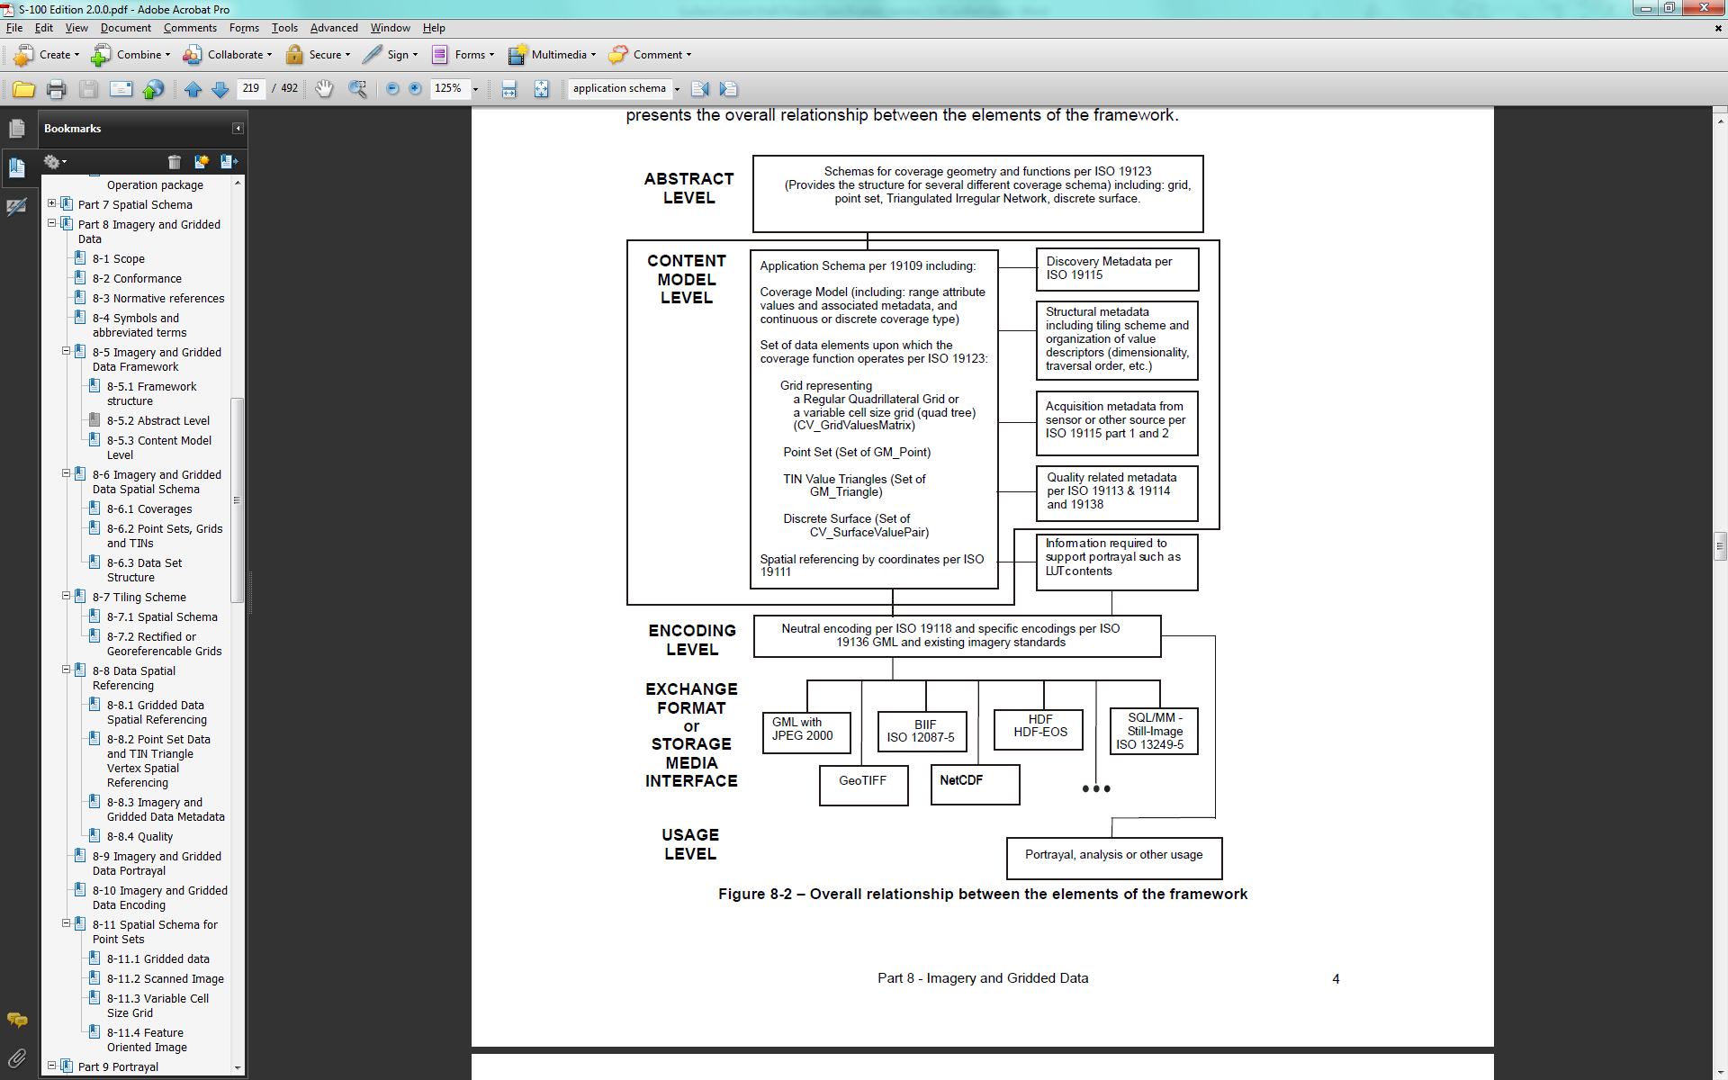

Figure 1.1 - Overall relationship between the elements of the framework (from S-100, Part 8).

The Hierarchical Data Format version 5 (HDF5) promotes compatible data exchange due to its common neutral encoding format, and is the format used for this data product. HDF5 is object oriented and suitable for many types of data and forms the basis of the Network Common Data Form (NetCDF), a popular format used for scientific data.

## 1.2 Scope

This document describes an S-100 compliant product specification for surface currents and it specifies the content, structure, and metadata needed for creating a fully compliant S-111 product and for its portrayal within an S-100 electronic charting environment. This product specification includes the content model, the encoding, the feature catalogue and metadata. The surface current product may be used either alone or combined with other S‑100 compatible data.

## References

### 1.3.1 Normative

**S-44*.*** *IHO Standards for Hydrographic Surveys,* 5th Edition February 2008.

**S-100.** *IHO Universal Hydrographic Data Model, ver. 3.0.0. (*April 2017).

**S-101.** *IHO Electronic Navigational Chart Product Specification,* July 2014.

**S-102**. *IHO Bathymetric Surface Product Specification,* April 2012.

**ISO 8601. 2004.** *Data elements and interchange formates - Information interchange - Representation of dates and times.* 2004.

**ISO 3166-1. 1997.** *Country Codes.* 1997.

**ISO/TS 19103. 2005.** *Geographic information - Conceptual schema language.* 2005.

**ISO 19111. 2003.** *Geographic information - Spatial referencing by coordinates.* 2003.

**ISO 19115. 2003.** *Geographic information - Metadata.* 2003.

**ISO 19115-2. 2009.** *Geographic information - Metadata - Part 2: Extension for imagery and gridded data.* 2009.

**ISO/TS 19123. 2005.** *Geographic information - Schema for coverage geometry and functions.* 2005.

**ISO 19129. 2009.** *Geographic information - Imagery, gridded and coverage data framework.* 2009.

**ISO 19131. 2007.** *Geographic information - Data product specifications.* 2007.

**ISO/IEC 19501. 2005.** *Information technology - Unified Modeling Language (UML) Version 1.4.2.* 2005.

**netCDF –** *Network Common Data Form: Unidata –* www.unidata.ucar.edu/software/netcdf

**HDF5 –** *Hierarchical Data Format version 5 –* www.hdfgroup.org

### Informative

**ISO 19101. 2002.** *Geographic information - Reference model.* 2002.

**ISO 19103-2. 2005.** *Geographic information - Conceptual schema language - Part 2.* 2005.

**ISO 19105. 2000.** *Geographic information - Conformance and testing.* 2000.

**ISO 19107. 2003.** *Geographic information - Spatial schema.* 2003.

**ISO 19108. 2002.** *Geographic information - Temporal schema.* 2002.

**ISO 19109. 2005.** *Geographic information - Rules for application schema.* 2005.

**ISO 19110. 2005.** *Geographic information - Methodology for feature cataloguing.* 2005.

**ISO 19113. 2002.** *Geographic information - Quality principles.* 2002.

**ISO 19116. 2004.** *Geographic information - Positioning services.* 2004.

**ISO 19117. 2005.** *Geographic information - Portrayal.* 2005.

**ISO 19118. 2005.** *Geographic information - Encoding.* 2005.

**ISO 19128. 2005.** *Geographic information - Web Map Server interface.* 2005.

**ISO/TS 19130. 2010.** *Geographic information - Imagery sensor models for geopositioning.* 2010.

**ISO/TS 19130-2. 2010.** *Geographic information - Imagery sensor models for geopositioning - Part 2.* 2010.

**ISO 19132. 2007.** *Geographic information - Location-based services – Reference model.* 2007.

**ISO 19133. 2005.** *Geographic Information - Location-based services - Tracking and navigation.* 2005.

**ISO 19136. 2007.** *Geographic information - Geography Markup Language (GML).* 2007.

**ISO/TS 19138. 2006.** *Geographic information - Data quality measures.* 2006.

**ISO 19142. 2010.** *Geographic information - Web Feature Service.* 2010.

**ISO 19144-1. 2009.** *Geographic information - Classification systems – Part 1: Classification system structure.* 2009.

**ISO 19145. 2010.** *Geographic information - Registry of representations of geographic point location.* 2010.

**ISO 19153. 2010.** *Geographic information - Geospatial Digital Rights Management Reference Model (GeoDRM RM) 1).* 2010.

**ISO 19156. 2010.** *Geographic information - Observations and measurements.* 2010.

**ISO 19157. 2010.** *Geographic information - Data quality.* 2010.

**ISO 19158. 2010.** *Geographic Information - Quality assurance of data supply.* 2010.

*Springer Handbook of Geographic Information.* 2012.

**CO-OPS – Tide and Current Glossary 2000**

**Wikipedia.** *Wikipedia.* [Online]

## Terms, Definitions and Abbreviations

### 1.4.1 Use of Language

Within this document:

• “Must” indicates a mandatory requirement.

• “Should” indicates an optional requirement, that is the recommended process to be followed, but is not mandatory.

• “May” means “allowed to” or “could possibly”, and is not mandatory.

### Terms and Definitions

The S-100 framework is based on the ISO 19100 series of geographic standards. The terms and definitions provided here are used to standardize the nomenclature found within that framework, whenever possible. They are taken from the references cited in Clause 1.3, modifications were made when necessary. Additional terms have also been included (see ANNEX B). Terms that are defined in this clause or in ANNEX B are highlighted in **bold**.

**coordinate**

one of a sequence of n numbers designating the position of a point in n-dimensional space

NOTE: In a **coordinate reference system**, the **coordinate** numbers are qualified by units

[ISO 19107, ISO 19111]

**coordinate reference system**

coordinate system that is related to an **object** by a **datum**

NOTE: For geodetic and **vertical datums**, the **object** will be the Earth

[ISO 19111]

**coverage**

**feature** that acts as a **function** to return values from its **range** for any **direct position** within its spatial, temporal, or spatiotemporal **domain**

EXAMPLE: Examples include a raster **image**, polygon overlay, or digital elevation matrix

NOTE: In other words, a **coverage** is a **feature** that has multiple values for each **attribute** type, where each **direct position** within the geometric representation of the **feature** has a single value for each **attribute** type

[ISO 19123]

**coverage geometry**

configuration of the **domain** of a **coverage** described in terms of **coordinates**

[ISO 19123]

**data product**

**dataset** or **dataset series** that conforms to a **data product specification**

NOTE: The S-111 data product consists of metadata and one or more sets of speed and direction values [ISO 19131]

**data quality**

a set of elements describing aspects of quality, including a measure of quality, an evaluation procedure, a quality result, and a scope

**depth-specific current**

the water current at a specified **depth** below the **sea surface**

**direct position**

**position** described by a single set of **coordinates** within a **coordinate reference system**

[ISO 19107]

**domain**

well-defined set**. Domains** are used to define the **domain** set and **range** set of **attributes**, operators, and **functions**

NOTE: *Well-defined* means that the definition is both necessary and sufficient, as everything that satisfies the definition is in the set and everything that does not satisfy the definition is necessarily outside the set

[ISO/TS 19103, ISO 19107, ISO 19109]

**feature**

abstraction of real-world phenomena

EXAMPLE**:** The phenomenon named *Eiffel Tower* may be classified with other similar phenomena into a **feature type** named *tower*

NOTE 1: A **feature** may occur as a **type** or an **instance**. **Feature type** or feature instance shall be used when only one is meant

NOTE 2: In UML 2, a **feature** is a property, such as an operation or **attribute**, which is encapsulated as part of a list within a classifier, such as an interface, **class**, or **data type**

[ISO 19101, ISO/TS 19103, ISO 19110]

**feature attribute**

**characteristic** of a **feature**

EXAMPLE 1: A **feature attribute** named *colour* may have an **attribute** value *green* which belongs to the **data type** *text*

EXAMPLE 2: A **feature attribute** named *length* may have an **attribute** value *82.4* which belongs to the **data type** *real*

NOTE 1**:** A **feature attribute** may occur as a **type** or an **instance**. **Feature attribute** type or **feature attribute** instance is used when only one is meant

NOTE 2: A **feature attribute** type has a name, a **data type**, and a **domain** associated to it. A **feature attribute** instance has an **attribute** value taken from the **domain** of the **feature attribute** type

NOTE 3: In a **feature catalog**, a **feature attribute** may include a value **domain** but does not specify **attribute** values for **feature** instances

[ISO 19101, ISO 19109, ISO 19110, ISO 19117]

**function**

rule that associates each element from a **domain** (source, or **domain** of the **function**) to a unique element in another **domain** (target, codomain, or **range**)

[ISO 19107]

**geometric object**

spatial **object** representing a geometric set

NOTE: A **geometric object** consists of a **geometric primitive**, a collection of **geometric primitives**, or a **geometric complex** treated as a single entity. A **geometric object** may be the spatial representation of an **object** such as a ***feature***or a significant part of a ***feature***

[ISO 19107]

**georeferenced grid**

**grid** for which cells can be located geographically by the use of specific algorithms or additional data.

**grid**

network composed of a set of elements, or cells, whose vertices, or nodes, have defined positions within a coordinate system. See also **georeferenced grid, regular grid, rectangular grid, ungeorectified grid, node,** and **grid point**.

[ISO 19123]

**grid cell**

element of a grid defined by its vertices, or **nodes**

**grid point**

point located at the intersection of two or more **grid** **cells** in a **grid.** Also called a **node**.

[ISO 19123]

**layer-averaged surface current**

the water current averaged over the vertical, from the surface to a specified **depth** below the sea surface.

EXAMPLE: the current averaged from 0 metres (sea surface) down to 10 metres.

**node**

a point located at the vertex of a grid cell. Also called a **grid point**.

**range <coverage>**

set of **feature attribute** values associated by a **function** with the elements of the **domain** of a **coverage**

[ISO 19123]

**record**

finite, named collection of related items (**objects** or values)

NOTE: Logically, a **record** is a set of pairs *<*name, item*>*

[ISO 19107]

**rectangular grid**

an orthogonal grid whose cells are rectangles.

**regular grid**

a **georeferenced rectangular grid** with geodetic coordinates, with the X-axis directed eastward, the Y-axis directed northward, and uniform spacing of points in each direction. Spacing units are degrees of arc.

**sea surface**

a two-dimensional (in the horizontal plane) field representing the air-sea interface, with high-frequency fluctuations such as wind waves and swell, but not astronomical tides, filtered out.

EXAMPLE: sea surface, river surface, and lake surface

NOTE**:** This implies marine water, lakes, waterways, navigable rivers, etc.

**surface current**

the horizontal motion of water at a navigationally significant **depth,** or the vertical average over a **depth,** represented as a velocity **vector** (i.e., speed and direction). **Depths** may extend from the **sea surface** down to 25 metres.

NOTE: IHO Hydrographic Dictionary: current: surface. A current that does not extend more than a few (2-3) metres below the surface.

**surface current direction**

the direction toward which the surface current flows. Units are arc-degrees.

[CO-OPS 2000]

NOTE: measured clockwise from true north. AKA set.

**surface current speed**

the speed (rate of change of position over time) of a surface current. Units are knots.

**tessellation**

partitioning of a space into a set of conterminous geometric objects having the same dimension as the space being partitioned [ISO 19123] NOTE A tessellation composed of congruent regular polygons or polyhedra is a regular tessellation; One composed of regular, but non-congruent polygons or polyhedra is semi-regular. Otherwise the tessellation is irregular**.**

**uncertainty**

the interval about a given value that will contain the true value at a given **confidence** level.

NOTE: **uncertainty** is the estimate of the **error** in any measurement or value; since the **error** (difference between true and observed value) depends on true value, which can never be measured. For practical purposes, the **confidence** level is 95% and the **uncertainty** is defined herein as 1.96 times the standard deviation of the differences between observed and predicted values (cf. S-44. *IHO Standards for Hydrographic Surveys*, 5th Edition, February 2008).

**ungeorectified grid**

grid with non-uniform point spacing in any coordinate system. Includes triangular and curvilinear coordinate grids whose node positions cannot be calculated from the positions of other nodes.

### Abbreviations

This product specification adopts the following convention for symbols and abbreviated terms:

|  |  |
| --- | --- |
| ECDIS | Electronic Chart Display Information System |
| ENC | Electronic Navigational Chart |
| HDF | Hierarchical Data Format (HDF5 is the fifth release) |
| IEEE | Institute of Electrical and Electronics Engineers |
| IHO | International Hydrographic Organization |
| ISO | International Organization for Standardization |
| NetCDF | Network Common Data Form |
| SCWG | Surface Currents Working Group |
| UML | Unified Modelling Language |
| UTC | Coordinated Universal Time |

## 1.5 General S-111 Data Product Description

This clause provides general information regarding the data product.

**Title:** Surface Current Information

**Abstract:** Encodes information and parameters for use with surface current data

**Content:** A conformant dataset may contain features associated with surface currents. The specific content is defined by the Feature Catalogue and the Application Schema.

**Spatial Extent:**

**Description:** Global, marine areas only

**East Bounding Longitude:** 180

**West Bounding Longitude: -**180

**North Bounding Latitude:** 90

**South Bounding Latitude:** -90

**Purpose:** The data shall be collected/produced for the purposes related to surface current use.

## Data Product Specification Metadata and Maintenance

### 1.6.1 Product Specification Metadata

This information uniquely identifies this Product Specification and provides information about its creation and maintenance. For further information on dataset metadata see the metadata clause.

**Title:** S-111 Surface Current Product Specification

**S-100 Version**: 3.0.0

**S-111 Version**: 1.0.0

**Date**: 2017-1-15

**Language**: English

**Classification**: Unclassified

**Contact**:

International Hydrographic Bureau,   
4 quai Antoine 1er,  
B.P. 445  
MC 98011 MONACO CEDEX  
Telephone: +377 93 10 81 00  
Telefax: + 377 93 10 81 40

**Role**: Owner

**URL**: <http://www.iho.int/mtg_docs/com_wg/SCWG/SCWG_Misc/S-111.pdf>

**Identifier**: S111

**Maintenance**: For reporting issues which need correction, use the contact information.

### HO Product Specification Maintenance

#### Introduction

Changes to S-111 will be released by the IHO as a new edition, revision, or clarification.

#### New Edition

New Editions of S-111 introduce significant changes. New Editions enable new concepts, such as the ability to support new functions or applications, or the introduction of new constructs or data types. New Editions are likely to have a significant impact on either existing users or future users of S-111. All cumulative *revisions* and *clarifications* must be included with the release of approved New Editions.

#### Revisions

Revisions are defined as substantive semantic changes to S-111. Typically, revisions will change S-111 to correct factual errors; introduce necessary changes that have become evident as a result of practical experience or changing circumstances. A revision must not be classified as a clarification. Revisions could have an impact on either existing users or future users of S‑111. All cumulative clarifications must be included with the release of approved corrections revisions.

Changes in a revision are minor and ensure backward compatibility with the previous versions within the same Edition. Newer revisions, for example, introduce new features and attributes. Within the same Edition, a dataset of one version could always be processed with a later version of the feature and portrayal catalogues. In most cases a new feature or portrayal catalogue will result in a revision of S-111.

#### Clarification

Clarifications are non-substantive changes to S-111. Typically, clarifications: remove ambiguity; correct grammatical and spelling errors; amend or update cross references; insert improved graphics in spelling, punctuation and grammar. A clarification must not cause any substantive semantic change to S-111.

Changes in a clarification are minor and ensure backward compatibility with the previous versions within the same Edition.

**1.6.2.5 Version Numbers**

The associated version control numbering to identify changes (**n**) to S-111 must be as follows:

New Editions denoted as **n**.0

Revisions denoted as n.**n**

Clarifications denoted as n.n.**n**

# 2. SPECIFICATION SCOPES

This product specification outlines the flow of data from inception, through the national Hydrographic Office (HO), to the end user. The data may be observed or modelled. Requirements for data and metadata are provided. This document does not include product delivery mechanisms.

**Scope ID**: Global

**Level**: 006 — series

**Level name**: Surface Current Dataset

# 3. DATASET IDENTIFICATION

A surface current dataset that conforms to this Product Specification uses the following general information for distinction:

**Title:** Surface Current Data Product

**Alternate Title:** None

**Abstract:** The data product is a file containing surface water current data for a particular geographic region and set of times, along with the accompanying metadata describing the content, variables, applicable times and locations, and structure of the data product. Surface current data includes speed and direction of the current, and may represent observed or mathematically-predicted values. The data may consist of currents at a small set of points where observations and/or predictions are available, or may consist of numerous points organized in a grid as from a hydrodynamic model forecast. Measures of the quality of position, speed, direction, and time data are included.

**Topic Category:** Transportation (ISO 19115 Domain Code 018).

**Geographic Description:** Areas specific to marine navigation.

**Spatial Resolution:** Varies (e.g., 0.1 km to 1000 km). The spatial resolution varies according to the model and the size of grid spacing, or on the number of observing locations adopted by the producer (Hydrographic Office).

**Purpose:** Surface current data are intended to be used as stand-alone data or as a layer in an ENC.

**Language:** English (mandatory).

**Classification:**  Data may be classified as one of the following:

Unclassified

Restricted

Confidential

Secret

Top Secret

**Spatial Representation** **Types:** Coverage

**Point of Contact:** Producing agency.

**Use Limitation:** Invalid over land.

# 4. DATA CONTENT AND STRUCTURE

## 4.1 Introduction

This Section discusses the application schema, which is described in UML; the feature catalogue; dataset types, in which there is an extensive discussion of the current data; dataset loading and unloading; and geometry.

Surface current data consist of the current speed and direction near the sea surface. The data may either be depth-specific current or layer-averaged surface current. Current data usually are represented as a time series of values for either a single point (i.e., one geographic location) or for an array of points.

## 4.2 Application Schema

This application schema shall be expressed in UML. The details of the Application Schema are given in ANNEX C.

## 4.3 Feature Catalogue

### 4.3.1 Introduction

The S-111 Feature Catalogue describes the feature types, information types, attributes, attribute values, associations and roles which may be used in a Surface Current Dataset. See ANNEX D – FEATURE CATALOGUE.

The S-111 Feature Catalogue is available in an XML document which conforms to the S-100 XML Feature Catalogue Schema and can be downloaded from the IHO website.

### 4.3.2 Feature Types

#### 4.3.2.1 Geographic

Geographic (geo) feature types form the principle content of S-111 and are fully defined by their associated attributes and information types.

#### 4.3.2.2 Meta

Meta features contain information about other features within a dataset. Information defined by meta features override the default metadata values defined by the dataset descriptive records. Meta attribution on individual features overrides attribution on meta features.

### 4.3.3 Feature Relationship

A feature relationship links instances of one feature type with instances of the same or a different feature type. In S-111, there are no feature relationships.

### 4.3.4 Information Types

Information types define identifiable pieces of information in a dataset that can be shared between other features. They have attributes but have no relationship to any geometry; information types may reference other information types.

### 4.3.5 Spatial Quality

Spatial quality attributes (Figure 4.1) are carried in an information class called **spatial quality**. Only points, multipoints and curves can be associated with spatial quality. Currently no use case for associating surfaces with spatial quality attributes is known, therefore this is prohibited. Vertical uncertainty is prohibited for curves as this dimension is not supported by curves.

Surface currents are usually defined at one or more individual locations, so spatial quality applies to these locations.

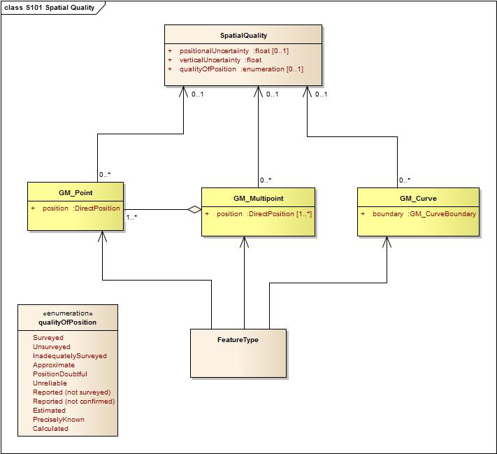

Figure 4.1 - Spatial Quality Information Type.

### 4.3.6 Attributes

S-100 defines attributes as either simple or complex. S-111 uses eight types of simple attributes; they are listed in Table 4.1. There are no complex attributes. A compound attribute is an array containing multiple simple, and possibly dissimilar, attribute types.

Table . - Simple feature attribute types.

|  |  |
| --- | --- |
| **Type** | **Definition** |
| Enumeration | A fixed list of valid identifiers of named literal values |
| Boolean | A value representing binary logic. The value can be either True or False. The default state for Boolean type attributes (i.e. where the attribute is not populated for the feature) is False. |
| Real | A signed Real (floating point) number consisting of a mantissa and an exponent |
| Integer | A signed integer number. The representation of an integer is encapsulation and usage dependent. |
| CharacterString | An arbitrary-length sequence of characters including accents and special characters from a repertoire of one of the adopted character sets |
| Date | A date provides values for year, month and day according to the Gregorian Calendar. Character encoding of a date is a string which must follow the calendar date format (complete representation, basic format) for date specified inS-100, Clause 4a-5.6.4). See also ISO 8601:1988.  EXAMPLE 19980918 (YYYYMMDD) |
| Time | A time is given by an hour, minute and second. Character encoding of a time is a string that follows the local time (complete representation, basic format) format defined in S-100, Clause 4a-5.6.4). See also ISO 8601:1988.  EXAMPLE: 183059Z |
| Date and Time | A DateTime is a combination of a date and a time type. Character encoding of a DateTime shall follow S-100, Clause 4a-5.6.4). See also ISO 8601:1988.  EXAMPLE: 19850412T101530Z |

## 4.4 Spatial Schema

Surface current data are represented in two ways: arrays of points contained in a regular grid, and sets of points not described by a regular grid. Further details on the data product are given in Clause 10 – DATA PRODUCT FORMAT.

Surface current data has four basic types, based on their sources:

* 1. observed or predicted values at a number of stationary locations,
* 2. predicted values (often from hydrodynamic models) arranged in a regular grid,
* 3. values at multiple locations but not in a regular grid, and
* 4. observed values at a moving station (such as a surface drifter).

The four types of data have structures that can be described by two S-100 coverages: S100_Point Coverage and S100_Grid Coverage (S-100 v 3.0.0, Clause 8-7).

**Grid Coverage** The class S100_Grid Coverage represents a set of values assigned to the points in a two-dimensional grid. Attributes include *interpolationType, dimension, axisNames, origin, coordinateReferenceSystem, offsetVectors, origin, extent, sequencingRule, startSequence, and rangeType.*

**Point Coverage** The class S100_Point Coverage represents a set of values, such as speed and direction values, assigned to a set of arbitrary X,Y points. Each point is identified by a horizontal coordinate geometry pair (X,Y) and assigned one or more values as attribute values. These values are organized in a record for each point. Attributes include *domainExtent, rangeType, metadata, commonPointRule, geometry*, and *value*.

The types of data and their corresponding coverages are shown in Table 4.2.

Table 4.2 – Surface current data types and their coverages.

|  |  |  |
| --- | --- | --- |
| **N** | **Type of Data** | **Coverage** |
| 1 | Time series data at one or more stationary locations | S100_Point |
| 2 | Regularly-gridded data at one or more times | S100_Grid |
| 3 | Ungeorectified gridded data or point set data at one or more times | S100_Point |
| 4 | Time series data for one moving platform | S100_Point |

### 4.4.1 Regular Grids

S-111 regular grid geometry is an implementation of S100_Grid Coverage (Part 8 – Imagery and Gridded Data). The spatial grids for the regular grid type are two dimensional, orthogonal, and georeferenced (with the X axis directed toward the east), and are defined by several attributes, including grid origin, spacing, and grid indexing. These parameters are explained in more detail below. A typical regular grid and some of its parameters are shown in Figure 4.2.

The attribute *dimension* is 2, and the variable *interpolationType* has the value of ‘discrete’, since there is no spatial interpolation used for surface currents.

idl

Figure 4.2 – Schematic of the regular grid and some of its attributes. The *offsetVectors* are shown as the Latitudinal Spacing and Longitudinal Spacing. The *origin* is shown at the lower left corner of the grid.

The grid is oriented to the Earth by the Coordinate Reference System (CRS), with the variable *coordinateReferenceSystem.* The *origin* contains the latitude and longitude as a *DirectPosition* and is located at the lower left (southwest) extent of the grid.

S-111 grids allow for different spacing of points along the X axis and the Y axis. For rectangular grids the offset vector establishes the cell size. The attribute *offsetVectors* carries the two vectors for grid spacing (Latitudinal Spacing and Longitudinal Spacing). The first vector is 90 degrees clockwise from CRS north, and represents the distance between grid values on the X axis. The second vector is 0 degrees clockwise from CRS north, and represents the distance between the values on the Y axis. The distances are given in degrees.

The attribute *extent* effectively defines a bounding rectangle describing where data is provided. The attribute extent carries two sub attributes; *low* and *high*. The sub attribute *low* carries the value “0, 0” to indicate the start of the extent is the southwest (lower left) corner of the grid. The sub attribute *high*, carries the value of the highest position along the X axis and the highest position along the Y axis. Together they form the grid coordinate of the upper right corner.

The sequence rule for a regular cell size grid is straightforward. When the cells are all of the same size, the cell index can be derived from the position of the Record within the sequence of

Records. The attribute *sequencingRule* has two subattributes; *type* and *scanDirection*. The sub attribute *type* carries the value “linear”, and the subattribute *scanDirection* carries the value “X, Y”. Together with the value “0, 0” stored in the attribute *startSequence*, they indicate that for S‑111 the grid values along the X axis at the lowest Y axis position are stored first, starting with the left most value going right, followed by the values along the X axis at the next increment upward along the Y axis, and so on till the top of the Y axis. The last value in the value sequence of the grid will be at the top rightmost positon in the grid. In the figure, first all columns in row 1 are selected, then all columns in row 2, and so on.

### 4.4.2 Points

The S-111 Point Coverage is quite flexible and is used herein to describe three broad categories of spatial data: one or more current stations at fixed locations, ungeorectified gridded data, and drifting platform data.

For this type of data (Figure 4.3), the *axisNames* are the same as for the regular grid. However, the *origin* is arbitrary, and the *extent* (cf. the bounding rectangle) may be defined by the minimum and maximum of the geographic positions of the stations. The total number of locations (tidal current stations, ungeorectified grid points, or drifter locations) must be specified. Also, attributes like spacing and scan direction have no meaning. The position of the locations is carried in the one-dimensional arrays X and Y.

idl

Figure 4.3 – Schematic of the point coverage and some of its attributes. Stations, or nodes in an ungeorectified grid, appear as filled-in rectangles, are labeled and have a format such as ‘s1’.

### 4.4.3 Summary

The spatial schema information from the previous two sections is summarized in Table 4.3.

|  |  |  |
| --- | --- | --- |
| **Attribute** | **Value** | **Remarks** |
| **S100_Grid Coverage** | | |
| dimension | 2 |  |
| origin | gridOriginLongitude, gridOriginLatitude | Values from Carrier Metadata |
| axisNames | ‘Longitude’,’Latitude’ |  |
| offsetVectors | gridSpacingLongitudinal, gridSpacingLatitudinal | Values from Carrier Metadata |
| extent: low | ‘0, 0’ |  |
| extent: high | ‘numROW-1, numCOL-1’ | Values from Carrier Metadata |
| sequencingRule: type | ‘linear’ |  |
| sequencingRule: startSequence | ‘0, 0’ |  |
| commonPointRule | ‘average’ |  |
| interpolationType | ‘discrete’ | There is no spatial interpolation for surface currents |
| rangeType | name:data type | Pairs which describes an attribute type included in the range of the coverage: e.g., ‘surfaceCurrentSpeed: real’ |
| **S100_Point Coverage** | | |
| domainExtent | EX_GeographicExtent (ISO 19115) | Envelope based on all longitudes and all latitudes. |
| axisNames | ‘Longitude’,’Latitude’ |  |
| rangeType | name:data type | Pairs which describes an attribute type included in the range of the coverage |
| metadata | URI | Link to metadata |
| commonPointRule | ‘average’ |  |
| geometry | GM_Point |  |
| value | Real number | Corresponds to speed and direction values |

Table 4.3 – Attributes and their values for S100_Grid Coverage and S100_Point Coverage.

# 5. COORDINATE REFERENCE SYSTEMS (CRS)

The location of a feature in the S-100 standard is defined by means of coordinates, which relate a feature to a position. The S-111 CRS is a compound system, with a two-dimensional ellipsoidal horizontal component and a one-dimensional datum-related vertical component (cf. S-100, Part 6 – Coordinate Reference Systems).

## 5.1 Horizontal Reference System

For an ENC the horizontal CRS must be the ellipsoidal (geodetic) system EPSG: 4326 (WGS84). The full reference to EPSG: 4326 can be found at *www.epsg-registry.org.*

**Horizontal coordinate reference system:** EPSG: 4326 (WGS84)

**Projection:** None

**Coordinate reference system registry:** EPSG Geodetic Parameter Registry

**Date type (according to ISO 19115):** 002- publication

**Responsible party:** International Association of Oil and Gas Producers (IOGP)

## 5.2 Vertical Reference System

The vertical coordinate is directed upward (i.e., away from the Earth’s center) from its origin, the vertical datum, and has units of metres. That is, a positive value for the level of the current relative to the vertical datum means that the level is above the vertical datum. This is consistent with the bathymetric CRS in S-102. The vertical datum is not an ellipsoid but is one of the following: (a) the sea surface (defined in Clause 1.4.2), (b) a vertical, sounding, or chart datum (MSL, LAT, etc.), or (c) the sea floor. Since these vertical datums can have significant spatial variation, there may be a comparable spatial variation in data quality. Any quality measure may represent a regional average or an extreme ‘worst case’ value.

## 5.3 Temporal Reference System

The temporal reference system is the Gregorian calendar for date and UTC for time. Time is measured by reference to Calendar dates and Clock time in accordance with ISO 19108:2002, Temporal Schema clause 5.4.4. A date variable will have the following 8-character format: *yyyymmdd*. A time variable will have the following 7-character format: *hhmmssZ*. A date-time variable will have the following 16-character format: *yyyymmddThhmmssZ*.

# 6. DATA QUALITY

## 6.1 Assessment of Data

Data quality allows users and user systems to assess fitness for use of the provided data. Data quality measures and the associated evaluation are reported as metadata of a data product. This metadata improves interoperability with other data products and provides usage by user groups that the data product was not originally intended for. The secondary users can make assessments of the data product usefulness in their application based on the reported data quality measures.

The prescribed precision (see ANNEX A – DATA CLASSIFICATION AND ENCODING GUIDE) of current speed (0.01 kn) and direction (0.1 arc-deg) is close to the perceived accuracy of the data, but the increased precision is useful for time integration of current vectors and for the computation of spatial gradients (i.e., non-navigational uses).

Important factors in the quality of surface current data for navigation consists of the quality of

* the observed data,
* the predicted/forecast data,
* the positional data, and
* the time stamp.

Factors determining the accuracy of the data are shown in Table 6.1. Information of the quality of the components of the data is normally available in field survey reports, QC analyses, or other technical reports.

Table 6.1 – Data types and accuracy factors

|  |  |
| --- | --- |
| **Type of Data** | **Factors Influencing Accuracy** |
| Observed Current | Accuracy of the sensors  Processing techniques |
| Predicted/forecast Current | Quality of input data  Timeliness of input data  Mathematical modelling techniques  Accuracy of harmonic constants |
| Horizontal Position | Accuracy of geolocation techniques  Model grid accuracy |
| Vertical Position | Accuracy of vertical datum |
| Time stamp | Sensor accuracy  Data time tagging accuracy |

Data quality measures for the entire data set are included in Table 12.2. These include speedUncertainty, directionUncertainty, horizontalUncertainty, verticalUncertainty, and timeUncertainty.

## 6.2 Additional Components

Additional data quality measures include Completeness, Logical Consistency, Thematic Accuracy, Aggregation, and Usability.

Completeness consists of commission and omission of data. For surface current data in gridded form, there is likely to be an excess of data for a region. For observed or historical, there is likely to be a dearth of data. In each case, missing data or points over land are tagged with a unique value. A Surface Current coverage data set is complete when the grid coverage value matrix contains direction and speed values or the null value for every vertex point defined in the grid, and when all of the mandatory associated metadata is provided. See ANNEX E - TESTS OF COMPLETENESS (NORMATIVE).

Logical Consistency ensures that the data are stored in a consistent manner: the HDF structure used to hold the data is was designed to enforce such consistency. In addition, the placement of current arrow symbols is consistent with the accepted coastline so that the centroid of the arrow is place within the water domain (see Figure 9.1), and if the water depth is zero, the symbol is not shown.

Thematic Accuracy insures that the values represented (speed and direction) are representative of the true situation. Measurement and modeling errors may put limits on these values.

Aggregation describes global quality values relate to a particular dataset. For surface currents, each dataset will be evaluated separately.

Usability will be continually assessed through user and manufacturer response to the symbols and analysis presented in the latest Product Specification.

# 7. DATA CAPTURE AND CLASSIFICATION

The Surface Current product contains data processed from sensors or derived from the output from mathematical models. In most cases, the data collected by the HO must be translated, sub-setted, reorganized, or otherwise processed to be made into a usable data format.

## 7.1 Data Sources

Surface current data comes primarily from a few specific sources: observations, astronomical predictions, analyses, and forecast models. When such data are produced and quality-controlled by an HO, they are suitable for inclusion in the Surface Current data product. See ANNEX F – SURFACE CURRENT DATA.

**Observational Data** Observational surface current data comes initially from *in situ* sensors in the field (e.g. current meters or drifting platforms) or from high-frequency radar, and such sensors are monitored by the HO. After reception, the data are quality-controlled and stored by the HO. Some of the observed data may be available for distribution within minutes of being collected and are thus described as being in real time. Other data may be days or years old, and are called historical data.

**Astronomical Predictions** Astronomical predictions are produced when a sufficiently long time series of observed currents has been obtained and the data has been harmonically analyzed by the HO to produce a set of amplitude and phase constants. There may be a single set of constants to represent flood and ebb currents along a principal direction, or two sets of constants to represent the northward and eastward components of the current. The harmonic values can then be used to predict the astronomical component of the current as a time series covering any desired time interval. In addition, the harmonic constants may be used to estimate tidal currents for a generic tidal cycle, with the specific amplitude and direction of the current based on the tide range at a specified nearby tide station, and the specific phase of the current based on the time of high water at the same nearby tide station. Data such as these may be available for single stations or, if the stations are numerous, they may be arranged by the HO into a gridded field or a tidal atlas.

**Analyzed and Hybrid Values** Analyzed current values may be produced from sea-surface topography, data assimilation, statistical correlations, or other means. A hybrid method combines two or more approaches.

**Hindcast and Forecast Data** Hydrodynamic models numerically solve a set of fluid dynamic equations in two or three dimensions, and rely on observational data, including water levels and winds, to supply boundary conditions. Model grids may be either regular or ungeorectified. Such models are often run several times per day, and in each run there is usually a hindcast and a forecast. The hindcast is a model simulation that attempts to recreate present conditions by using the most recent observational data, while a forecast is a simulation made for many hours into the future using predicted winds, water levels, etc. The results are saved for a limited number of times, and are stored as arrays that derive from the model’s grid. These models and methods are developed, run, and monitored by the HO.

These descriptions are summarized in Table 7.1.

Table 7.1 – Types of surface current data, based on the source of the data.

|  |  |  |  |
| --- | --- | --- | --- |
| **Type** | **Name** | **Code** | **Description** |
| 1 | Historical observation | O | Observation made hours, days, etc., in the past |
| 2 | Real-time observation | R | Observation no more than a few minutes old |
| 3 | Astronomical prediction | A | Value computed using harmonic constants only |
| 4 | Analysis or hybrid method | Y | Calculation by statistical or other indirect methods, or a combination of methods |
| 5 | Hydrodynamic model hindcast | M | Gridded data from a two- or three-dimensional dynamic simulation of past conditions using only observed data for boundary forcing |
| 6 | Hydrodynamic model forecast | F | Gridded data from a two- or three-dimensional dynamic simulation of future conditions using predicted data for boundary forcing |

## 7.2 The Production Process

Nearly all available information on surface currents available from the HO must be reformatted to meet the standards of this Product Specification (Figure 10.1– the S-111 format). This means (a) populating the carrier metadata block (Clause 12.3) with the relevant data and (b) reorganizing the speed and direction data when using the encoding rules (see ANNEX G – HDF5 ENCODING).

### 7.2.1 Metadata

Metadata is derivable from the information available from the HO. Recall that the definition of uncertainty (Sec. 1.3.2) is based on the 95% confidence level. The following variables may require additional processing:

* + The bounding rectangle is computable from either the distribution of stations or nodes, or from grid parameters
  + Position uncertainties may be available from the HO’s metadata; otherwise they must be calculated
  + Speed and direction uncertainties, if specified as a single value for the dataset, may be available from the HO; otherwise they must be calculated

### 7.2.2 Surface Current Data

Observational currents and astronomical tidal current predictions at a single location and gridded forecast data must normally be reformatted to fit the S-111 standard. The following may require additional calculations:

* Current depth values for modeled data grid points and for observational data (such as for moored current meters) may be require re-referencing to a different vertical datum.
* For gridded data, if a land mask array is included, the mask value is substituted into the gridded values as appropriate.
* Time stamps, if given in local time, must be converted to UTC.

### 7.2.3 Digital Tidal Atlas Data

Tidal atlas information may require additional processing to produce a time series. A tidal atlas typically contains speed and direction information for a number of locations, the valid time of which is expressed as a whole number of hours before and after time of high water, or current flood, at a reference tidal water level station (Table F.1). The speed and direction for any time are computed as a function of the daily predicted tides or currents at the reference station. The conversion into a time series is the responsibility of the HO.

# 8. MAINTENANCE

## 8.1 Maintenance and Update Frequency

Surface currents change rapidly, so more-or-less continual revision or updating of the data is essential. For real-time observations, new values are periodically collected (on the order of once every 5 minutes). For a forecast, the entire field of currents is created one or more times per day. New issues of real-time observations or forecasts are not considered new editions, but new datasets. New editions may occur in predicted time series data.

Tidal atlas or harmonic constant data are updated much less often, typically on an annual basis. Table 8.1 summarizes this information.

Table 8.1 – Typical update/revision intervals and related information

for S-111 products produced by a single HO.

|  |  |  |  |
| --- | --- | --- | --- |
| **Data Types** | **Interval** | **Number Of Spatial Locations** | **Number Of Time Values Per Location** |
| Harmonic Constant  Tidal Predictions | 1 year | 100 to 1,000 | 8,760 (hourly data) |
| Model Forecasts | 6 hr | 100,000 to 1,000,000 | 1 to 24 |
| Real-time Observations | 0.1 hr | 1 to 10 | 1 to 240 |
| HF Radar Observations | 0.1 hr | 10,000 to 100,000 | 1 to 24 |

NOTE: Because of the possibility of hourly release of new datasets, the ECDIS system must check on the availability of new data at a similar frequency.

## 8.2 Data Source

Data is produced by the HO by collecting observational values, predicting astronomical tides, or running analysis or hindcast/forecast models. These data are typically quality-controlled and reformatted to conform to file size limitations and the S-111 standard encoding.

## 8.3 Production Process

S-111 data sets, including the metadata and the coverages for current speed and direction, are updated by replacement of the entire data product. HOs routinely collect observational data and maintain an analysis and/or forecast capability. When new data become available (often several times per day), the data is reformatted and made available for dissemination.

# 9. PORTRAYAL

**9.1 Introduction**

This section describes means of displaying surface current vectors to support navigation, route planning and route monitoring. Two types of data are discussed in depth. They are:

point data, which would apply to historical data, astronomical predictions, and real-time data at a small number of locations, and

sets of multiple points, which would apply to analyses, coastal radar observations, and model-based hindcasts and forecasts. For multiple point data, the current vector portrayal characteristics used for single-point data can be adapted to displaying data at individual points.

For example, a point portrayal may be provided to display currents at significant locations such as turning points or where real-time observations are available. A multiple-point portrayal may be provided for voyage planning where a mariner’s selection of routes may be influenced by an overview of the currents. Note that not each portrayal category (single point and multiple point) may be available for all types of currents data (historical observations, real-time observations, astronomical predictions, and forecast total currents).

All recommended sizes are given assuming a minimum size ECDIS display of 270 by 270 mm or 1020 by 1020 pixels.

**9.2 Display of Current at a Single Point**

Portrayal of current using single point data should be used for instances where the data source is a current meter (e.g., a historical or real-time current measuring device) at a single geographic location.

### 9.2.1 Arrow Shape

The generalized arrow shape must be created using the input dimensions shown (Figure 9.1) and scaled according to the current speed and the display area. This shape is unique and so does not conflict with existing arrow and arrow-like shapes previously approved for use in ECDIS (Figure 9.2).

The arrow’s ‘pivot point’ is located on the arrow symbol along the vertical centreline and is at a distance from the bottom equal to one-half the quantity ‘al’. The pivot point is placed at the corresponding position (longitude and latitude) on the chart image.

The arrow must be drawn with a black border so that the symbol stands out against backgrounds of similar colours.

(0.0, -5.0)

(2.0, -1.5)

(-2.0, -1.5)

(1.0, -1.5)

(-1.0, -1.5)

(0.5, 5.0)

(-0.5, 5.0)

+

X direction

Y direction

Figure 9.1 – Standard arrow symbol for use in representing surface currents. The coordinates of the vertices (x, y) are shown in mm. The ‘+’ shows the location of the pivot point at (0.0, 0.0) and the y axis is pointing downward. Maximum height is 10 mm and maximum width is 4 mm.

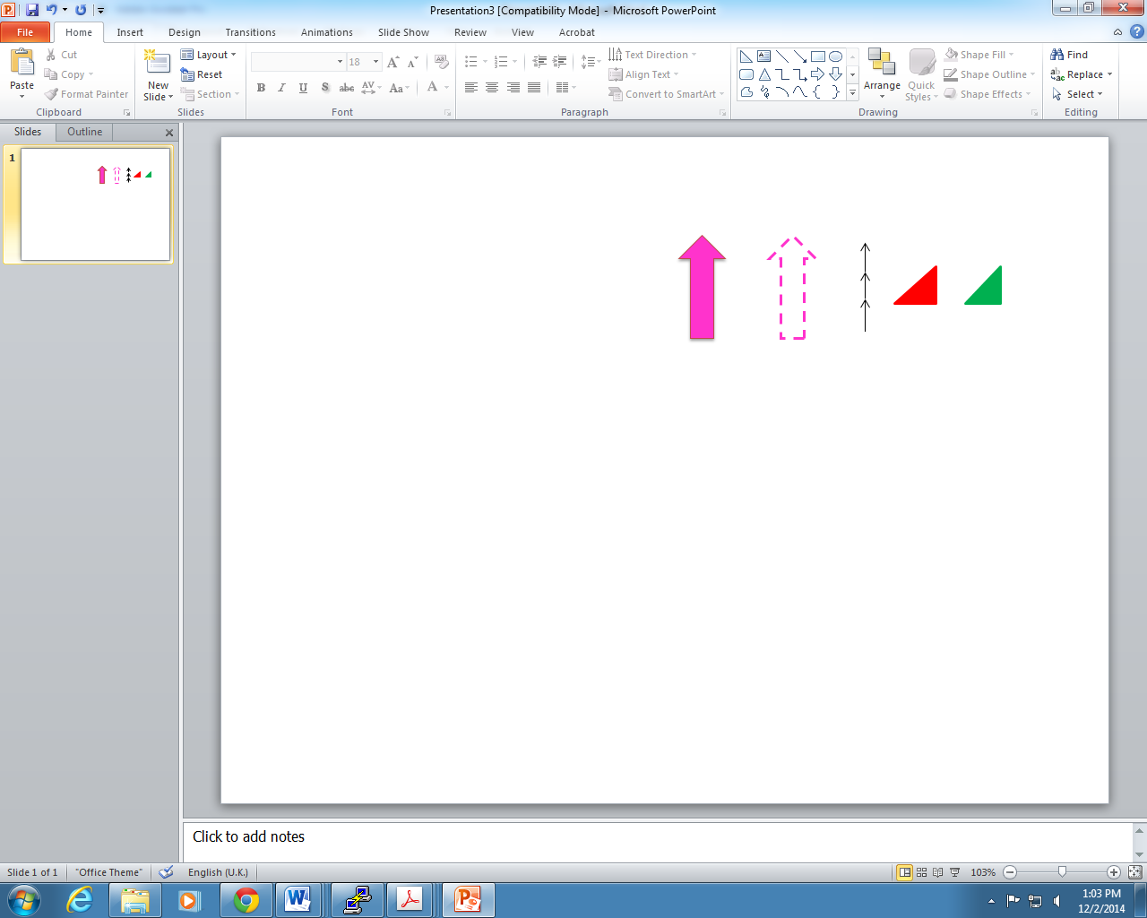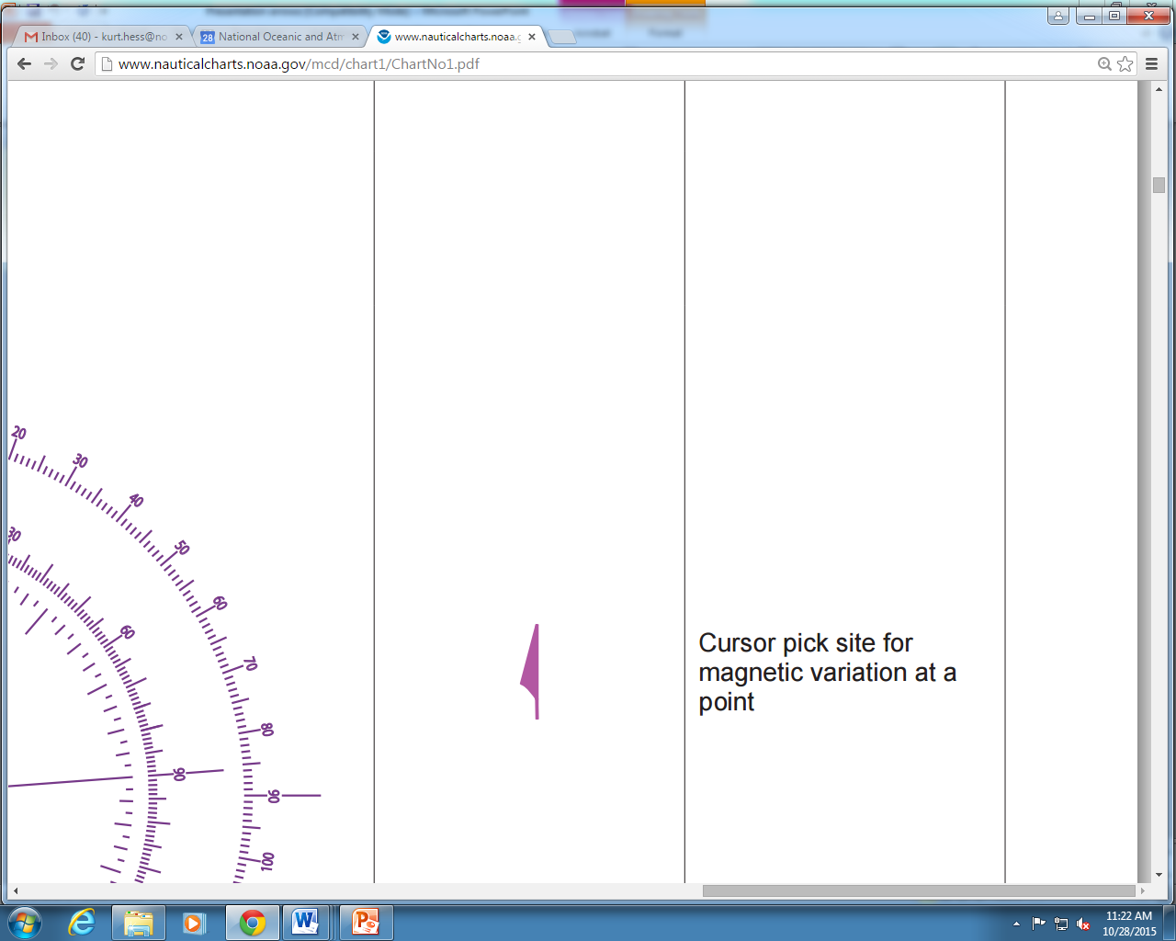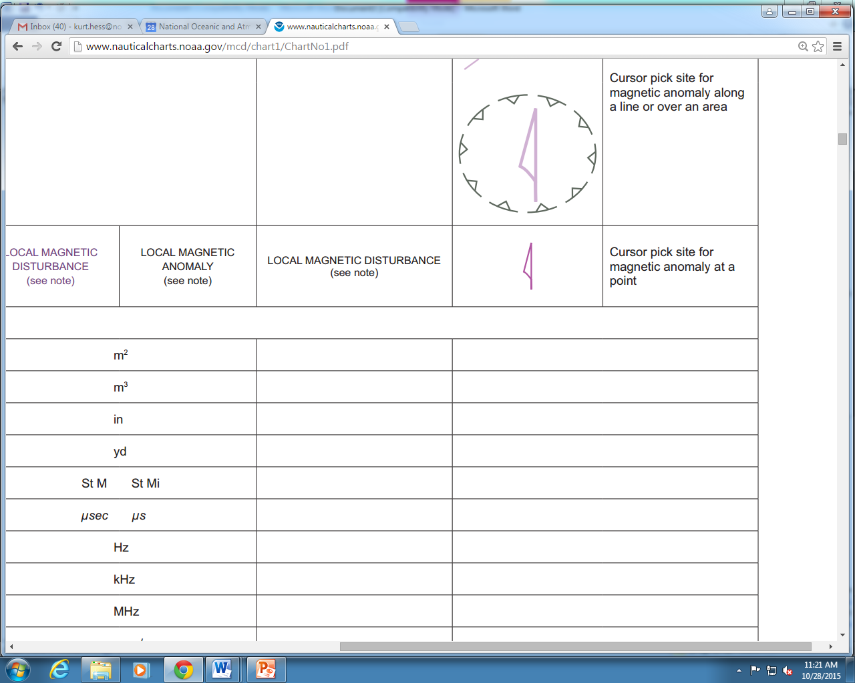

(a) (b) (c) (d) (e) (f) (g)

Figure 9.2 – Existing arrow types and approximate colours approved for use in ECDIS: (a) and (b) for traffic separation schemes, (c) for recommended (one-way) tracks, (d) and (e) for conical buoys,

and (f) and (g) for magnetic variation and anomaly.

### 9.2.2 Arrow Direction

The direction of the arrow symbol must be the direction (relative to true north) toward which the current is flowing (Figure 9.3). If the map projection is Mercator, angles are preserved, so current direction is identical to direction on the screen. For other map projections, the portrayed direction must be computed.

idl

Figure 9.3 – Portrayal of the arrow’s direction, based on the current direction. The dashed line is the arrow’s centerline, and the origin of the East-North axis is at the arrow’s pivot point.

True north has a direction of 0 degrees.

### 9.2.3 Arrow Colour and Speed Bands

The colour of the arrow must be based on the speed value of the data, and must have 9 bands corresponding to the speed ranges (Table 9.1). The range of speeds (Table 9.1) was selected to (a) emphasize differences at low speeds (0.0 to 3 kn), and (b) be capable of displaying large currents (13 kn and above).

NOTE: The largest tidal currents may be those in the strait near Saltstrumen, Norway, which reach 22 kn.

Table 9.1 – Speed ranges (knots) for the 9-band display.

|  |  |  |  |
| --- | --- | --- | --- |
| **Speed Band** | **Minimum Speed (kn)** | **Maximum Speed (kn)** | **Appx. Interval (kn)** |
|
| 1 | 0.00 | 0.49 | 0.5 |
| 2 | 0.50 | 0.99 | 0.5 |
| 3 | 1.00 | 1.99 | 1 |
| 4 | 2.00 | 2.99 | 1 |
| 5 | 3.00 | 4.99 | 2 |
| 6 | 5.00 | 6.99 | 2 |
| 7 | 7.00 | 9.99 | 3 |
| 8 | 10.00 | 12.99 | 3 |
| 9 | 13.00 | 99.99 | 87 |

Colours are associated with each speed band, and must be distinguishable in the three viewing environments: day, dusk, and night. Color values for day conditions are shown in Table 9.2. Colours for dusk and night conditions are given in ANNEX H – COLOUR TABLES. (The monitor gamma values need to be taken into account – refer to IHO standards).

Table 9.2 – Colour schema for day conditions.

|  |  |  |  |  |  |  |
| --- | --- | --- | --- | --- | --- | --- |
| **Speed Band** | **Colour** | **Colour Scale Intensity** | | | **Hex RBG** | **Displayed Colour** |
| **Red** | **Green** | **Blue** |
| 1 | purple | 118 | 82 | 226 | 7652E2 |  |
| 2 | dark blue | 72 | 152 | 211 | 4898D3 |  |
| 3 | light blue | 97 | 203 | 229 | 61CBE5 |  |
| 4 | dark green | 109 | 188 | 69 | 6DBC45 |  |
| 5 | light green | 180 | 220 | 0 | B4DC00 |  |
| 6 | yellow-green | 205 | 193 | 0 | CDC100 |  |
| 7 | orange | 248 | 167 | 24 | F8A718 |  |
| 8 | pink | 247 | 162 | 157 | F7A29D |  |
| 9 | red | 255 | 30 | 30 | FF1E1E |  |

### 9.2.4 Arrow Size

The arrow size (height and width) must be a function of the current speed, and for a given speed must be the same regardless of the source of the data. The standard arrow symbol (Figure 9.1) is scaled up or down in size, depending on the speed it is intended to represent.

Let S represent the value of the current speed. An upper limit on the size of the arrow is imposed by requiring the scaling input speed value not to exceed a reference high value, Shigh. The recommended value for Shigh is the lower limit value in the highest group in Table 9.2, which is 13.0 kn. The value of Shigh should be the same for all data sets from multiple sources so that the same speed in different data will be displayed with the same arrow length.

It is desirable to display a small arrow at a location where data is usually available (e.g., a grid point) but the speed is less than 0.01 kn. This can be accomplished by setting a minimum reference speed, Slow, so that, as a result, a ‘point’ is displayed. When the speed S falls below Slow, then Slow is substituted for S.

A third parameter is the reference speed, Sref, at which the arrow symbol has a length equal to the scaling height parameter, Href. Here Sref is chosen to be 5 kn and Href is taken to be 10.0 mm. Let S be the current speed to be displayed. If S exceeds Shigh, then Shigh is substituted for that speed, since areas of extremely high current speeds are rare and are likely to be avoided by navigators anyway. Therefore,a current with a speed of S will be displayed with a height, H (mm), computed by:

H = Href∙min{max(Slow,S),Shigh}/Sref. [Eqn. 9.1]

The arrow width is scaled in a similar fashion. A summary of recommended scaling values is given in Table 9.3.

Table 9.3 – Summary of recommended values for arrow display size (see Eqn. 9.1). With these values, an arrow representing 5 kn will have a length of 10 mm.

|  |  |  |
| --- | --- | --- |
| **Constant** | **Description** | **Recommended Value** |
| Href | Reference height for arrow scaling | 10 mm |
| Sref | Reference speed for arrow scaling | 5 kn |
| Slow | Minimum speed to be used for arrow length computations | 0.01 kn |
| Shigh | Maximum speed to be used for arrow length computations | 13 kn |

### 9.2.5 Numerical Values

Current speed and direction, and additional data related to uncertainty and other metadata, should be visible when selected by placing the cursor within the solid area of the arrow shape (Figure 9.4). The data are invisible initially, and when the cursor is placed on the arrow, the data will be shown temporally. If the arrow is clicked, data will be shown continuously until another point is clicked. The information shown when the arrow is clicked will be displayed in black text inside a box with a white (or other colour for dusk and/or night viewing) background and a black border with a 1 pixel line thickness. The box must have zero transparency.

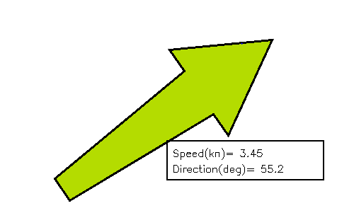

Figure 9.4 – Example of the display of the first level of numerical information available by cursor selection. Note: Arrow length is not to scale.

There should be at least three levels of detail of information (Table 9.4). In the first level, speed (kn) and direction (arc-degrees clockwise from true north) shall be displayed. In the second level, there are six additional items, each with appropriate units: data source/station name, latitude, longitude, date, time, and current depth or layer thickness. In the third level, there are at least five additional items: uncertainty in speed, direction, horizontal position, vertical position and time. A sample image showing a vector with the first level of information is shown in Figure 9.4. The additional levels are accessed by a cursor pick capability (cf. S-101. IHO Electronic Navigational Chart Product Specification).

Table 9.4 – Sample of numerical information displayed in text at the location of a current vector,

organised into levels of priority.

|  |  |
| --- | --- |
| **Priority**  **Level** | **Text Information Displayed** |
| 1 | Speed, Direction |
| 2 | Data source or station name, Latitude, Longitude, Depth of current, Valid Date, Valid Time |
| 3 | Uncertainty in speed, Uncertainty in direction, Uncertainty in horizontal position, Uncertainty in vertical position, Uncertainty in time |

NOTE: The text box in Figure 9.4 requires the use of two additional colours: black for the text and box outline, and white for the interior of the box. Standard ISO colours are to be used. The interior of the box will have zero transparency.

### 9.2.6 Transparency

The symbol transparency must be adjusted according to the background chart/image used (Table 9.5). The value alpha represents the level of opaqueness (relative to the background image) of the arrow and the numerical values displayed. An alpha value of 1 denotes zero transparency and an alpha value of 0 denotes 100% transparency.

Table 9.5 - Alpha (opaqueness) values for arrows with various

display backgrounds.Transparency is 1.0 minus the alpha value.

|  |  |
| --- | --- |
| **Background** | **Alpha** |
| Satellite image | 1.0 |
| Raster Nautical Chart | 1.0 |
| ENC Day | 1.0 |
| ENC Dusk | 0.4 |
| ENC Night | 0.2 |

### 9.2.7 Scalable Vector Graphics

In ECDIS, the arrow symbol (e.g. Figure 9.5) is drawn using Scalable Vector Graphics (SVG) instructions. SVG allows a symbol of any given size, orientation, and colour to be displayed by only a few instructions. The coordinate system for the symbol is defined as follows. The overall width and height of the symbol are defined in mm. The viewbox covers the range of coordinates used for the symbol. The pivot point of the symbol is designed to be at the 0.0, 0.0 position. The default coordinate system used for S-100 SVG has the origin in the upper left corner with the x‑axis pointing to the right and the y-axis pointing down.

For example, the using the image coordinates shown in Figure 9.1b, the SVG coordinate system, and Lref of 10 mm, a ‘path’ command would contain

M -0.5, 5. L -0.5, 5.0 -1.0,-1.5 -2.,-1.5 0.,-5.0 2.0,-1.5 1.0,-1.5 0.5,5.0 -0.5, 5.0 Z

where M is the *moveto* instruction, L is the *lineto* instruction, and Z denotes the end of the drawing. The coordinates are given in mm. See ANNEX I – SCALABLE VECTOR GRAPHICS for more details.

### 9.2.8 Symbol Placement

The arrow symbol is placed on the georeferenced background so that the pivot point of the symbol (Figure 9.1) is positioned at the geographic coordinates of the current station or grid point.

NOTE 1: The HO must insure that the arrow’s pivot point does not lie on the displayed representation of land, i.e., that the current data and the shoreline are consistent.

NOTE 2: The HO must insure that the arrow’s pivot point does not lie in a geographic area designated as intertidal when the time-varying water depth has gone to zero.

However, since some stations or grid points are near land, and depending on arrow size, on occasion it is unavoidable that occasionally some part of the arrow symbol will overlie the land or intertidal area.

**9.3 Display of Regularly Gridded Data**

The display of gridded data depicts a surface current field of multiple arrows (Figure 9.5), with each individual arrow having the qualities described in Clause 9.2. The acceptable arrowhead style for gridded arrows is the style defined in Figure 9.1. As with single-point data, the speed and direction values at individual vectors must be available when the cursor is placed over a vector.

NOTE: current direction angles cannot be interpolated (in either space or time) directly, but must be derived using the X and Y components of speed. That is, interpolation must be of the east/west and north/south components of speed separately, with the interpolated components then used to calculate speed and direction.

### 9.3.1 High Resolution

A high-resolution display (i.e., zooming in) of regularly gridded data display produces a lower density of data (Figure 9.6). It is not recommended that spatial interpolation be used to estimate current values at locations between grid points or point coverage locations.

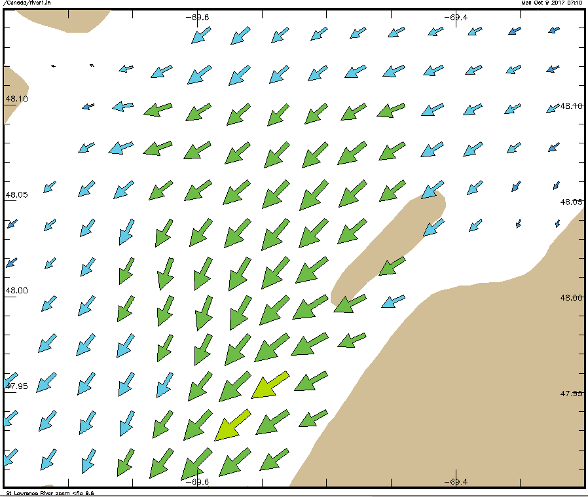

Figure 9.5 - Arrows representing gridded surface current data, with length increasing with speed, and Sref is 5 kn, Href is 20 mm, and the maximum speed in the data in the image is 3.15 kn. Coastline added for clarity. (data courtesy of St. Lawrence Global Observatory, Canada)

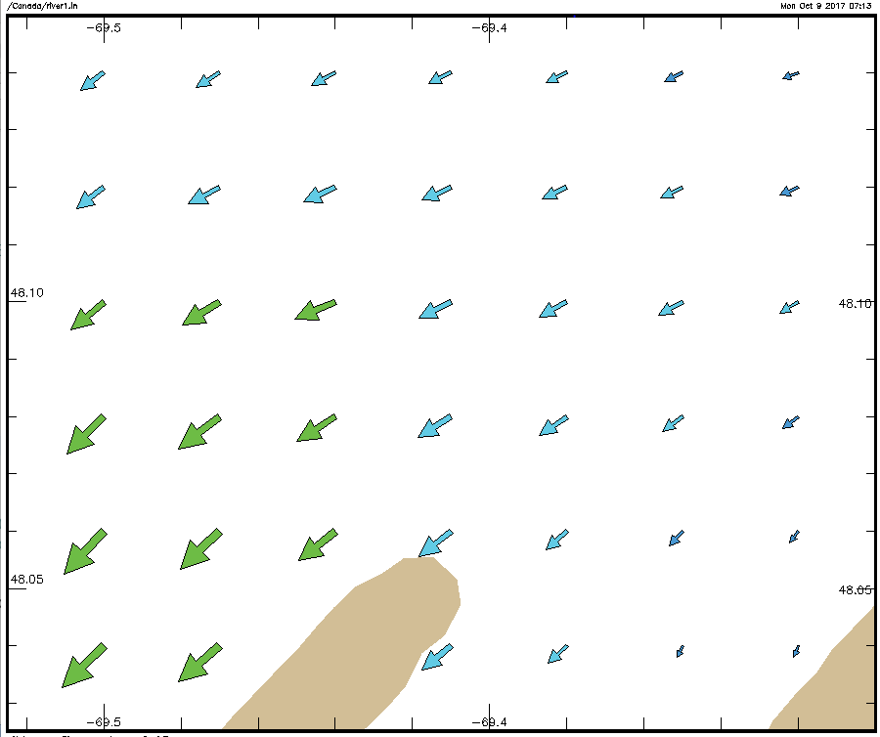

Figure 9.6 – Display of surface current data (see Figure 9.5) but at a higher resolution

(data courtesy of St. Lawrence Global Observatory, Canada).

### 9.3.2 Low Resolution

Displaying at a low resolution (i.e., zooming out) increases the density of symbols (Figure 9.7a). However, by applying a thinning algorithm, the number of vectors may be reduced (Figure 9.7b). In this case, every fourth vector was plotted.

An example of thinning of regularly gridded data is as follows. Suppose that the grid cell’s diagonal as displayed has a distance of D mm and represents the grid spacing. Note that D is dependent on the specific geographic area and the size of the viewing monitor. If every nth cell is displayed, the displayed spacing is nD. Next, suppose the length of the arrow representing the maximum speed in the displayed field is Lsmax mm. Then the ratio of the maximum arrow length to the displayed grid spacing is constrained to be less than a prescribed maximum value, Rmax, here taken to be 0.5. Thus

R = Lsmax/(nD) < Rmax  [Eqn. 9.2]

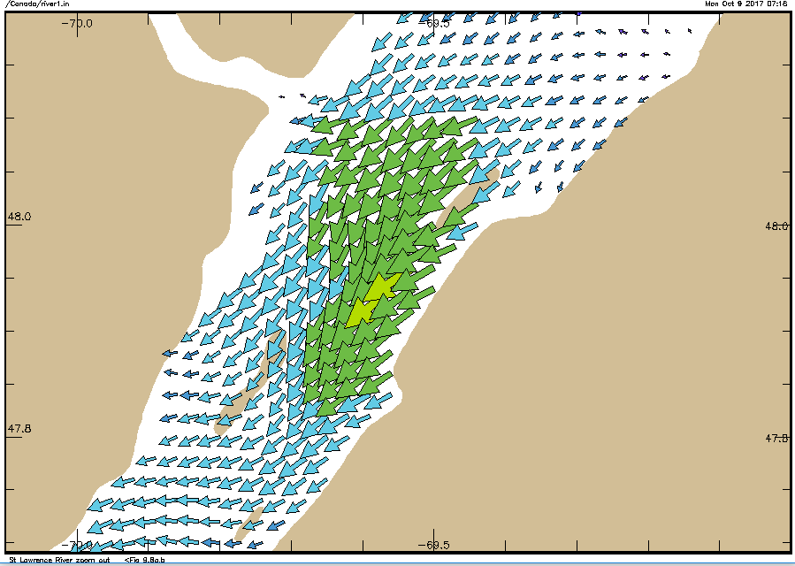

(a)

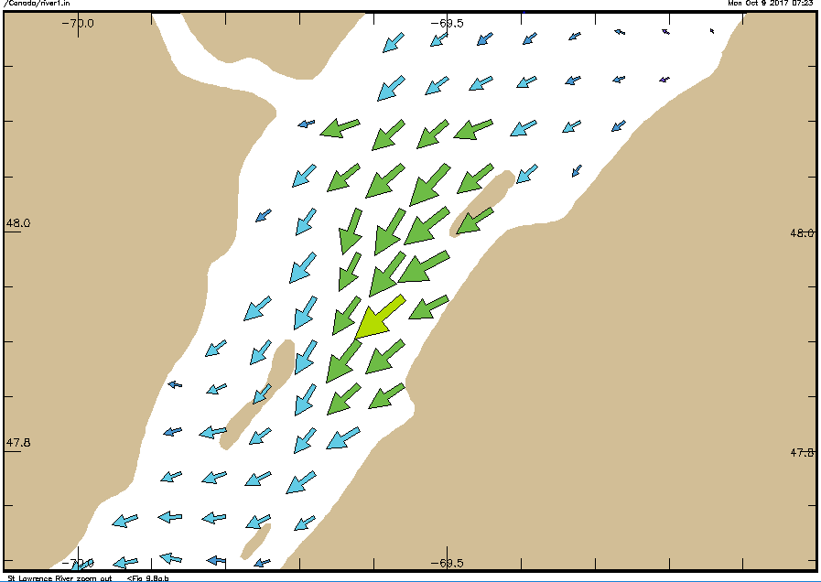

(b)

Figure 9.7 – (a) Surface current vectors (see Figure 9.6) displayed with identical parameters, but at low resolution. (b) Current vectors as in (a), but ‘thinned’ by plotting every fourth point. Note that the coastline data in the figure may differ from that used to determine model boundaries; in practice, the arrow pivot point must not be placed over land. (data courtesy of St. Lawrence Global Observatory, Canada).

If the above inequality cannot be met with increment n equal to 1, then a new value for n is computed by the following formula:

n =1 + fix(Lsmax/(DRmax)) [Eqn. 9.3]

where fix() is a function that returns the truncated integer value. For plotting, arrows at every nth column and every nth row are drawn, making sure that the row and column with the maximum vector is drawn (Figure 9.7b).

## 9.4 Temporal Rules

The metadata variables related to time are the *dateTimeOfFirstRecord, dateTimeOfLastRecord, timeRecordInterval*, and *numberOfTimes.* The time selected for display (i.e., past, present, or future) of the surface currents by the display system will typically not correspond exactly to the timestamp of the input data. For a correct display, the ECDIS will have to select the correct data.

For data with only a single record (where the timestamp of the earliest value equals that of the latest value) such as real-time data, the surface current values are displayed only if the display time is later than the timestamp and the absolute time difference between the display time and the data timestamp is less than a discrimination interval (e.g., 5 minutes). For a single record, the variable *timeRecordInterval* (see Clause 12.3) can be used to set the discrimination interval.

For data with multiple times, if the selected display time is later than the first timestamp and earlier than the last timestamp, then the closest but immediately preceding values in the data are displayed. However, if the selected display time is earlier than the first timestamp then the data is not displayed. If the selected time is later than the last timestamp, then surface current values at that time are displayed only if the absolute time difference between the display time and the data timestamp is less than a discrimination interval (e.g., the value of the variable *timeRecordInterval*)*.*

## 9.5 Placement of Legend

The legend, which is to be displayed as an option, must show the relationship between the arrow colours and the speed values. A sample is shown in Figure 9.8. The precise position of the legend if it appears on the monitor will be determined so as to minimize the obscuring of other important navigational information.

idl

Figure 9.8 – Sample surface current speed scale based on the colours

and speed bands in Table 9.1.

## 9.6 Interoperability

Interoperability principles determine priority in display of elements so that important image elements, such as depth numerals, are not obscured by current vectors. Surface current portrayal will conform to interoperability rules as they are established.

**Symbol Priority**

Details about symbol priority will be determined in accordance with S-100 standards when they are developed.

One example involves the use of the older charting symbol for currents. When an S-111 dataset is displayed, symbols from the S-101 ECDIS nautical charting suite, in the area where the new data is displayed, must not be displayed. Such symbols include those for tidal stream tables (plus their points and boundary areas), flood and ebb tide stream arrows and their values and boundary areas, and other symbols for rip currents, eddies, breakers, and non-tidal currents.

**Colour Discrimination**

Another criterion is that the arrows colours be distinct when displayed against a background of similar colour. Table 9.6 shows the background colours for various water depth types, and Figure 9.9 shows typical arrows for the nine speed bands. The black arrow border allows the arrow symbol to stand out against the blue and green backgrounds.

Table 9.6 - Chart background colours in two colour scales

(courtesy of Korean Hydrographic and Oceanographic Administration).

|  |  |  |  |  |  |  |  |
| --- | --- | --- | --- | --- | --- | --- | --- |
| **Name** | **sRGB** | | | **xyL** | | | **Displayed**  **Colour** |
| **Red** | **Green** | **Blue** | **x** | **y** | **L** |
| Deep Water | 201 | 237 | 255 | 0.28 | 0.31 | 80 |  |
| Medium Deep Water | 167 | 218 | 252 | 0.26 | 0.29 | 65 |  |
| Medium Shallow Water | 130 | 202 | 255 | 0.23 | 0.25 | 55 |  |
| Very Shallow Water | 97 | 184 | 255 | 0.21 | 0.22 | 45 |  |
| Intertidal | 88 | 175 | 156 | 0.26 | 0.36 | 55 |  |
| No Values | 147 | 174 | 187 | 0.28 | 0.31 | 40 |  |

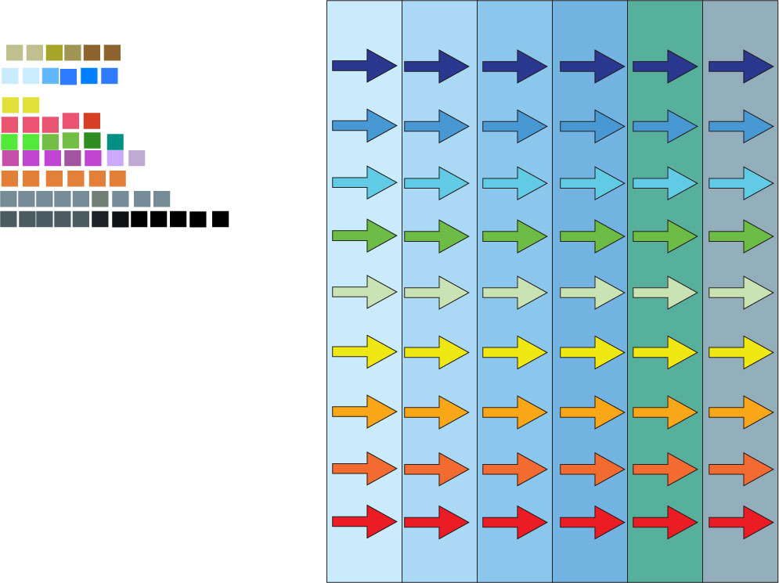

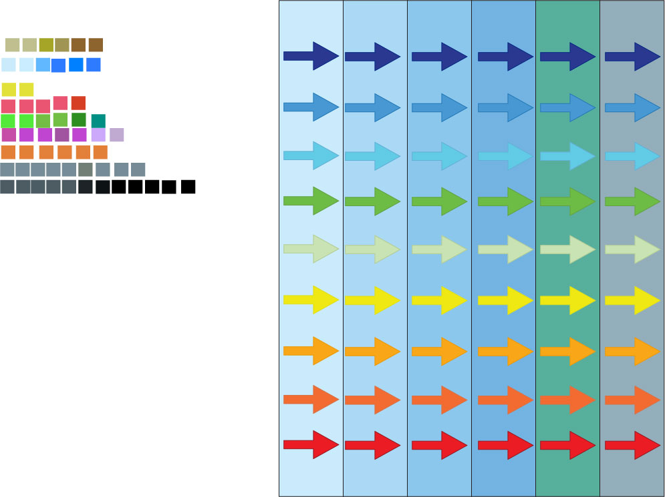

(a)

(b)

Figure 9.9 – Arrows displayed against the (daytime) background colours in Table 9.6. (a) Arrows with borders and (b) without borders. (Figures courtesy of University of New Hampshire)

## 9.7 Sample Representation

Surface currents vectors comprise a layer to be displayed on demand and, possibly, on top of other data and layers. Consideration must be made so as not to obscure critical navigational data nor create confusion by using symbols or colours similar to those in other layers. Figure 9.10 shows a sample display.

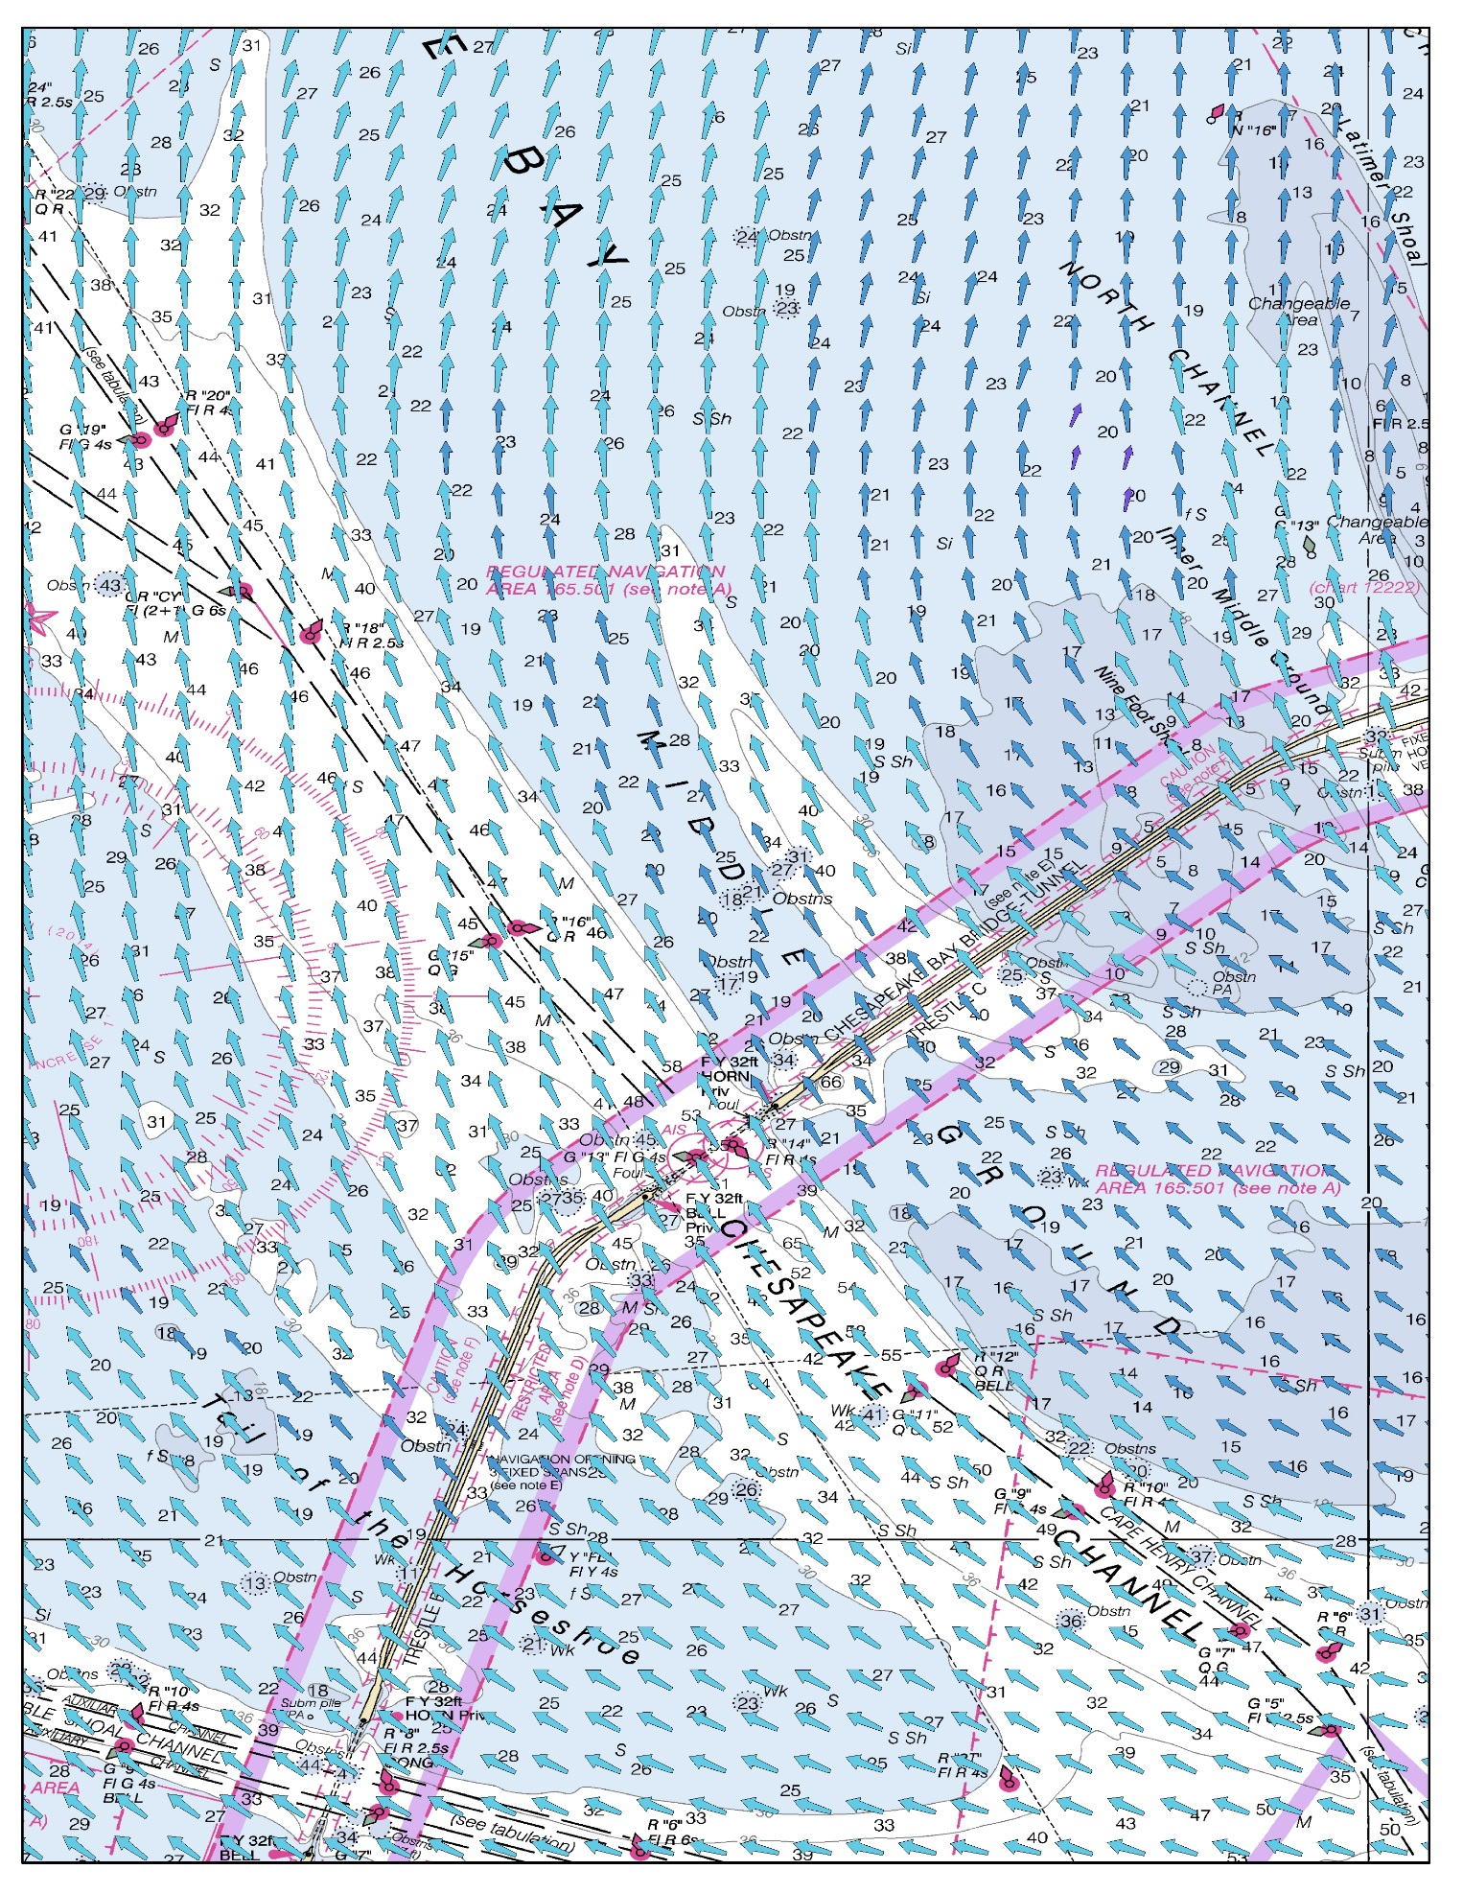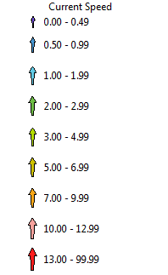

Figure 9.10 – Sample depiction of gridded surface current data in an electronic chart

(Image courtesy of the University of New Hampshire, US).

**9.8 Portrayal Rules**

A summary of the portrayal rules appears in ANNEX J – SURFACE CURRENT PORTRAYAL RULES.

# 10. DATA PRODUCT FORMAT (ENCODING)

## 10.1 Introduction

The Surface Current Data Product must be encoded using the Hierarchical Data Format standard, Version 5 (HDF5). The structure of the data product is discussed in Clause 10.2.

**Format Name:** HDF-5

**Character Set:** MD_CharacterSetCode (ISO 19115)

**Specification:** S-100 profile of HDF-5

## 10.2 Product Structure

The key idea at the core of the data product structure is this: the organization of the information is substantially the same for each of the various types of data, but the information itself will be interpreted differently.

The data types are (a) time series data for one or more individual, fixed stations, (b) regularly-gridded data for multiple times, (c) ungeorectified gridded data for multiple times, and (d) moving platform (e.g., surface drifter) data with a constant time interval.

For all data types, the product structure includes (a) a carrier metadata block, which is followed by (b) one or more Groups which contain either position data or the surface current data. The speed and direction information are saved in arrays that hold gridded data, point data, or a time series. The product structure allows multi-dimensional arrays of data to be grouped with metadata. The basic structure of the S-111 data product is shown in Figure 10.1. The format of the data product (cf. Figure F.5 and Table G.2) is described below and the Carrier Metadata is discussed in Clause 12.3.

|  |  |  |
| --- | --- | --- |
|  | **S-111 Data Product** |  |
|  |  |  |
|  | Carrier Metadata |  |
|  |  |  |
|  | **Group_F** |  |
|  | Feature name |  |
|  | Feature attribute array |  |
|  |  |  |
|  | **Group_XY (conditional)** |  |
|  | Longitude values array (*m*=0,*numPOS*-1) |  |
|  | Latitude values array (*m*=0,*numPOS-*1) |  |
|  |  |  |
|  | **Group_001** |  |
|  | Title1 |  |
|  | Valid Date-Time1 |  |
|  | Surface current speed array (*i*=0,*numCOL*-1, *j*=0,*numROW-*1) |  |
|  | Surface current direction array (*i*=0,*numCOL-*1, *j*=0,*numROW-*1) |  |
|  |  |  |
|  | **Group_002** |  |
|  | Title2 |  |
|  | Valid Date-Time2 |  |
|  | Surface current speed array (*i*=0,*numCOL-*1, *j*=0,*numROW-*1) |  |
|  | Surface current direction array (i=0,*numCOL-*1, *j*=0,*numROW-*1) |  |
|  |  |  |
|  | **Group_*numGRP*** |  |
|  | Title*numGRP* |  |
|  | Valid Date-Time*numGRP* |  |
|  | Surface current speed array (*i*=0,*numCOL-*1, *j*=0,*numROW-*1) |  |
|  | Surface current direction array (*i*=0,*numCOL-*1, *j*=0,*numROW-*1) |  |
|  |  |  |

Figure 10.1 - Schematic of the S-111 data product structure. The four parameters

*numPOS,*numCOL, numROW, and numGRP are explained in Table 10.2.

Group_XY appears only for *dataCodingFormat* = 1, 3 or 4 (Table 10.1).

### 10.2.1 Carrier Metadata

The carrier metadata contains attributes that describe the data product and is used for:

* interpretation of the data product in the event that that the Exchange Set metadata is unavailable, and
* a source of information for the Exchange Set metadata.

Since each type of data will be interpreted differently, the type of data must be identified by the variable *dataCodingFormat,* as shown in Table 10.1.

Table 10.1 - Values of the variable *dataCodingFormat.*

|  |  |
| --- | --- |
| **dataCodingFormat** | **Type of Data** |
| 1 | Time series data at one or more fixed stations |
| 2 | Regularly-gridded data at one or more times |
| 3 | Ungeorectified gridded data or point set data at one or more times |
| 4 | Time series data for one moving platform |

### 10.2.2 Conditional Group_XY

Group_XY contains all the locations (longitude and latitude values) that will have data values (speed and direction) represented in the Data Groups. These values are stored in one-dimensional arrays of size *numPOS*.

This group is present in the data product only for time series data, ungeorectified gridded data, and moving platform data (i.e., when *dataCodingFormat* is 1, 3 or 4). If *dataCodingFormat* is 2, Group_XY is not present.

The interpretation of the kinds of locations depends on the *dataCodingFormat* as well. The values and number of stations/drifters (respectively) for each data type are explained in Table 10.2.

Table 10.2 - Values for the Group_XY.

|  |  |  |  |
| --- | --- | --- | --- |
| **dataCodingFormat** | **Data Type** | **Location Data** | **Array Size** |
| 1 | Time Series at fixed stations | Position of current stations | *numberOfStations* |
| 3 | Ungeorectified gridded data | Location of the grid nodes | *numberOfNodes* |
| 4 | Time Series at a single moving station | Position of the station over time | *numberOfTimes* |

### 10.2.3 Data Sets

For regularly gridded data, the speed and direction arrays are two dimensional, with dimensions *numPointsLongitudinal* and *numPointsLatitudinal*. By knowing the grid origin and the grid spacing, the position of every point in the grid can be computed by simple formulae.

The datasets contain a title, and date-time stamp, and the arrays containing surface current speed and direction. These three components are explained below.

**Title**

The title is a character description of the data in the group. For multiple fixed stations, the title can include the station name and number, to assist in identifying the station.

**Date-Time Stamp**

For gridded and pointset data (*dataCodingFormat* = 2 or 3), the time stamp is the time of validity for all points in the grid.

**Data Arrays**

The speed and direction values (surfaceCurrentSpeed and surfaceCurrentDirection) are stored in two dimensional arrays, with a prescribed number of columns (*numCOL*) and rows (*numROW*).

For a time series of fixed or moving stations (*dataCodingFormat* = 1 or 4), the speed and direction values will be for times in the series as determined by the starting date-time and the data time interval. Each array is virtually one-dimensional, as the number of rows is set to 1.

For a regular grid or ungeorectified grid (*dataCodingFormat* = 2 or 3), the speed and direction values will be for each point in the grid, and for the time given by the date-time stamp.

### 10.2.4 Groups

Each group contains speed and direction data:

* In a time series for one fixed or moving station (*dataCodingFormat* = 1 or 4), or
* In an array of values at one specific time (*dataCodingFormat* = 2 or 3).

The Groups are numbered 1, 2, etc., up to the maximum number of Groups, *numGRP*.

* For fixed station data, the number of Groups equals the number of stations,
* For regular and ungeorectified grids, the number of Groups is the number of time records,
* For moving platform data, aside from Group_XY, there is only one Group, corresponding to a single drifter; additional drifters can be accommodated in additional data products.

### 10.2.5 Summary of Generalized Dimensions

To summarize, for non-regularly gridded data only, there is an initial Group with X and Y position, stored in one-dimensional arrays of size *numPOS*. Following that, there are data Groups containing the speed and direction data, which are stored in two-dimensional arrays of size *numROWS* by *numCOLS*. The total number of data Groups is *numGRPS*.

The four variables that determine the array sizes (*numROWS*, *numCOLS*. *numPOS,* and *numGRPS)* are different, depending upon which coding format is used. Their descriptions are given in Table 10.3.

Table 10.3 – The array dimensions used in the data product.

|  |  |  |  |  |  |
| --- | --- | --- | --- | --- | --- |
| **Data Coding Format** | **Data Type** | **numPOS** | **numCOL** | **numROW** | **numGRP** |
| 1 | Fixed Stations | numberOfStations | numberOfTimes | 1 | numberOfStations |
| 2 | Regular Grid | (not used) | numPointsLongitudinal | numPointsLatitudinal | numberOfTimes |
| 3 | Ungeorectified Grid | numberOfNodes | numberOfNodes | 1 | numberOfTimes |
| 4 | Moving Platform | numberOfTimes | numberOfTimes | 1 | 1 |

## 10.3 HDF5 Encoding

The product structure has been designed for compatibility with the HDF5 capabilities. The HDF5 encoding of the data set is discussed in ANNEX G – HDF5 ENCODING.

# 11. DATA PRODUCT DELIVERY

## 11.1 Introduction

This section describes how the Surface Current Data Product is to be delivered from the HO to the end user (i.e., navigation officer, route planner, etc.).

Method of transfer will be primarily web-based, including ftp, although some products (astronomical predictions) may be delivered via storage media. The data will be supplied either directly from the HO or through a third party supplier.

Due to the cost of transmitting data via Internet, it is desirable to limit file size and updating frequency whenever possible. The exchange dataset file size, as created by the HO and before compression, is limited to 10 MB. Two common data compression schemes are Zip and Rar (Radio acoustic ranging). In addition, the file may be encrypted.

Updating of files typically means issuing a new forecast, or disseminating the latest observed currents for a specific geographic region. This may occur several times per day. Therefore, all files must contain a date-time of issuance of the product. Because of the potentially high frequency (i.e., hourly or less) availability of new datasets, the ECDIS system must check for new data at a similar frequency.

## 11.2 Exchange Datasets

Exchange Sets produced by the HO consist of files containing an XML Exchange Catalogue, the HDF5 Data Products, and auxiliary files (Figure 11.1). The auxiliary files include an XML Feature Catalogue, an XML Portrayal Catalogue, SVG files, and additional supporting XML files for alarms and indications, and for interoperability.

The Data Products include one or more data sets (but of the same S-100 Product Specification types), with each product covering a specific geographic region and specific period of time. The Exchange Catalogue lists the products and contains the discovery metadata.

|  |  |  |
| --- | --- | --- |
|  | **Exchange Dataset** |  |
|  |  |  |
|  | **Exchange Catalogue** |  |
|  | Metadata (includes list of files in Exchange Dataset) |  |
|  | Auxiliary files (Feature and Portrayal Catalogue, SVG Files, etc.) |  |
|  |  |  |
|  | **Data Products** |  |
|  | Data Product No. 1 |  |
|  | Data Product No. 2 |  |
|  | Data Product No. 3 |  |
|  | Data Product No. 4 |  |
|  | Etc. |  |
|  |  |  |

Figure 11.1 – Schematic diagram of the Exchange Dataset.

The dataset size, even after compression, is limited to 10 MB. This size was chosendue to the cost of transmitting data via the internet.

## 11.3 Exchange Catalogue

The exchange catalogue (normally in XML format) acts as the table of contents for the exchange set. The catalogue file of the exchange set must be named S111ed1.CAT; no other file in the exchange set may have the same name. The contents of the exchange catalogue, which includes the metadata, are described in Clause 12.

## 11.4 Data Product File Naming

The data product file contains both a carrier metadata block and one or more sets of speed and direction arrays (see Clause 10 – Data Product Format). There is no generally accepted file naming convention. However, the filename extension for HDF5 (e.g., .h5 or .hdf5) must be used to denote the file format. Characters may be lower or upper case.

## 11.5 Support Files

This Data Product requires no support files.

# 12. METADATA

## 12.1 Introduction

For information exchange, there are several categories of metadata required:

* metadata about the overall exchange dataset and catalogue,
* discovery metadata about each of the datasets contained in the catalogue, and
* discovery metadata about the support files that make up the package.

The discovery metadata classes have numerous attributes which enable important information about the datasets and accompanying support files to be examined without the need to process the data, e.g. decrypt, decompress, load etc. Other catalogues can be included in the exchange set in support of the datasets such as feature, portrayal, coordinate reference systems, codelists etc. The attribute “purpose” of the support file metadata provides a mechanism to update support files more easily.

## 12.2 Discovery Metadata

An outline of the overall concept of an S-111 exchange set for the interchange of geospatial data and its relevant metadata is explained in the following figures. Figure 12.1 depicts the realization of the ISO 19139 classes which form the foundation of the exchange set. The overall structure of the S-111 metadata for exchange sets is modelled in Figures 12.2 and 12.3. More detailed information about the various classes is shown in Figure 12.4. Whether the individual metadata parameters are mandatory or optional is defined in the individual tables.

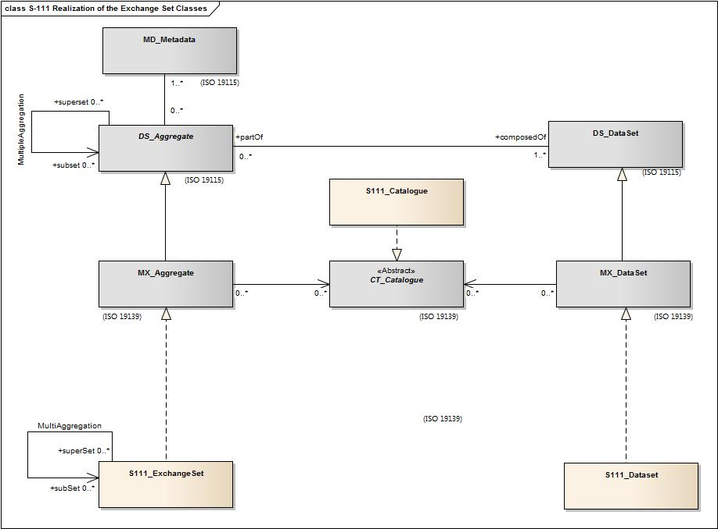

Figure 12.1 - Realization of the exchange set classes. Note that there are no support files.

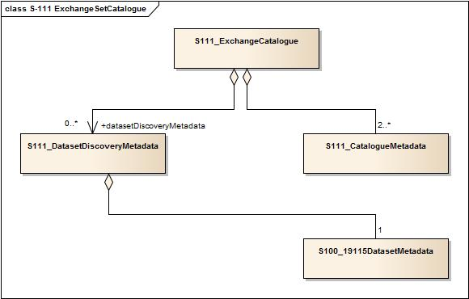iF0

Figure 12.2 - S-111 ExchangeSet Catalogue.

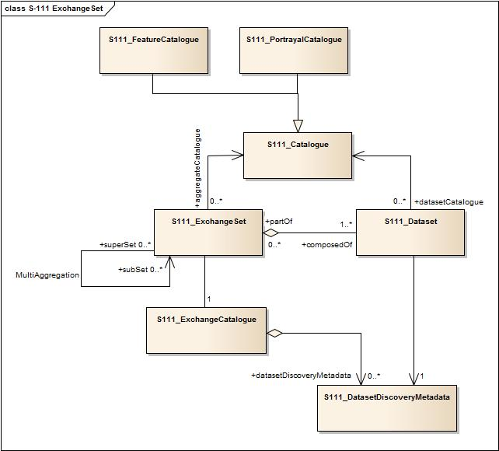

Figure 12.3 – S-111 ExchangeSet.

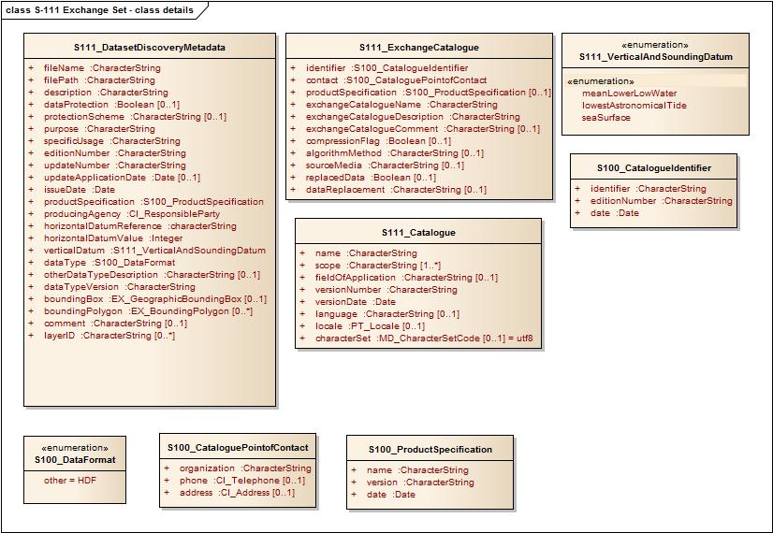

Figure 12.4 - S-111 Exchange Set: Class details.

### 12.2.1 S111_ExchangeCatalogue

Each exchange set has a single S100_ExchangeCatalogue which contains meta information for the data and support files in the exchange set.

| **Name** | **Description** | **Mult** | **Value** | **Type** | **Remarks** |
| --- | --- | --- | --- | --- | --- |
| S100_ExchangeCatalogue | An exchange catalogue contains the discovery metadata about the exchange datasets and support files | - |  | - | - |
| Identifier | Uniquely identifies this exchange catalogue | 1 |  | S100_CatalogueIdentifier |  |
| Contact | Details about the issuer of this exchange catalogue | 1 |  | S100_CataloguePointOfContact |  |
| productSpecification | Details about the product specifications used for the datasets contained in the exchange catalogue | 0..1 |  | S100_ProductSpecification | Conditional on all the datasets using the same product specification |
| exchangeCatalogueName | Catalogue filename | 1 |  | CharacterString | In S-101 it would be CATLOG.101 |
| exchangeCatalogueDescription | Description of what the exchange catalogue contains | 1 |  | CharacterString |  |
| exchangeCatalogueComment | Any additional Information | 0..1 |  | CharacterString |  |
| compressionFlag | Is the data compressed | 0..1 |  | Boolean | Yes or No |
| algorithmMethod | Type of compression algorithm | 0..1 |  | CharacterString | Eg. RAR, ZIP, h5repack |
| sourceMedia | Distribution media | 0..1 |  | CharacterString |  |
| replacedData | If a data file is cancelled is it replaced by another data file | 0..1 |  | Boolean |  |
| dataReplacement | Cell name | 0..1 |  | CharacterString |  |

### 12.2.2 S100_CatalogueIdentifier

|  |  |  |  |  |  |
| --- | --- | --- | --- | --- | --- |
| **Role Name** | **Name** | **Description** | **Mult** | **Type** | **Remarks** |
| Class | S100_CatalogueIdentifier | An exchange catalogue contains the discovery metadata about the exchange datasets and support files | - | - | - |
| Attribute | identifier | Uniquely identifies this exchange catalogue | 1 | CharacterString |  |
| Attribute | editionNumber | The edition number of this exchange catalogue | 1 | CharacterString |  |
| Attribute | date | Creation date of the exchange catalogue | 1 | Date |  |

### 12.2.3 S100_CataloguePointofContact

|  |  |  |  |  |  |
| --- | --- | --- | --- | --- | --- |
| **Role Name** | **Name** | **Description** | **Mult** | **Type** | **Remarks** |
| Class | S100_CataloguePointOfContact | Contact details of the issuer of this exchange catalogue | - | - | - |
| Attribute | organization | The organization distributing this exchange catalogue | 1 | CharacterString | This could be an individual producer, value added reseller, etc. |
| Attribute | phone | The phone number of the organization | 0..1 | CI_Telephone |  |
| Attribute | address | The address of the organization | 0..1 | CI_Address |  |

### 12.2.4 S100_DatasetDiscoveryMetaData

Data in the Discovery Metadata are used to identify the relevance of the dataset to the particular application.

| **Name** | **Description** | **Mult** | **Value** | **Type** | **Remarks** |
| --- | --- | --- | --- | --- | --- |
| S100_DatasetDiscoveryMetadata | Metadata about the individual datasets in the exchange catalogue | - |  | - | - |
| fileName | Dataset file name | 1 |  | CharacterString |  |
| filePath | Full path from the exchange set root directory | 1 |  | CharacterString | Path relative to the root directory of the exchange set. The location of the file after the exchange set is unpacked into directory <EXCH_ROOT> will be <EXCH_ROOT>/<filePath>/<filename> |
| description | Short description giving the area or location covered by the dataset | 1 |  | CharacterString | E.g. a harbour or port name, between two named locations etc. |
| dataProtection | Indicates if the data is encrypted | 0..1 |  | Boolean | 0 indicates an unencrypted dataset  1 indicates an encrypted dataset |
| protectionScheme | specification or method used for data protection | 0..1 |  | CharacterString | Eg S-63 |
| digitalSignature | Indicates if the data has a digital signature | 0..1 |  | Boolean | 0: unsigned  1: datafile is digitally signed  [to be reconciled when S-100 finalizes digital signature elements] |
| digitalSignatureValue | Digital signature | 0..1 |  | CharacterString | This contains a base64 encoding of the hexadecimal numbers comprising the digital signature itself. The content of these fields are defined, along with the algorithms for their calculation, in S-63 ed2.0 Part (C).  [to be reconciled when S-100 finalizes digital signature elements] |
| classification | Indicates the security classification of the dataset | 0..1 |  | Enumeration | One of the following from ISO 19115 MD_SecurityConstraints>‌MD_ClassificationCode (codelist)  1. unclassified  2. restricted  3. confidential  4. secret  5. top secret |
| purpose | The purpose for which the dataset has been issued | 1 |  | MD_Identification>purpose  CharacterString | E.g. new, re-issue, new edition, update etc. |
| specificUsage | The use for which the dataset is intended | 1 |  | CharacterString | E.g. in the case of ENCs this would be a navigation purpose classification. |
| editionNumber | The edition number of the dataset | 1 |  | CharacterString | When a data set is initially created, the edition number 1 is assigned to it. The edition number is increased by 1 at each new edition. Edition number remains  the same for a re-issue. |
| issueDate | date on which the data was made available by the data producer | 1 |  | Date |  |
| productSpecification | The product specification used to create this dataset | 1 |  | S111_ProductSpecification |  |
| producingAgency | Agency responsible for producing the data | 1 |  | CI_ResponsibleParty |  |
| horizontalDatumReference | Reference to the register from which the horizontal datum value is taken | 1 |  | characterString | EPSG |
| horizontalDatumValue | Horizontal Datum of the entire dataset | 1 |  | Integer | 4326 |
| verticalDatum | Vertical Datum of the entire dataset | 1 |  | S100_VerticalAndSoundingDatum |  |
| soundingDatum | Sounding Datum of the entire dataset | 1 |  | Enumeration S100_VerticalAndSoundingDatum | Not relevant to S-111.  Fixed value corresponding to literal localDatum from S100_VerticalAndSoundingDatum. |
| dataType | The encoding format of the dataset | 1 |  | S100_DataFormat |  |
| otherDataTypeDescription | Encoding format other than those listed. | 0..1 |  | CharacterString |  |
| dataTypeVersion | The version number of the dataType. | 1 |  | CharacterString |  |
| dataCoverage | Area covered by the dataset | 1 |  | S100_DataCoverage |  |
| comment | Any additional information | 0..1 |  | CharacterString |  |

### 12.2.5 S111_DataCoverage

|  |  |  |  |  |  |
| --- | --- | --- | --- | --- | --- |
| **Name** | **Description** | **Mult** | **Value** | **Type** | **Remarks** |
| S100_DataCoverage |  | - |  | - | - |
| ID | Uniquely identifies the coverage | 1 |  | Integer | - |
| boundingBox | The extent of the dataset limits | 1 |  | EX_GeographicBoundingBox | - |
| boundingPolygon | A polygon which defines the actual data limit | 1..* |  | EX_BoundingPolygon | - |
| optimumDisplayScale | The scale with which the data is optimally displayed | 0..1 |  | Integer |  |
| maximumDisplayScale | The maximum scale with which the data is displayed | 0..1 |  | Integer |  |
| minimumDisplayScale | The minimum scale with which the data is displayed | 0..1 |  | Integer |  |

#### 12.2.5.1 EX_GeographicBoundingBox

From ISO 19115:2003 Corr. 1 (2006).

| **Name** | **Description** | **Mult** | **Type** | **Remarks** |
| --- | --- | --- | --- | --- |
| EX_GeographicBoundingBox | geographic position of the dataset | - | - | Defined in ISO 19115 |
| westBoundLongitude | western-most coordinate of the limit of the dataset extent, expressed in longitude in decimal degrees (positive east) | 1 | Real | Arc degrees |
| eastBoundLongitude | eastern-most coordinate of the limit of the dataset extent,  expressed in longitude in decimal degrees (positive east) | 1 | Real | Arc degrees |
| southBoundLatitude | southern-most coordinate of the limit of the dataset extent,  expressed in latitude in decimal  degrees (positive north) | 1 | Real | Arc degrees |
| northBoundLatitude | northern-most, coordinate of the limit of the dataset extent  expressed in latitude in decimal  degrees (positive north) | 1 | Real | Arc degrees |

#### 12.1.5.2 EX_BoundingPolygon

From ISO 19115:2003 Corr. 1 (2006).

| **Name** | **Description** | **Mult** | **Type** | **Remarks** |
| --- | --- | --- | --- | --- |
| EX_BoundingPolygon | boundary enclosing the dataset,  expressed as the closed set of  (x,y) coordinates of the polygon  (last point replicates first point) | - | - | Defined in ISO 19115 |
| polygon | sets of points defining the  bounding polygon | 1 | GM_Object | Must be a GM_Polygon  (See S-100 Part 7, ISO 19107, ISO 19136) |

### 12.2.6 S100_VerticalAndSoundingDatum

| **Role Name** | **Name** | **Description** | **Mult** | **Type** | **Remarks** |
| --- | --- | --- | --- | --- | --- |
| Class | S100_VerticalAndSoundingDatum | Allowable vertical and sounding datums | - |  |  |
| Value | meanLowWaterSprings |  | - | - | 1 |
| Value | meanSeaLevel |  | - | - | 2 |
| Value | meanLowerLowWaterSprings |  | - | - | 3 |
| Value | lowestLowWater |  | - | - | 4 |
| Value | meanLowWater |  | - | - | 5 |
| Value | lowestLowWaterSprings |  | - | - | 6 |
| Value | approximateMeanLowWaterSprings |  | - | - | 7 |
| Value | indianSpringLowWater |  | - | - | 8 |
| Value | lowWaterSprings |  | - | - | 9 |
| Value | approximateLowestAstronomicalTide |  | - | - | 10 |
| Value | nearlyLowestLowWater |  | - | - | 11 |
| Value | meanLowerLowWater |  | - | - | 12 |
| Value | lowWater |  | - | - | 13 |
| Value | approximateMeanLowWater |  | - | - | 14 |
| Value | approximateMeanLowerLowWater |  | - | - | 15 |
| Value | meanHighWater |  | - | - | 16 |
| Value | meanHighWaterSprings |  | - | - | 17 |
| Value | highWater |  | - | - | 18 |
| Value | approximateMeanSeaLevel |  | - | - | 19 |
| Value | highWaterSprings |  | - | - | 20 |
| Value | meanHigherHighWater |  | - | - | 21 |
| Value | equinoctialSpringLowWater |  | - | - | 22 |
| Value | lowestAstronomicalTide |  | - | - | 23 |
| Value | localDatum |  | - | - | 24 |
| Value | internationalGreatLakesDatum1985 |  | - | - | 25 |
| Value | meanWaterLevel |  | - | - | 26 |
| Value | lowerLowWaterLargeTide |  | - | - | 27 |
| Value | higherHighWaterLargeTide |  | - | - | 28 |
| Value | nearlyHighestHighWater |  | - | - | 29 |
| Value | highestAstronomicalTide |  | - | - | 30(HAT) |

### 12.2.7 S111_DataFormat

|  |  |  |  |  |  |
| --- | --- | --- | --- | --- | --- |
| **Role Name** | **Name** | **Description** | **Mult** | **Type** | **Remarks** |
| Class | S100_DataFormat | Encoding format | - | - |  |
| Value | HDF5 | Format | 1 | Character |  |

### 12.2.8 S100_ProductSpecification

|  |  |  |  |  |
| --- | --- | --- | --- | --- |
| **Name** | **Description** | **Mult** | **Type** | **Remarks** |
| S100_ProductSpecification | The Product Specification contains the information needed to build the specified product | - | - | - |
| name | The name of the product specification used to create the datasets | 1 | CharacterString | S-111 Surface Current Product Specification |
| version | The version number of the product specification | 1 | CharacterString | 1.0.0 |
| date | The version date of the product specification | 1 | Date |  |

### 12.2.9 S100_CatalogueMetadata

Identifies components of the Catalogue.

|  |  |  |  |  |  |
| --- | --- | --- | --- | --- | --- |
| **Name** | **Description** | **Mult** | **Value** | **Type** | **Remarks** |
| S100_CatalogueMetadata |  | - |  | - | - |
| filename | The name for the catalogue | 1..* |  | CharacterString |  |
| fileLocation | Full location from the exchange set root directory | 1..* |  | CharacterString | Path relative to the root directory of the exchange set. The location of the file after the exchange set is unpacked into directory <EXCH_ROOT> will be <EXCH_ROOT>/<filePath>/<filename> |
| scope | Subject domain of the catalogue | 1..* |  | S111_CatalogueScope |  |
| versionNumber | The version number of the product specification | 1..* |  | CharacterString |  |
| issueDate | The version date of the product specification | 1..* |  | Date |  |
| productSpecification | The product specification used to create this file | 1..* |  | S100_ProductSpecification |  |
| digitalSignatureReference | Digital Signature of the file | 1 |  | CharacterString | Reference to the appropriate digital signature algorithm |
| digitalSignatureValue | Value derived from the digital signature | 1 |  | CharacterString |  |

### 12.2.10 S100_CatalogueScope

|  |  |  |  |  |  |
| --- | --- | --- | --- | --- | --- |
| **Role Name** | **Name** | **Description** | **Mult** | **Type** | **Remarks** |
| Class | S100_CatalogueScope |  | - | - | - |
| Value | featureCatalogue |  |  |  |  |
| Value | portrayalCatalogue |  |  |  |  |

### 12.2.11 S100_19115DatasetMetadata

Information here pertains to the data product, and repeats some of the variables in the Carrier Metadata (Clause 12.3).

|  |  |  |  |  |  |
| --- | --- | --- | --- | --- | --- |
| **Name** | **Description** | **Mult** | **Value** | **Type** | **Remarks** |
| S100_19115DatasetMetadata |  | - |  | - | - |
| typeOfCurrentData | Type or source of current data (Table 7.1) | 1 |  | Enumeration | 1: Historical observation  2: Real-time observation  3: Astronomical prediction  4: Analysis or hybrid method  5: Hydrodynamic model hindcast  6: Hydrodynamic model forecast |
| dataCodingFormat | Data organization index, used to read the data (Table 10.1) | 1 |  | Enumeration | 1: Time series at fixed stations  2: Regularly-gridded arrays  3: Ungeorectifiedgridded arrays  4: Moving platform |
| methodCurrentsProduct | Methodology | 1 |  | CharacterString | Brief description of current meter type, forecast method or model, etc. |
| minSurfCurrentSpeed | Minimum current speed in the dataset | 0..1 |  | Real | -1.0 (unknown) or positive value (kn) |
| maxSurfCurrentSpeed | Maximum current speed in the dataset | 0..1 |  | Real | -1.0 (unknown) or positive value (kn) |

## 12.3 Carrier Metadata

The carrier metadata (Table 12.1, Figure C.3) consists of the data and parameters needed to read and interpret the information in the surface currents data product even if the other S-111 MetaData files are unavailable.

Not included at present, but what may be included in the future, are meta-features. Meta-features are vector features containing quality and other meta-information. For example, The S-101 meta-features are defined in the S-101 draft DCEG, and include:

1. DataCoverage
2. QualityOfBathymetricData
3. QualityofNonBathyMetricData
4. NavigationalSystemOfMarks
5. HorizontalUncertainty
6. VerticalUncertainty
7. SoundingDatum
8. VerticalDatum
9. QualityOfSurvey

Much of the information carried by S-101 meta-features is not relevant to HDF5 products. For meta-information which is relevant (e.g., uncertainty), HDF5 products encode it in carrier metadata and other places. Meta-features are not used in S-111 and therefore the root group does not use the "Meta features" attribute defined in S-100- Part 10c.

## 12.4 Language

The language used for the metadata is English.

| **N** | **Name** | **Camel Case** | **Data Type** | **Remarks and/or Units** |
| --- | --- | --- | --- | --- |
| 1 | Product specification number and version | productSpecification | Character | This must be encoded as ‘S-111.X.X.X’, with Xs representing the version number |
| 2 | Date-Time of data product issue | dateTimeOfIssue | Character | DateTime. Must be consistent with issueDate in discovery metadata. |
| 3 | Name of geographic region | nameRegion | Character |  |
| 4 | Name of geographic  sub-region | nameSubregion | Character |  |
| 5 | Horizontal datum | horizontalDatumReference | Character | EPSG |
| 6 | Horizontal datum number | horizontalDatumValue | Integer | 4326 (for WGS84) |
| 7 | Valid Time of Earliest Value | dateTimeOfFirstRecord | Character | DateTime |
| 8 | Valid Time of Latest Value | dateTimeOfLastRecord | Character | DateTime |
| 9 | Time interval | timeRecordInterval | Integer | Seconds. Cf. discrimination time |
| 10 | Number of time records | numberOfTimes | Integer |  |
| 11 | Type of current data  (Table 7.1) | typeOfCurrentData | Enumeration | 1: Historical observation  2: Real-time observation  3: Astronomical prediction  4: Analysis or hybrid method  5: Hydrodynamic model hindcast  6: Hydrodynamic model forecast |
| 12 | Data organization index, used to read the data  (Table 10.1) | dataCodingFormat | Enumeration | 1: Time series at fixed stations  2: Regularly-gridded arrays  3: Ungeorectified gridded arrays  4: Moving platform |
| 13 | Number of fixed stations | numberOfStations | Integer | Used only if dataCodingFormat = 1 |
| 14 | Vertical reference | depthTypeIndex | Enumeration | 1: Layer average  2: Sea surface  3: Vertical datum (see verticalDatum)  4: Sea bottom |
| 15 | Depth value | surfaceCurrentDepth | Float | Layer thickness (depthTypeIndex=1), or height (depthTypeIndex=2, 3, 4) (m) |
| 16 | Vertical datum reference | verticalDatum | Enumeration | See S111_VerticalAndSoundingDatum |
| 17 | Longitude of grid origin | gridOriginLongitude | Float | Arc Degrees (if dataCodingFormat=2) |
| 18 | Latitude of grid origin | gridOriginLatitude | Float | Arc Degrees (if dataCodingFormat=2) |
| 19 | Grid spacing, long. | gridSpacingLongitudinal | Float | Arc Degrees (if dataCodingFormat=2) |
| 20 | Grid spacing, lat. | gridSpacingLatitudinal | Float | Arc Degrees (if dataCodingFormat=2) |
| 21 | Number of points, long. | numPointsLongitudinal | Integer | iMax (if dataCodingFormat=2) |
| 22 | Number of points, lat. | numPointsLatitudinal | Integer | jMax (if dataCodingFormat=2) |
| 23 | First grid point num., long. | minGridPointLongitudinal | Integer | 0 (if dataCodingFormat=2) |
| 24 | First grid point num., lat. | minGridPointLatitudinal | Integer | 0 (if dataCodingFormat=2) |
| 25 | Nodes in ungeorectified grid | numberOfNodes | Integer | Used if dataCodingFormat=3 |
| 26 | Land mask value | gridLandMaskValue | Float | Negative value (e.g. -1.0 or -99.999). Also denotes a missing value. |
| 27 | Speed uncertainty | speedUncertainty | Float | -1.0 (unknown) or positive value (kn) |
| 28 | Direction uncertainty | directionUncertainty | Float | -1.0 (unknown) or positive value (arc deg) |
| 29 | Horizontal position uncertainty | hotizontalUncertainty | Float | -1.0 (unknown) or positive value (m) |
| 30 | Vertical position uncertainty | verticalUncertainty | Float | -1.0 (unknown) or positive value (m) |
| 31 | Time uncertainty | timeUncertainty | Float | -1.0 (unknown) or positive value (s) |
| 32 | Methodology | methodCurrentsProduct | Character | Brief description of current meter type, forecast method or model, etc. |
| 33 | Min. current speed in dataset | minDatasetCurrentSpeed | Float | -1.0 (unknown) or positive value (kn) |
| 34 | Max.current speed in dataset | maxDatasetCurrentSpeed | Float | -1.0 (unknown) or positive value (kn) |

Table 12.1 Carrier metadata. Items 1 to 10 contain information that can be copied to the discovery metadata. Items 11 to 16 contain information on the type and organization of the current data. Items 17 to 26 contain information on gridded data. Items 27 to 31 contain information on uncertainty. Items 32 to 34 contain general information. The data type conforms to HDF terminology.

* + 1. DATA CLASSIFICATION AND ENCODING GUIDE

A.1 Features

1. Surface Current (*surfaceCurrent)*

|  |  |  |  |
| --- | --- | --- | --- |
| IHO Definition: FEATURE: **SURFACE CURRENT:** a set of value items required to define a dataset representing direction and speed of the surface water current. | | | |
| **S-111 Geo Feature: Surface Current** | | | |
| **Primitives: S-100_Grid Coverage, S-100_PointSet** | | | |
| **S-111 Attribute** | **Allowable Encoding Value** | **Type** | **Multiplicity** |
| Surface Current Speed | must be in decimal knots, max resolution 0.01 knot | RE | 1 |
| Surface Current Direction | must be in decimal degrees, max resolution 0.1 degree | RE | 1 |

A.2 Feature Attributes

The number of attributes (*numberAttributes*) is 2.

1. Surface Current Speed (*surface*C*urrentSpeed*)

|  |
| --- |
| **Surface Current Speed:** IHO Definition: SPEED**.** Rate of motion. The terms speed and VELOCITY are often used interchangeably, but speed is a scalar, having magnitude only, while VELOCITY is a vector quantity, having both magnitude and direction. Speed may either be the ship's speed through water or the SPEED MADE GOOD over ground. |
| Unit: knot (kn) |
| Resolution: 0.01 kn |
| Format: xxx.xx |
| Examples: 2.54 |
| Remarks:   * Valid speed always non-negative * Negative number denotes land mask * 0.01 kn equals 0.5144 cm/s |
|  |

1. Surface Current Direction (*surfaceCurrentDirection*)

|  |
| --- |
| **Surface Current Direction:** IHO Definition: DIRECTION OF CURRENT. The direction toward which a CURRENT is flowing, called the SET of the CURRENT. Also called current direction |
| Unit: degree (of arc) (˚) |
| Resolution: 0.1 ˚ |
| Format: xxx.x |
| Examples: 298.3 |
| Remarks:   * direction clockwise from true north * Valid direction always non-negative * Negative number denotes land mask |
|  |

* + 1. ADDITIONAL TERMS AND DEFINITIONS

Terms that are defined in this Annex or in Clause 1.4.2 are highlighted in **bold**.

**accuracy**

closeness of agreement between an observed value and the true value or a reference value accepted as true

NOTE 1: A test result can be observations or measurements

NOTE 2: For positioning services, the test result is a measured value or set of values

NOTE 3: For observations and measurements, true values are not obtainable. In their place reference values which are accepted as true values are used

[ISO 19157, ISO 19116]

**application**

manipulation and processing of **data** in support of user requirements

[ISO 19101]

**application schema**

conceptual **schema** for **data** required by one or more **applications**

[ISO 19101]

**attribute**

a named element within a classifier that describes a **range** of values that **instances** of the classifier may hold

NOTE: An **attribute** is semantically equivalent to a composition association; however, the intent and usage are normally different

[ISO/TS 19103]

named property of an entity

NOTE: Describes a geometrical, topological, thematic, or other **characteristic** of an entity

[ISO/TS 19130]

**attribute** *<***UML***>*

**feature** within a classifier that describes a **range** of values that **instances** of the classifier may hold

[ISO/TS 19103]

**characteristic**

abstraction of a property of an **object** or of a set of **objects**

NOTE: **Characteristics** are used for describing concepts

[ISO 1087-1, ISO 19146]

distinguishing **feature**

NOTE 1: A **characteristic** can be inherent or assigned

NOTE 2: A **characteristic** can be qualitative or Quantitative

NOTE 3: There are various classes of **characteristics**, such as the following: physical (e.g., mechanical, electrical, chemical, or biological), sensory (e.g., related to smell, touch, taste, sight, or hearing), behavioral (e.g., courtesy, honesty, or veracity), temporal (e.g., punctuality, reliability, or availability), ergonomic (e.g., physiological, or related to human safety), and functional (e.g., maximum speed of an aircraft)

[ISO 19113]

**class** *<***UML***>*

description of a set of **objects** that share the same **attributes**, operations, methods, relationships, and semantics

NOTE: A **class** may use a set of interfaces to specify collections of operations it provides to its

environment. See: interface

[ISO/TS 19103-2]

**classification**

abstract representation of real-world phenomena using **classifiers**

[ISO 19144-1]

**classifier**

a **model** element that describes behavioral and

structural features

[ISO/TS 19103]

definition used to assign **objects** to legend **classes**

NOTE: **Classifiers** can be defined algorithmically or

according to a set of classification system-specific

rules

[ISO 19144-1]

**classifier** *<***UML***>*

mechanism that describes behavioral and structural

features

NOTE: Classifiers include interfaces, classes, data

types, and components

[ISO/TS 19103-2]

**conceptual model**

**model** that defines concepts of a universe of discourse

[ISO 19101]

**confidence**

**accuracy** of a **data** quality result

[ISO 19157]

**conformance**

fulfilment of specified requirements

[ISO 19105]

**constraint**

condition or restriction expressed in natural-language text or in a machine-readable language for the purpose of declaring some of the semantics of an element

[ISO/TS 19103]

restriction on how a link or turn may be traversed by a vehicle, such as a vehicle **classification**, or physical or temporal **constraint**

[ISO 19133]

**constraint** *<***UML***>*

condition or restriction expressed in natural-language text or in a machine-readable language for the purpose of declaring some of the semantics of an element

[ISO/TS 19103]

NOTE:Certain **constraints** are predefined in the UML; others may be user defined. **Constraints** are one of three extensibility mechanisms in UML. See: tagged value, stereotype

[retired version of ISO/TS 19103]

**content model**

information view of an **application schema**

NOTE: The term “information view” comes from the ISO Reference **model** for Open distributed processing (RM-ODP) as specified in ISO 19101-2

[ISO/TS 19129]

**continuous coverage**

**coverage** that returns different values for the same **feature attribute** at different **direct positions** within a single spatial **object**, temporal **object**, or spatiotemporal **object** in its **domain**

NOTE: Although the **domain** of a **continuous coverage** is ordinarily bounded in terms of its spatial and/or temporal extent, it can be subdivided into an infinite number of **direct positions**

[ISO 19123]

**coverage domain**

Consists of a collection of **direct positions** in a coordinate space that may be defined in terms of up to three spatial dimensions as well as a temporal dimension.

[Springer 2012]

**curve**

one-dimensional **geometric primitive**, representing the continuous **image** of a line

NOTE: The boundary of a **curve** is the set of **points** at either end of the **curve**. If the **curve** is a cycle, the two ends are identical, and the **curve** (if topologically closed) is considered to not have a boundary. The first **point** is called the start **point**, and the last is the end **point**. Connectivity of the **curve** is guaranteed by the *continuous* ***image*** *of a line* clause. A topological theorem states that a continuous **image** of a connected set is connected

[ISO 19107]

**data**

reinterpretable representation of **information** in a formalized manner suitable for communication, interpretation, or processing

[ISO 19115]

**data product specification**

detailed description of a **dataset** or **dataset series** together with additional **information** that will enable it to be created, and supplied to and used by another party

NOTE: A **data product specification** provides a description of the universe of discourse and a specification for mapping the universe of discourse to a **dataset**. It may be used for production, sales, end-use, or other purpose

[ISO 19131]

**data type**

a descriptor of a set of values that lack identity (independent existence and the possibility of side-effects)

EXAMPLE: Integer, Real, Boolean, String, and Date

NOTE: **Data types** include primitive predefined **types** and user-definable **types**

[ISO/TS 19103]

specification of a value **domain** with operations allowed on values in this **domain**

EXAMPLE: Integer, Real, Boolean, String, and Date

NOTE 1: **Data types** include primitive predefined ***types***and user-definable **types**

NOTE 2: A **data type** is identified by a term, e.g., Integer. Values of the **data types** are of the specified value **domain**, e.g., all integer numbers between −65 537 and 65 536. The set of operations can be +, -, *, and /, and is semantically well defined. A **data type** can be simple or complex. A simple **data type** defines a value **domain** where values are considered atomic in a certain context, e.g., Integer. A complex **data type** is a collection of **data types** which are grouped together. A complex **data type** may represent an **object** and can thus have identity

[ISO 19118]

**data value**

an **instance** of a **data type**; a value without identity

NOTE: A value may describe a possible state of an **object** within a **class** or **type** (**domain**)

[ISO/TS 19103]

**dataset**

identifiable collection of **data**

NOTE: A **dataset** may be a smaller grouping of **data** which, though limited by some **constraint** such as spatial extent or **feature type**, is located physically within a larger **dataset**. Theoretically, a **dataset** may be as small as a single **feature** or **feature attribute** contained within a larger **dataset**. A hard-copy map or

chart may be considered a **dataset**

NOTE: The principles which apply to **datasets** may

also be applied to **dataset series** and reporting groups

[ISO 19101, ISO 19115, ISO 19117]

**dataset series**

collection of **datasets** sharing the same **product specification**

[ISO 19115]

**datum**

parameter or set of parameters that define the **position** of the origin, the scale, and the orientation of a **coordinate** system

NOTE 1: A **datum** defines the **position** of the origin, the scale, and the orientation of the axes of a **coordinate** system

NOTE 2: A **datum** may be a geodetic **datum**, a **vertical datum**, an engineering **datum**, an **image** **datum**, or a temporal **datum**

[ISO 19111, ISO 19116]

**depth**

distance of a **point** from a chosen reference surface measured downward along a line perpendicular to that surface

NOTE: A **depth** above the reference surface will have a negative value

[ISO 19111]

**element** *<***XML***>*

basic **information** item of an XML document containing child **elements**, **attributes**, and character **data**

NOTE: From the XML **information** set: “Each XML document contains one or more **elements**, the boundaries of which are either delimited by start-tags and end-tags, or, for empty **elements**, by an empty-element tag. Each **element** has a **type**, identified by name, sometimes called its *generic identifier* (GI), and may have a set of **attribute** specifications. Each **attribute** specification has a name and a value.”

[ISO 19136]

**elevation**

the altitude of the ground level of an object, measured from a specified vertical datum.

[IHO:S100 GFM]

**encoding**

conversion of **data** into a series of codes

[ISO 19118]

**error**

discrepancy with the universe of discourse

[ISO 19138]

**feature catalog**

catalog containing definitions and descriptions of the **feature types**, **feature attributes**, and feature relationships occurring in one or more sets of geographic **data**, together with any **feature** operations that may be applied

[ISO 19101, ISO 19110]

**feature type**

classifier for **features**, defined by the set of **characteristic** properties that all **features** of this type carry

[ISO 19109]

class of **features** having common **characteristics**

[ISO 19156]

**format**

a language construct that specifies the representation, in character form, of **data** **objects** in a record, file, message, storage device, or transmission channel

[ISO 19145]

**framework**

relationship between the elements of the **content model** and the separate **encoding** and **portrayal** mechanisms

[ISO/TS 19129]

**geographic location**

longitude, latitude, and **elevation** of a ground or elevated **point**

[ISO/TS 19130-2]

NOTE: For the purpose of this document elevated **point** will be a **depth** based on a specified **datum**.

[CARL 2015]

**geometric complex**

set of disjoint **geometric primitive**s where the boundary of each **geometric primitive** can be represented as the union of other **geometric primitives** of smaller dimension within the same set

NOTE: The **geometric primitives** in the set are disjoint in the sense that no **direct position** is interior to more than one **geometric primitive**. The set is closed under boundary operations, meaning that, for each element in the **geometric complex**, there is a collection (also a **geometric complex**) of **geometric primitives** that represents the boundary of that element. Recall that the boundary of a **point** (the only 0-D primitive **object** type in geometry) is empty. Thus, if the largest dimension **geometric primitive** is a solid (3-D), the composition of the boundary operator in this definition terminates after at most three steps. It is also the case that the boundary of any **object** is a cycle

[ISO 19107]

**geometric object**

spatial **object** representing a geometric set

NOTE: A **geometric object** consists of a **geometric primitive**, a collection of **geometric primitives**, or a **geometric complex** treated as a single entity. A **geometric object** may be the spatial representation of an **object** such as a ***feature***or a significant part of a ***feature***

[ISO 19107]

**geometric primitive**

**geometric object** representing a single, connected, homogeneous element of space

NOTE: **Geometric primitives** are non-decomposed **objects** that present **information** about geometric configuration. They include **points**, **curves**, surfaces, and solids

[ISO 19107]

**georectified**

corrected for positional displacement with respect to the surface of the Earth

[ISO 19115-2]

**gridded data**

**data** whose **attribute** values are associated with **positions** on a **grid** **coordinate** system

[ISO 19115-2]

**image**

gridded **coverage** whose **attribute** values are a numerical representation of a physical parameter

NOTE: The physical parameters are the result of measurement by a sensor or a prediction from a **model**

[ISO 19115-2]

**implementation**

realization of a specification

NOTE: In the context of the ISO geographic **information** standards, this includes specifications of geographic **information** services and **datasets**

[ISO 19105]

**information**

knowledge concerning objects, such as facts, events, things, processes, or ideas, including concepts, that within a certain context has a particular meaning

[ISO 19118]

**instance**

individual entity having its own identity and value

NOTE: A classifier specifies the form and behavior of a set of **instances** with similar properties

[ISO/TS 19103]

**object** that realizes a **class**

[ISO 19107]

**layer**

basic unit of geographic **information** that may be requested as a map from a server

[ISO 19128]

**lineage**

chain of legal ownership of content; history of ownership

[ISO 19153]

**metadata**

**data** about **data**

[ISO 19115]

**metamodel** *<***UML***>*

model that defines the language for expressing other

models

NOTE: A **metamodel** is an instance of

a meta-metamodel

[ISO/TS 19103]

**model**

abstraction of some aspects of reality

[ISO 19109]

**navigation**

combination of routing, route transversal, and tracking

NOTE: This is essentially the common term **navigation**, but the definition decomposes the process in terms used in the packages defined in this international standard

[ISO 19133]

**object**

entity with a well-defined boundary and identity that encapsulates state and behavior

NOTE 1: An **object** is an **instance** of a **class**

NOTE 2: This term was first used in this way in the general theory of object-oriented programming, and later adopted for use in this same sense in UML. **Attributes** and relationships represent state. Operations, methods, and state machines represent behavior

NOTE 3: A GML **object** is an XML **element** of a **type** derived from AbstractGMLType

[ISO 19107]

**object** *<***UML***>*

a discrete entity with a well-defined boundary and identity that encapsulates state and behavior; an **instance** of a **class**

[ISO/TS 19103]

**point**

zero-dimensional **geometric primitive**, representing a **position**

NOTE: The boundary of a **point** is the empty set

[ISO 19107]

**point coverage**

**coverage** that has a **domain** composed of **points**

[ISO 19123]

**point set**

set of 2, 3 or n dimensional points in space.

[S-100]

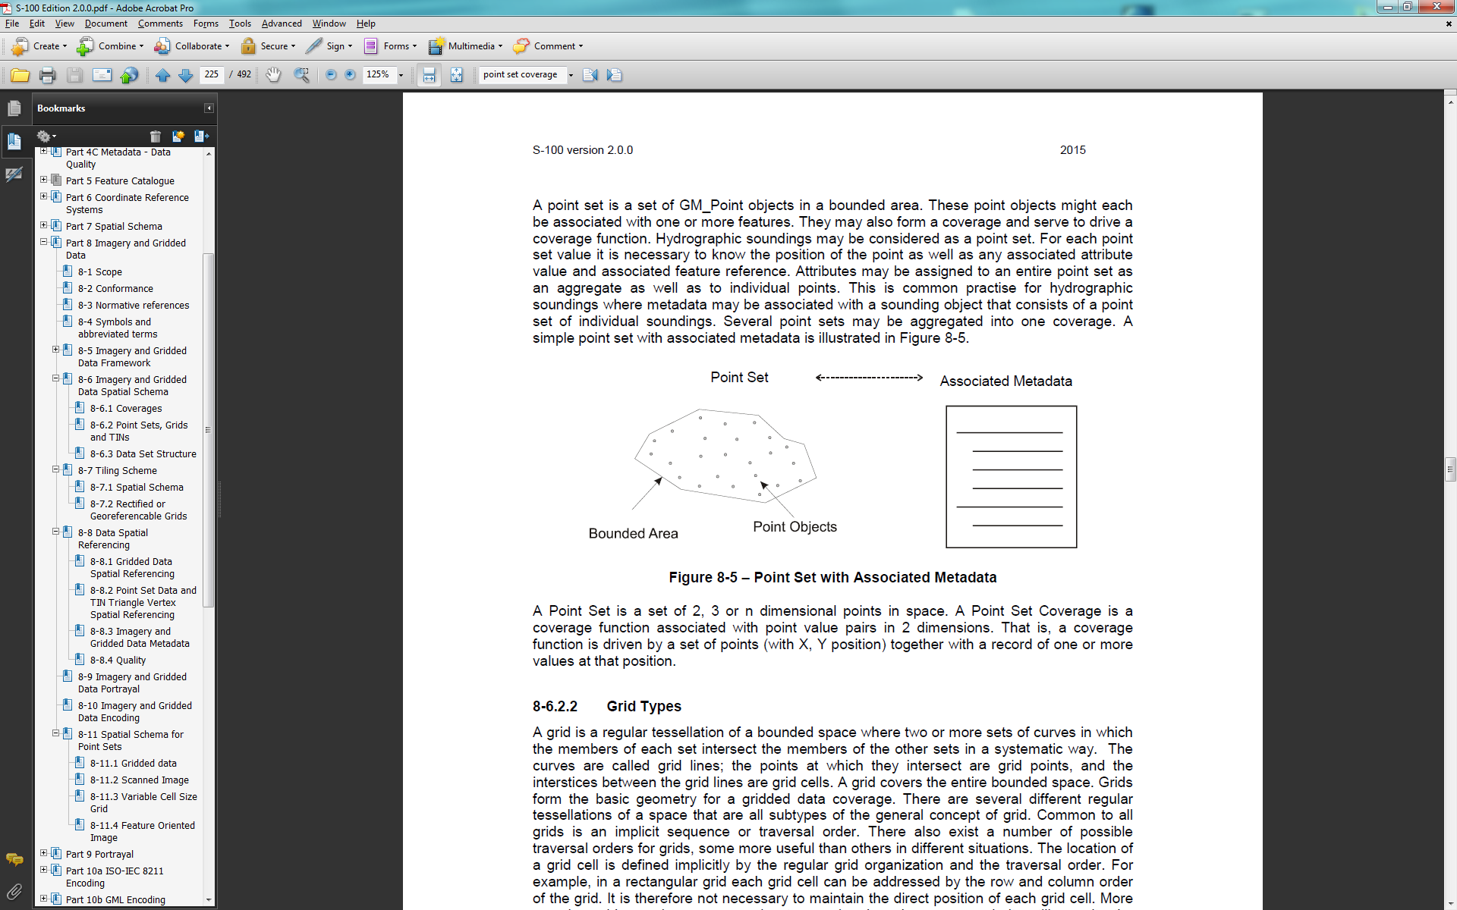

**point set coverage**

**coverage** function associated with point value pairs in 2 dimensions.

[S-100]

NOTE: a coverage function is driven by a set of points (with X, Y position) together with a record of one or more values at that position.

**portrayal**

presentation of **information** to humans

[ISO 19109, ISO 19117]

**portrayal catalogue**

collection of defined **portrayals** for a feature catalogue

NOTE: Content of a portrayal catalogue includes **portrayal functions**, **symbols**, and **portrayal context.** [ISO 19117]

**portrayal context**

circumstances, imposed by factors extrinsic to a geographic dataset, that affect the **portrayal**

of that dataset.

EXAMPLE: Factors contributing to portrayal context

may include the proposed display or map scale, the

viewing conditions (day/night/dusk), and the display

orientation requirements (north not necessarily at the

top of the screen or page), among others

NOTE: Portrayal context may influence the selection

of portrayal functions and construction of symbols

[ISO 19117]

**portrayal function**

function that maps geographic features to symbols

NOTE: Portrayal functions can also include parameters

and other computations that are not dependent on

geographic feature properties

[ISO 19117]

**portrayal function set**

function that maps a feature catalog to a symbol set

[ISO 19117]

**portrayal rule**

specific kind of portrayal function expressed in

a declarative language

NOTE: A declarative language is rule based and

includes decision and branching statements

[ISO 19117]

**portrayal service**

generic interface used to portray features

[ISO 19117]

**portrayal specification**

collection of operations applied to the feature instance

to portray it

[ISO 19117]

**position**

**data type** that describes a **point** or geometry potentially occupied by an **object** or person

NOTE: A **direct position** is a semantic subtype of **position**. **Direct positions** as described can only define a **point**, and therefore not all **positions** can be represented by a **direct position**. That is consistent with the *is type of* relation. An ISO 19107 geometry is also a **position**, but not a **direct position**

[ISO 19132]

**positional accuracy**

closeness of **coordinate** value to the true or accepted value in a specified reference system

NOTE: The term *absolute accuracy* is sometimes used for this concept to distinguish it from relative **positional accuracy**. Where the true **coordinate** value may not be perfectly known, **accuracy** is normally tested by comparison with available values that can best be accepted as true

[ISO 19116]

**product**

result of a process

[ISO 19158]

**product specification**

description of the universe of discourse and

a **specification** for mapping the universe of discourse

to a **dataset**

[ISO 19158]

**profile**

**set** of one or more base standards or subsets of base standards, and, where applicable, the identification of chosen clauses, classes, options, and parameters of those base standards, that are necessary for accomplishing a particular **function**

NOTE: A **profile** is derived from base standards so that, by definition, **conformance** to a **profile** is **conformance** to the base standards from which it is derived

[ISO 19101, ISO 19106]

**profile** *<***UML***>*

definition of a limited extension to a reference **metamodel** with the purpose of adapting the **metamodel** to a specific platform or **domain**

[ISO/TS 19103]

**quadrilateral grid coverage**

may be a **rectified grid** or a **referenceable grid**.

[Springer 2012]

**quality**

totality of **characteristics** of a **product** that bear on its ability to satisfy stated and implied needs

[ISO 19101, ISO 19109]

Degree to which a set of inherent **characteristics** fulfills requirements

NOTE 1: The term ***quality***can be used with adjectives such as poor, good or excellent

NOTE 2: *Inherent*, as opposed to *assigned*, means existing in something, especially as a permanent **characteristic**

[ISO 19157]

NOTE 3: For the purposes of this technical specification the quality **characteristics** of **product** include:

– **Data** quality (the elements of which are described by ISO 19113)

– Volume of delivery

– Schedule of delivery

– Cost of production and/or update

[ISO 19158]

**range**

set of all values a **function** *f* can take as its arguments vary over its **domain**

[ISO 19136]

**referenceable grid**

**requires** a formula of higher order that transforms into a coordinate reference system.

EXAMPLE: the perspective transformation with eight

parameters.

[Springer 2012]

**render**

conversion of digital graphics data into visual form

EXAMPLE Generation of an image on a video display

[ISO 19117]

**schema**

formal description of a **model**

NOTE: In general, a **schema** is an abstract representation of an **object**’s **characteristics** and relationship to other **objects**. An XML **schema** represents the relationship between the **attributes** and **elements** of an XML **object** (for example, a document or a portion of a document)

[ISO 19101]

**sequence**

finite, ordered collection of related items (**objects** or values) that may be repeated

NOTE: Logically, a **sequence** is a set of pairs *<*item, offset*>*. LISP syntax, which delimits **sequences** with parentheses and separates elements in the **sequence** with commas, is used in this international standard

[ISO 19107]

**set**

unordered collection of related items (**objects** or values) with no repetition

[ISO 19107]

**specification**

declarative description of what something is or does

NOTE: Contrast: **implementation**

[retired version of ISO/TS 19103]

**timestamp**

value of time at which an **object**’s state is measured and recorded

[ISO 19132]

**symbol**

portrayal primitive that can be graphic, audible, or

tactile in nature, or a combination of these

[ISO 19117]

**tuple**

ordered list of values

NOTE 1: The number of values in a tuple is immutable

NOTE 2: the ordered list will generally be a finite **sequence** of **features,** each of a specific **feature type**

[ISO 19136, ISO 19142]

**type**

a specification of the general structure and behavior of a **domain** of **objects** without providing a physical **implementation**

NOTE: A **type** may have **attributes** and associations

[ISO/TS 19103]

**UML**

The Unified Modeling Language (**UML**) is a general-purpose [modeling language](http://en.wikipedia.org/wiki/Modeling_language) in the field of [software engineering](http://en.wikipedia.org/wiki/Software_engineering), which is designed to provide a standard way to visualize the design of a system.

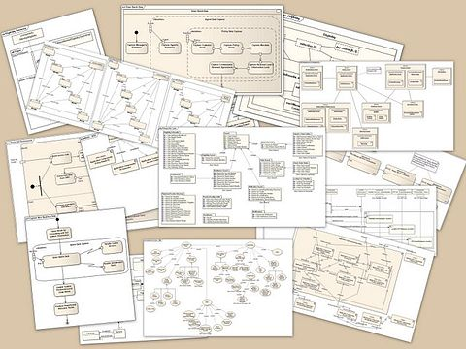

image courtesy of [Kishorekumar 62](http://en.wikipedia.org/wiki/User:Kishorekumar_62)

[Wikipedia 2015]

**UML application schema**

**application schema** written in UML in accordance with ISO 19109

[ISO 19136]**valid time**

time when a fact is true in the abstracted reality

[ISO 19108]

**vector**

quantity having direction as well as magnitude

NOTE: A directed line segment represents a **vector** if the length and direction of the line segment are equal to the magnitude and direction of the **vector**. The term *vector data* refers to **data** that represents the spatial configuration of **features** as a set of directed line segments

[ISO 19123]

**vertical coordinate system**

one-dimensional **coordinate** system used for gravity-related height or **depth** measurements

[ISO 19111]

**vertical datum**

**datum** describing the relation of gravity-related heights or **depths** to the Earth

NOTE: In most cases the **vertical datum** will be related to mean sea level. Ellipsoidal heights are treated as related to a three-dimensional ellipsoidal **coordinate** system referenced to a geodetic **datum**. **Vertical datums** include sounding **datums** (used for hydrographic purposes), in which case the heights may be negative heights or **depths**

[ISO 19111]

**ANNEX C. APPLICATION SCHEMA**

**Feature Class**

The Surface Current feature class (Figure C.1) has two mandatory attributes: *surfaceCurrentSpeed* and *surfaceCurrentDirection*. These variables capture the speed of current over ground and the general direction of the current at the location of the data. Each instance of surface current is only valid for a specific moment in time and may be part of a time series, as described in the metadata.

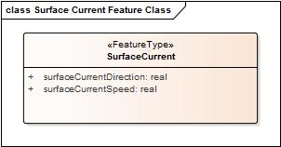  
Figure C.1 – Surface Current Feature Class.

**Surface Current Models**

Surface Currents are described for the area of interest as a coverage, using either (1) a regularly spaced grid or a (2) point coverage. The Surface Current Model (SCM) is described in Figure C.2.

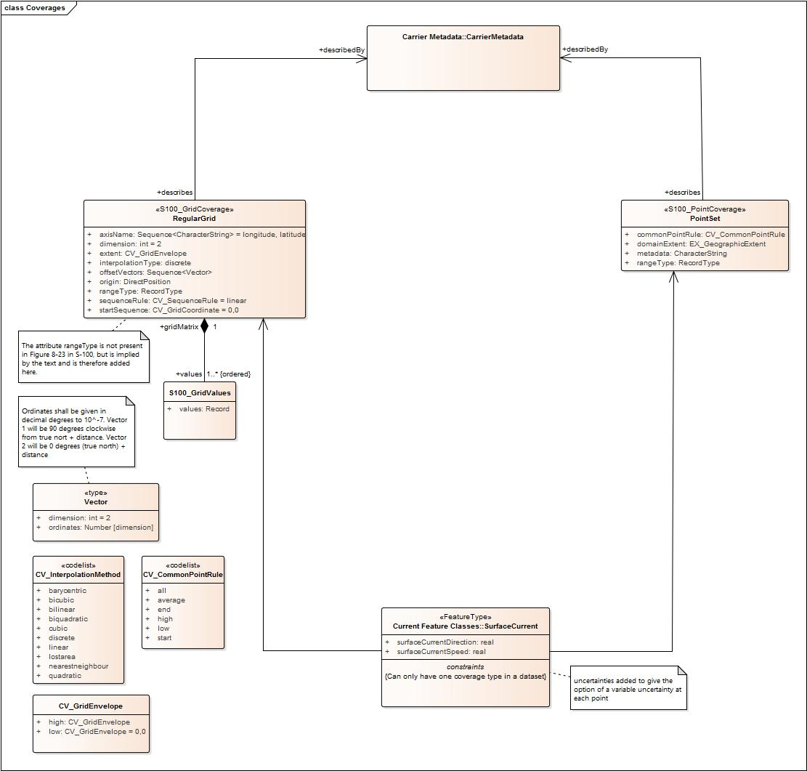

Figure C.2 - Surface Current Model.

**Metadata**

The metadata for the SCM is shown in Figure C.3.

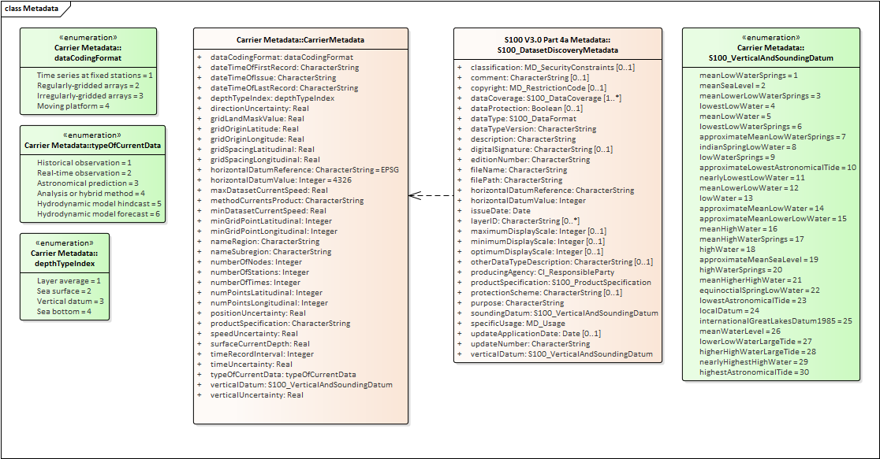

Figure C.3 – Metadata model for Surface Currents.

ANNEX D. FEATURE CATALOGUE

<?xml version="1.0" encoding="utf-8"?>

<S100FC:S100_FC_FeatureCatalogue xmlns:S100FC="http://www.iho.int/S100FC" xmlns:S100Base="http://www.iho.int/S100Base" xmlns:S100CI="http://www.iho.int/S100CI" xmlns:xlink="http://www.w3.org/1999/xlink" xmlns:S100FD="http://www.iho.int/S100FD" xmlns:xsi="http://www.w3.org/2001/XMLSchema-instance" xsi:schemaLocation="http://www.iho.int/S100FC S100FC.xsd">

<S100FC:name>S111</S100FC:name>

<S100FC:scope>Navigationally Significant Surface Current which may be used alone or as an auxiliary layer of data with an ENC.</S100FC:scope>

<S100FC:fieldOfApplication>Ocean Navigation</S100FC:fieldOfApplication>

<S100FC:versionNumber>0.1</S100FC:versionNumber>

<S100FC:versionDate>2016-12-15</S100FC:versionDate>

<S100FC:producer>

<S100CI:organisationName>IHO</S100CI:organisationName>

<S100CI:contactInfo>

<S100CI:phone>

<S100CI:voice>+337 93 10 81 00</S100CI:voice>

<S100CI:voice>+337 93 10 81 00</S100CI:voice>

<S100CI:voice>+337 93 10 81 00</S100CI:voice>

<S100CI:voice>+337 93 10 81 00</S100CI:voice>

<S100CI:voice>+337 93 10 81 00</S100CI:voice>

<S100CI:facsimile>+337 93 10 81 40</S100CI:facsimile>

</S100CI:phone>

<S100CI:address>

<S100CI:deliveryPoint>via TWCWG</S100CI:deliveryPoint>

<S100CI:deliveryPoint>via TWCWG</S100CI:deliveryPoint>

<S100CI:deliveryPoint>via TWCWG</S100CI:deliveryPoint>

<S100CI:deliveryPoint>via TWCWG</S100CI:deliveryPoint>

<S100CI:deliveryPoint>via TWCWG</S100CI:deliveryPoint>

<S100CI:postalCode>B.P.445</S100CI:postalCode>

<S100CI:country>MONACO</S100CI:country>

</S100CI:address>

<S100CI:onlineResource>

<S100CI:url>www.iho.int</S100CI:url>

</S100CI:onlineResource>

</S100CI:contactInfo>

<S100CI:role>pointOfContact</S100CI:role>

</S100FC:producer>

<S100FC:classification>unclassified</S100FC:classification>

<S100FC:S100_FC_SimpleAttributes>

<S100FC:S100_FC_SimpleAttribute>

<S100FC:name>Surface current direction</S100FC:name>

<S100FC:definition>DIRECTION OF CURRENT. The direction toward which a CURRENT is flowing, called the SET of the CURRENT. Also called current direction</S100FC:definition>

<S100FC:code>surfaceCurrentDirection</S100FC:code>

<S100FC:valueType>Real</S100FC:valueType>

</S100FC:S100_FC_SimpleAttribute>

<S100FC:S100_FC_SimpleAttribute>

<S100FC:name>Surface current speed</S100FC:name>

<S100FC:definition>Rate of motion. The terms speed and VELOCITY are often used interchangeably, but speed is a scalar, having magnitude only, while VELOCITY is a vector quantity, having both magnitude and direction. Speed may either be the ship's speed through water, or the SPEED MADE GOOD over ground.</S100FC:definition>

<S100FC:code>surfaceCurrentSpeed</S100FC:code>

<S100FC:valueType>Real</S100FC:valueType>

</S100FC:S100_FC_SimpleAttribute>

</S100FC:S100_FC_SimpleAttributes>

<S100FC:S100_FC_FeatureTypes>

<S100FC:S100_FC_FeatureType isAbstract="false">

<S100FC:name>Surface Current</S100FC:name>

<S100FC:definition>Water or other fluid in essentially horizontal motion.</S100FC:definition>

<S100FC:code>SurfaceCurrent</S100FC:code>

<S100FC:attributeBinding sequential="false">

<S100FC:multiplicity>

<S100Base:lower>1</S100Base:lower>

<S100Base:upper xsi:nil="false" infinite="false">1</S100Base:upper>

</S100FC:multiplicity>

<S100FC:attribute ref="surfaceCurrentSpeed"/>

</S100FC:attributeBinding>

<S100FC:attributeBinding sequential="false">

<S100FC:multiplicity>

<S100Base:lower>1</S100Base:lower>

<S100Base:upper xsi:nil="false" infinite="false">1</S100Base:upper>

</S100FC:multiplicity>

<S100FC:attribute ref="surfaceCurrentDirection"/>

</S100FC:attributeBinding>

<S100FC:featureUseType>Geographic</S100FC:featureUseType>

<S100FC:permittedPrimitives>coverage</S100FC:permittedPrimitives>

<S100FC:permittedPrimitives>pointSet</S100FC:permittedPrimitives>

</S100FC:S100_FC_FeatureType>

</S100FC:S100_FC_FeatureTypes>

</S100FC:S100_FC_FeatureCatalogue>

ANNEX E. TESTS OF COMPLETENESS (NORMATIVE)

**E.1 Coverage Consistency**

### E.1.1 Test case for coverage geometry

|  |  |
| --- | --- |
| Test purpose: | Verify that the coverage geometry corresponds to the conformance class |
| Conformance class | Gridded coverage, point coverage |
|  |  |
| Test method: | Check that the coverage geometry type complies with one of the two coverage types defined in the Application Schema defined in Annex C. |
| Test type: | Basic |

### E.1.2 Test case for extra data

|  |  |
| --- | --- |
| Test purpose: | Verify that a Gridded coverage data set is complete by testing that the grid coverage value matrix contains direction and speed values, or null values, for every vertex point defined in the grid, and when all of the mandatory associated metadata is provided.  Verify that a Point Coverage is complete by testing that the points containing direction and speed values are matched with a longitude-latitude pair, and when all of the mandatory associated metadata is provided. |
| Test method: | Check that for each feature, all of the mandatory metadata is provided, and that all of the vertex points have corresponding values. |
| Test type: | Basic |

### E.1.3 Test case for empty data

|  |  |
| --- | --- |
| Test purpose: | Verify that data is not missing |
| Test method: | Check that all mandatory metadata is provided, and test that all data values for the grid or point coverage established in the metadata are provided |
| Test type: | Basic |

## E.2 **Logical Consistency**

Check that grid extent defined in the metadata is consistent with grid spacing and number of points. Check that the number of null values in the speed grid equals the number in the direction grid. Check that the point coverage envelope is consistent with the minimum and maximum point locations.

### E.2.1 Conceptual Consistency

The implementation of the Surface Current Product is required to align with one of the two conformance classes defined in the appendix with the Abstract Test Suite and Conformance Classes.

### E.2.2 Domain Consistency

The attributive values are validated to ensure they are within defined range.

|  |  |
| --- | --- |
| Test purpose: | Verify that attribute values are within specified ranges |
| Test method: | Check that the surface current direction value attribute is within the range 0 to 360 degrees or are a null value and that the speed values are within the range specified or are a null value for the particular product specification defined by a producer. This would be validated by means of test software |
| Test type: | Basic |

### E.2.3 Positional Accuracy

For a gridded coverage the positional accuracy for the grid reference point and the length of the offset vectors defining the size of each grid cell, when specified, are defined in the metadata. For a Point Coverage the positional accuracy for the point is defined in the metadata.

|  |  |
| --- | --- |
| Test purpose: | Verify that the grid reference point and offset vector in a grid coverage, and the points in a point coverage, are defined and in accordance with the accuracy established for the data set by the producer. |
| Test method: | Verify that the positional accuracy of the defining points of the coverage is within the accuracy established for the data set by the producer, in particular the Hydrographic Office, by the use of test software. |
| Test type: | Basic |

### E.2.4 Temporal Accuracy

For a gridded coverage the temporal reference time for the data at all grid points is the same. Temporal accuracy is not defined.

# ANNEX F. SURFACE CURRENT DATA

This Annex describes the sources of data, methods of organizing surface current data (the time series and the grid), how the data product format is derived. In the last section we discuss additional features of current data.

F.1 Data Sources

For the purposes of this Product Specification, surface current data categorized as one of three types, depending on the source of production. These are:

* Historical and real-time observation,
* Astronomical prediction, and
* Model-based forecast or prediction.

An historical observation consists of a time series of values at a specific location or area, often at a specific elevation above the bottom or below the surface. Observations can be for a fixed point (current meter), a moving point (e.g., a Lagrangian drifter), along a vertical or horizontal line (Doppler profiler), or an area (coastal radar). A real-time (or near-real-time) observation is actually a historical observation but for the very recent past. The astronomical tidal current prediction is often a time series computed by a mathematical formula using harmonic constants. This prediction applies to a specific location and depth, and is often produced many months ahead of time.

The astronomical predictions for multiple stations are often combined into a digital tidal atlas, and the individual predicted currents are usually keyed to the time and amplitude of tidal water levels at a nearby station.

Finally, model-based forecasts or predictions are usually produced by a two- or three-dimensional numerical hydrodynamic model, and include astronomical tide, meteorological forcing, river inflow, spatially varying water density, and open ocean boundary inputs. A model-based hindcast, including an analysis, is based on historically-observed conditions. A forecast is usually produced to predict conditions a few hours or days ahead into the future.

F.2 Data Organization

Data are usually organized by the HO producer into either (a) a time series of values, such as for historical and real-time observations at a single point, or (b) a gridded set of values, such as from a model-based forecast or sea-surface analysis.

F.2.1 Time Series Data

An historical observation consists of a time series of values at a specific location or area, often at a specific elevation above the bottom or below the surface. Observations can be for a single point (current meter), along a line (Doppler profiler), or an area (coastal radar).

The data for individual current meter stations are most conveniently organized in a time series.

For example, for historical observations and astronomical predictions, each record in the series consists of a time for which the data are valid and the water current data itself: speed and direction. Descriptive data may be contained in a metadata block at the beginning of the file.

Real-time data is similar to historical data in that, in addition to dataset metadata, they include either a single near-real-time value or a time series of values for speed and direction, with the most recent being the near-real-time value. A sample file containing observations is shown in Figure F.1.

# Station ID: cb1101

# # Orientation: Down (Buoy-Mounted)

# # Time Zone: UTC

# # Approx. Depth: Near Surface

# # Blank rows indicate missing data. See our data

# # disclaimer online.

# #

# # Date Time Speed (knots) Dir (true)

# 2014-12-01 00:00:00 1.08 215

# 2014-12-01 00:06:00 1.00 225

# 2014-12-01 00:12:00 0.83 226

# 2014-12-01 00:18:00 0.73 230

# 2014-12-01 00:24:00 0.80 223

# 2014-12-01 00:30:00 0.77 236

# 2014-12-01 00:36:00 0.73 229

# 2014-12-01 00:42:00 0.61 224

# 2014-12-01 00:48:00 0.71 224

# 2014-12-01 00:54:00 0.71 220

# 2014-12-01 01:00:00 0.67 230

Figure F.1 – Portion of an actual text file containing surface current observations at 6-minute intervals. The native format is ASCII text (other options were available). Data courtesy of the Center for Operational Oceanographic Products and Services, US.

The sample file contains (a) a metadata block, with information on the station, location, instrument type, and depth, and (b) a header line followed by multiple lines of values which include the date and time, the current speed, and the current direction.

The file shown in Figure F.1 can be reformatted so that the metadata appears at the beginning of the file, and the speed at direction data is group for each time (Figure F.2a).

[Metadata block for station # 1]

Value of Time 1: 2014-12-01 00:00:00

Speed at Time 1 = 1.08

Direction at Time 1 = 215

Value of Time 2: 2014-12-01 00:06:00

Speed at Time 2 = 1.00

Direction at Time 2 = 225

Value of Time 3: 2014-12-01 00:12:00

Speed at Time 3 = 0.83

Direction at Time 3 = 226

Figure F.2a - Reformatted time series or real-time data.

The data in Figure F.2a can be rearranged so that all the speeds and all the directions appear in a sequence, as in Figure F.2b.

[Metadata block for station # 1]

Value of Time 1: 2014-12-01 00:00:00

Speed = 1.08, 1.00, 0.83

Direction = 215, 225, 226

Figure F.2b - Reformatted time series data

F.2.2 Gridded Data

For certain data products that cover a specific geographic area, the data are most likely to be gridded. Examples are hindcasts and forecasts produced by a hydrodynamic model, currents derived from the analysis of sea-surface topography, and currents derived from high-frequency coastal radar observations.

Many spatial grids are regular (i.e., having uniform spacing in each direction) and geodetic (with the X axis directed toward the east and Y axis directed toward the north). Such grids are defined by several parameters: the origin (longitude and latitude of a geographic point), the grid spacing along each axis (degrees), and the number of points along each axis. Given an uncertainty in the location of the origin and in the spacing, there will be an uncertainty on the precise position of the grid points. A portion of the metadata and the current speed data from a forecast model is shown in Figure F.3. There are similar data for the current direction grid.

NOTE: some datasets contain a land mask array, for the purpose of determining whether a grid point represents land or water. Herein the product specification uses a land mask value (e.g.,

‑99.999), which is substituted for a gridded value which is on land, to represent land, thus reducing the number of arrays required.

Dataset 'speed(knots)'

Size: 500x325

MaxSize: 500x325

Datatype: H5T_IEEE_F32LE (single)

ChunkSize: 1x325

Filters: deflate(9)

FillValue: 0.000000

Attributes:

'organization': 'Center Canadian Meteorological Service - Montreal (RSMC) (54) '

'Delta_Longitude': '0.02993999933078885 '

'Delta_Latitude': '0.019938461092802194 '

'forecastDateTime': '20140611_180000 '

'Product': 'Type: Forecast products Status: Operational products '

'Minimum_Latitude': '45.5 '

'Maximum_Latitude': '51.97999985516071 '

'Maximum_Longitude': '-56.030000334605575 '

'Number_Of_Cells_South_North': '325 '

'Minimum_Longitude': '-71.0 '

'Number_Of_Cells_West_East': '500 '

'generatedDateTime': '20140611_000000 '

'units': 'mm/s '

speed(knots) =

0, 0, 0, 0.5191959, 0.5159838, 0.5159435, 0.5186388,

0.5209069, 0.5167338, 0.5114825, 0.4738558, 0.378551, 0.2911682,

0.204335, 0.1294665, …

Figure F.3 - A portion of the actual metadata and the gridded current speed data produced by the

Canadian Meteorological Service from a model-based forecast. The native format is HDF5.

Note that the data for current speed in Figure F.3 is organized similarly to that for time series: (a) metadata followed by (b) a header record and then the data. However, unlike the time series, the data are valid for a single time (the value of which appears elsewhere in the metadata).

Current data produced on ungeorectified grids or on unstructured grids, or for surface drifters, may be incorporated by spatially referencing each individual velocity location by explicitly giving its latitude and longitude in the metadata.

For gridded data in general, the metadata for both speed and direction will be the same, so only one metadata block is required to describe both the speed and direction data (Figure F.4). The data for speed in Figure F.3 is a series of values at grid points, starting from the lower left corner of the grid and proceeding along the first row until the end, then starting with the first point in the second row, and so on. Note that for the two fields (speed and direction) in this example, the memory required is 0.325 mb.

[Metadata block for gridded fields]

Value of Time 1

Speed at T1 = 0, 0, 0, 0.5191959, 0.5159838, 0.5159435, 0.5186388, 0.5209069, 0.5167338, 0.5114825, 0.4738558, 0.378551, 0.2911682, 0.204335, 0.1294665, …

Direction at T1 = 0, 0, 0, 32.7725, 30.33029, 27.84417, 26.28601, 26.46908, 26.46744, 26.56505, 25.9423, 24.28312, 23.54004, 24.69553, 28.52312, …

Figure F.4 - A portion of a generalized file with the metadata and the gridded current speed and direction data at one specific time from a model-based forecast shown in Figure F.3.

F.3 Digital Tidal Atlas Data

A digital tidal atlas typically contains speed and direction information for a number of locations, the valid time of which is expressed as a whole number of hours before and/or after either time of high water at a reference tidal water level station or time of maximum flood current at a reference station. Often the speed and direction are given for both neap and spring tide conditions (Table F.1).

Data in the atlas format, when used with daily predictions of tidal water levels or currents at a reference station, can be converted into time series data (see Figure F.2b), and thus into the S-111 format. This conversion is to the responsibility of the HO.

Table F.1 – Example of digital tidal data for a station off the French coast. Speed and direction vary by hour relative to high water at a reference station, and by tide range. Data courtesy of Service Hydrographique et Océanographique de la Marine, France.

|  |  |  |  |  |
| --- | --- | --- | --- | --- |
| **Hour** | **Speed (ms-1)** | | **Direction (deg)** | |
| **Neap** | **Spring** | **Neap** | **Spring** |
| -6 | 0.924 | 0.991 | 234.0 | 232.8 |
| -5 | 0.991 | 1.047 | 235.4 | 233.5 |
| -4 | 1.015 | 1.104 | 233.1 | 234.8 |
| -3 | 0.939 | 1.132 | 233.4 | 233.0 |
| -2 | 0.447 | 0.947 | 233.7 | 233.3 |
| -1 | 0.302 | 0.061 | 232.8 | 200.1 |
| 0 | 0.444 | 0.292 | 232.5 | 56.0 |
| 1 | 0.562 | 0.044 | 232.5 | 68.2 |
| 2 | 0.596 | 0.469 | 232.4 | 231.2 |
| 3 | 0.620 | 0.662 | 232.5 | 231.3 |
| 4 | 0.705 | 0.779 | 232.7 | 231.6 |
| 5 | 0.797 | 0.886 | 233.0 | 232.1 |
| 6 | 0.876 | 0.967 | 233.5 | 232.6 |

F.4 Moving Platform Data

Moving platforms (e.g., surface Lagrangian drifters) float along with the currents and represent the motion at some depth depending on the specific design. The data are often available, in the raw form, as a list with locations and (usually non-equally-spaced) times (Figure F.5). The data are often telemetered from the drifter to a collection station.

OBJECTID,ARID,YR,MON,DD,HH,MM,SS,LAT,LON,ACC

127134,52299,2005,9,25,7,18,16,15.57400000000,142.82200000000,2

127135,52299,2005,9,25,8,58,0,15.57400000000,142.80000000000,2

127136,52299,2005,9,25,18,47,37,15.54300000000,142.72100000000,2

127137,52299,2005,9,25,19,47,45,15.54100000000,142.71100000000,2

127138,52299,2005,9,25,21,27,29,15.53300000000,142.69200000000,2

127139,52299,2005,9,26,6,55,6,15.49900000000,142.65500000000,1

127140,52299,2005,9,26,8,34,6,15.48600000000,142.64400000000,2

127141,52299,2005,9,26,18,35,27,15.43800000000,142.59300000000,1

127142,52299,2005,9,26,19,23,51,15.43300000000,142.59000000000,2

Figure F.5 - Portion of an Argos System CLS file describing

the positions and times of a specific Lagrangian drifter.

In the raw form, the data must be converted into speed and directions. This can be accomplished by cubic spline interpolation of the longitudes and latitudes separately, then dividing the difference in position by the differences in time. The data can be converted into time series data (see Figure F.2b), and thus into the S-111 format.

F.5 Preliminary Data Product Format

Two forms of data (Figures F.2b and F.4) are similar, the main difference being that the multiple values for each variable in Figure F.4 correspond to multiple grid points, rather than the multiple times in Figure F.2b (at a single station). Thus the two forms can be combined into a single form (Figure F.6, although the data are interpreted differently. Other forms of data (Figures F.4 and F.5) must be processed to fit the format.

|  |  |  |
| --- | --- | --- |
|  |  |  |
|  | Metadata Block |  |
|  | Location Data |  |
|  |  |  |
|  | Time and Location 1 |  |
|  | Surface current speed(s) |  |
|  | Surface current direction(s) |  |
|  |  |  |
|  | Time and Location 2 |  |
|  | Surface current speed(s) |  |
|  | Surface current direction(s) |  |
|  |  |  |

Figure F.6 – Schematic of the preliminary product data set. The product can represent either a time series

at a number of stations or gridded data.

F.6 Additional Features of the Data

The following sections described additional features of current data and types.

F.6.1 Vertical Reference Datums

The vertical location of the current in the water column is normally referenced to some vertical datum. In this Product Specification, the datum is selectable: it can be the sea surface, the sea bottom, or any of 30 standard tidal datums. The coordinate system axis is directed upward, so if the level of the current is below the datum, the depth will have a negative value. Levels referenced above the sea bottom will have a positive value. For a layer average, the thickness of the layer is specified as a positive value.

In principle, it is possible to transform elevations between the different datums. The separation between a standard tidal datum and the sea surface varies with time, and can be obtained by a prediction of the water level at the location of the current. In the case of a hydrodynamic model for currents, the model itself usually includes a water level prediction. The separation between the sea bottom and the standard tidal datum is often contained automatically in bathymetric data that is reference to a chart datum. If chart datum and the selected currents datum are different, an estimation of the difference in elevation is required.

F.6.2 Uncertainty

Uncertainty is the estimate of the error in any measurement or value; since the error (difference between true and observed value) depends on true value, which can never be measured. For practical purposes, the confidence level is 95% and the uncertainty is defined herein as 1.96 times the standard deviation of the differences between observed and predicted values (cf. S-44. *IHO Standards for Hydrographic Surveys*, 5th Edition February 2008). For multiple sources of uncertainty, the total propagated uncertainty is the relevant value.

For example, the comparison between a predicted speed and the observed speed is normally based on an analysis using the time series for each. The standard deviation of the speed differences at each point in the series can be computed by the common formula. The calculation is similar for direction. It should be noted that for model-based predictions, uncertainty usually increases with the projection into the future.

Uncertainty for location is somewhat different. Horizontal locations of fixed or drifting observing stations are determined by surveying or GPS. The inherent uncertainties in these types of measurements are normally documented. For gridded hydrodynamic model data, uncertainties are based on the precision of the grid parameters (origin and spacing) and, if used, on any transformation from Cartesian (flat plane) position to geographic location. For coastal radar, uncertainty in position may be estimated by the local geometry and radar’s accuracy in computing distances and angles.

Vertical locations of fixed or drifting observing stations are determined by surveying or GPS, and by configuration geometry. For gridded hydrodynamic model data, uncertainties are determined in a manner similar to the horizontal positions, but with consideration for uncertainties in instantaneous sea surface height, actual water depth, and vertical (if used).

Uncertainties in time are based on instrumentation and GPS parameters, record keeping, and computer/processing accuracy.

ANNEX G. HDF-5 ENCODING

G.1 Introduction

The Hierarchical Data Format 5 (HDF5) has been developed by the HDF Group as a file format for the transfer of imagery and gridded data. This Annex specifies an interchange format to facilitate the moving of files containing data records between computer systems. It defines a specific structure which can be used to transmit files containing data type and data structures specific to S-100.

For S-111 purposes, an HDF5 file is structured to consist of Groups and sub-Groups, each of which may consist of Attributes and Datasets. Datasets are designed to hold large amounts of numerical data and may be used to hold the speed and direction data. Attributes are designed to hold single-valued information which apply to Groups and may be used to hold the metadata, although Datasets could also be used to hold the metadata.

It should be noted that not all S-100 data formats are readily available in HDF5. Predefined HDF5 formats include Integer, Float (cf. Real in S-100), Character (cf. CharacterString in S‑100), and Enumeration but not Boolean, Date, Time, or DateTime formats. In S-111, Integer shall be used for Boolean variables, and Character shall be used for the date and time variables. These differences are summarized in Table G.1.

Table G.1 – Variable types in S-111 and equivalent types in HDF5.

If no HDF5 equivalent exists, the HDF5 type

in parentheses is to be used.

|  |  |
| --- | --- |
| **S-100 Variable Types** | **HDF5 Variable Types** |
| Real | Float |
| Integer | Integer |
| CharacterString | Character |
| Enumeration | Enumeration |
| Date | (Character) |
| Time | (Character) |
| Boolean | (Integer) |

The general structure of the data product (Figure 10.1) may be expressed as an organized HDF5 file as shown in Table G.2. The root directory contains the carrier metadata as Attributes, another group has the feature codes, and each data group contains a title and date-time as attributes, and the speed and direction values of the currents. Depending on the data type, there may be an additional Group_XY.

Table G.2 - HDF5 encoding scheme for Surface Currents. The total number of groups with speed and direction data is *numGRP*. Group_XY appears only when *dataCodingFormat* is 1, 3 or 4.

|  |  |  |  |  |
| --- | --- | --- | --- | --- |
| **Group** | **HDF5 Category** | **Name** | **HDF5 Data Type** | **Data Space** |
| / *(root)* | Attribute | See Table 12.1 | Integer, Float, Enumeration, or Character | (none) |
| /Group_F | Attribute | Feature code: ‘surfaceCurrent’ | Character | (none) |
| Attribute | Attribute codes:  ‘surfaceCurrentSpeed’,  ‘surfaceCurrentDirection’ | Character | Array (2-d): n=0, *numAttributes-1* |
| Attribute | Optional Information | Character | Array (2-d) |
| /Group_XY | Dataset | Longitude | Float | Array (1-d): n=0, *numPOS-1* |
| Dataset | Latitude | Float | Array (1-d): n=0, *numPOS-1* |
| /Group_001 | Attribute | Title | Character |  |
| Attribute | Date-Time | Character |  |
| Dataset | surfaceCurrentSpeed | Float | Array (2-d): i=0, *numCOL-1*, j=0,*numROW-1* |
| Dataset | surfaceCurrentDirection | Float | Array (2-d): i=0, *numCOL-1*, j=0,*numROW-1* |
| /Group_002 | Attribute | Title | Character |  |
| Attribute | Date-Time | Character |  |
| Dataset | surfaceCurrentSpeed | Float | Array (2-d): i=0, *numCOL-1*, j=0,*numROW-1* |
| Dataset | surfaceCurrentDirection | Float | Array (2-d): i=0, *numCOL-1*, j=0,*numROW-1* |
| /Group_*numGRP* | Attribute | Title | Character |  |
| Attribute | Date-Time | Character |  |
| Dataset | surfaceCurrentSpeed | Float | Array (2-d): i=0, *numCOL-1*, j=0,*numROW-1* |
| Dataset: | surfaceCurrentDirection | Float | Array (2-d): i=0, *numCOL-1*, j=0,*numROW-1* |

G.2 Carrier Metadata

The carrier metadata (Table 12.1) is contained as attributes in the root directory (Table G.2). The carrier metadata consists of the data and parameters that assist in reading and interpreting the information in the HDF5 product, in the event that the S-111 MetaData file is unavailable. In addition, some of this information is not included in the metadata.

## G.3 Group_F (Codes)

Group_F contains the Feature Code (*surfaceCurrent*) and the Feature Attribute codes (*surfaceCurrentSpeed* and *surfaceCurrentDirection*), which identify the variables in the Data Product by their Geospatial Information Registry names.

Each attribute array shall have the following character information: camel case name of the attribute, plain text name of the attribute, units of measurements, fill value, chunk size of the dataset, and HDF5 data type.

## G.4 Group_XY

Depending on the data format, there can be an initial group of longitudes and latitudes in Group_XY. This group contains no attributes but two datasets, X (longitude) and Y (latitude). The number of values is *numPOS*. This group appears for values of *dataCodingFormat* of 1, 3, and 4 (Table 10.1).

For a set of fixed stations or for a single moving station (*dataCodingFormat* of 1 or 4), the geographic location(s) (X,Y) appear in the same order as do the Groups that contain the speed and direction data. For example, X1 ,Y1 is the position of the station corresponding to the data in Group_001, and X2 ,Y2 is the position of the station corresponding to the data in Group_002.

For a ungeorectified grid (*dataCodingFormat* of 3), X1 ,Y1 is the geographic location corresponding to the first data value in Groups 1, 2, etc. Point X2 ,Y2 is the location corresponding to the second data value in Groups 1, 2, etc.

G.5 Data Groups

Each data Group contains two attributes (Title and Date-time) and two datasets (surfaceCurrentSpeed and surfaceCurrentDirection). The number of individual Groups is given by the metadata variable, *numGRP*.

The attribute Title contains character information used in identifying the individual station or other relevant information. The Date-time contains the time that applies to the entire set of values in the Group (*dataCodingFormat* of 2 or 3). The time interval between data Groups is given by the metadata variable *timeRecordInterval*.

For *dataCodingFormat* of 1 or 4, the time of the first value in all data Groups is given by the metadata value *dateTimeOfFirstRecord*. The time interval between individual values in the data arrays is given by the metadata variable *timeRecordInterval*.

For each individual Group, there are two datasets: a set of speed values and a set of direction values. The values are storred in two-dimensional arrays, with a given the number of rows (*numROW*) and columns (*numCOL*). For one-dimensional arrays (*dataFormatType* not 2), *numROW* equals one.

Values which represent different times are stored sequentially, from oldest to newest. In addition, if each Group represent a different time, they are numbered sequentially, from oldest to newest.

**Speed Values** The speed values are contained in a Float array. Each number representing speed (knots) has two digits to the right of the decimal point, and to the left of the decimal point, either a one- or two-digit number representing a valid speed, or a negative one (‘-1.00’) denoting either an non-displayed value or land location. A non-displayed value represents a location where the speed is available, but has a value below the threshold for displaying a symbol. Table G.3 shows a sample one-dimensional dataset.

Table G.3 – Sample one-dimensional speed dataset, where a negative one (‘-1.00’)

denotes a null value or land location.

|  |  |  |  |  |  |  |
| --- | --- | --- | --- | --- | --- | --- |
| -1.00 | -1.00 | 2.34 | 5.67 | 8.99 | 12.34 | 9.87 |

**Direction Values** The directions values are contained in a Float array. Each number representing direction (degrees, clockwise from true north) has one digit to the right of the decimal point, and to the left of the decimal point, either a one-, two-, or three-digit number representing a valid direction, or a negative one (‘-1.0’) denoting a non-displayed value or land location. Table G.4 shows a sample dataset.

Table G.4 – Sample one-dimensional direction dataset where a negative one (‘-1.0’)

denotes a null value or land location.

|  |  |  |  |  |  |  |
| --- | --- | --- | --- | --- | --- | --- |
| -1.0 | -1.0 | 345.1 | 356.2 | 4.3 | 8.9 | 12.3 |

G.6 Samples of HDF Data Files

The following are examples of HDF5 files data for each of the four data coding formats. Files were produced by Matlab® and were displayed in HDFView. Note that Group_F is identical for each type, and is only shown in Figures G.1 and G.7.

### G.6.1 Stationary Platform

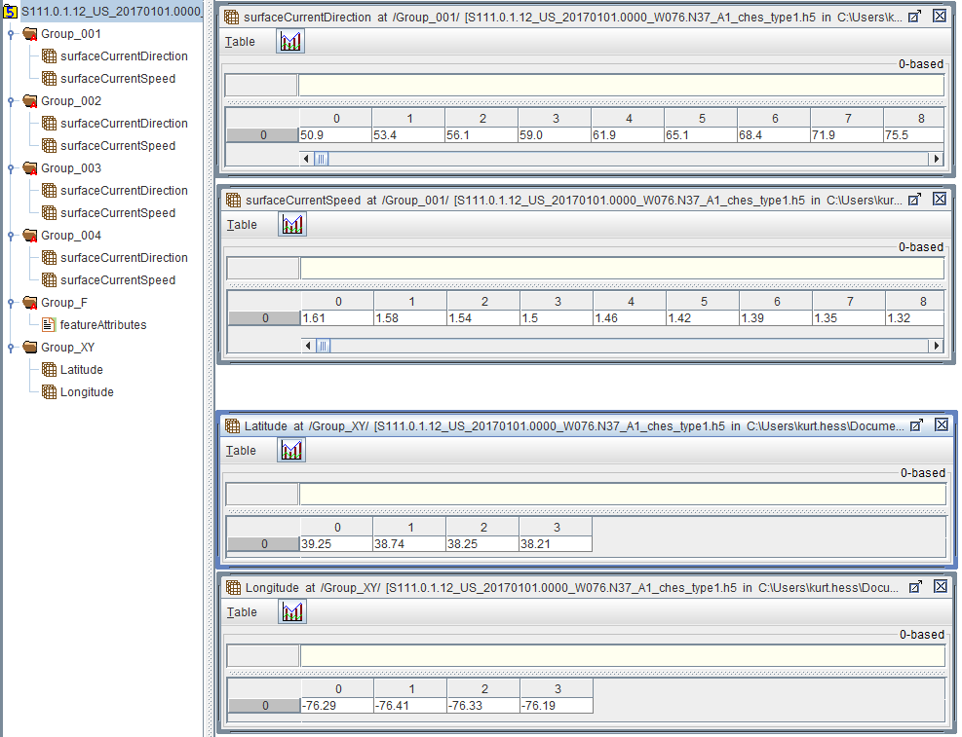

Figure G.1 – Sample file (using HDFView) containing speed and direction data (upper two panels) at four fixed observing stations, along with the longitudes and latitudes (lower teo panels) of the stations (*dataCodingFormat* = 1).

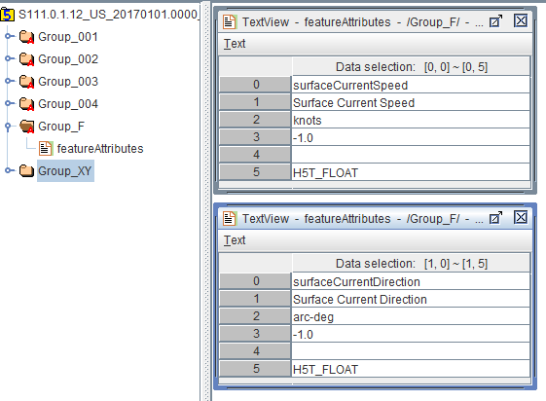

Figure G.2 – Attributes for speed and direction in Group_F. The value for index 4 (Chunk size) is shown as a blank for missing data.

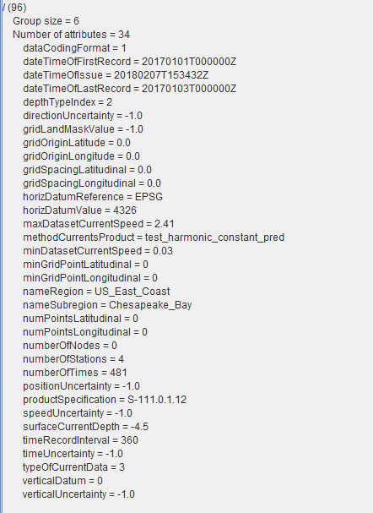

Figure G.3 – Display of a sample file (using HDFView) containing the 34 dataset root directory attributes (listed in alphabetical order) for fixed stations (*dataCodingFormat* = 1).

### G.6.2 Regular Grid

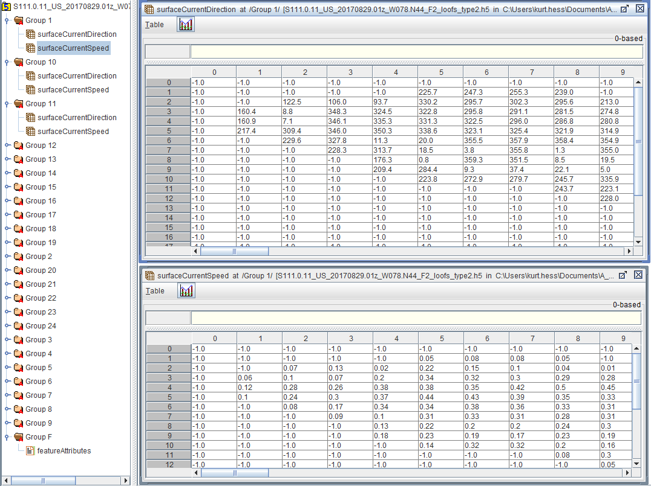

Figure G.4 – Display of a sample file (using HDFView) containing speed and direction data for a regular grid (*dataCodingFormat* = 2). The attributes in Group_F are the same as shown in Figure G.2.

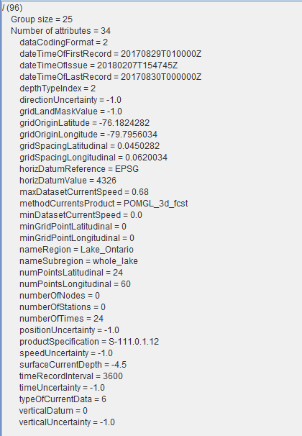

Figure G.5 – Display of a sample file (using HDFView) containing the 34 dataset root directory attributes (listed in alphabetical order) for a regular grid (*dataCodingFormat* = 2).

### G.6.3 Ungeorectified Grid

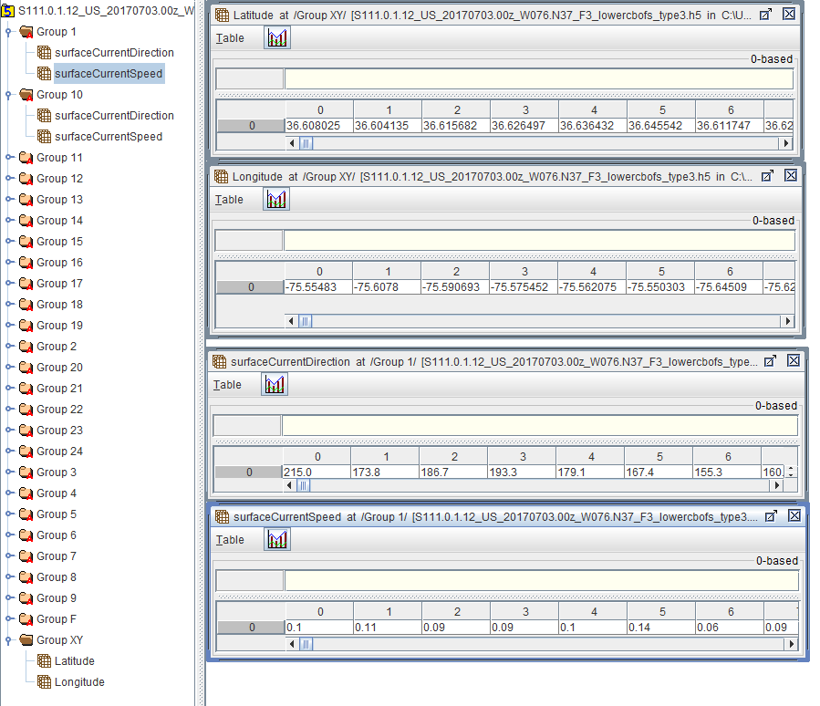

Figure G.6 – Display of a sample file (using HDFView) containing speed and direction data for an ungeorectified grid along with the longitudes and latitudes of the grid nodes (*dataCodingFormat* = 3). The attributes in Group_F are the same as shown in Figure G.2.

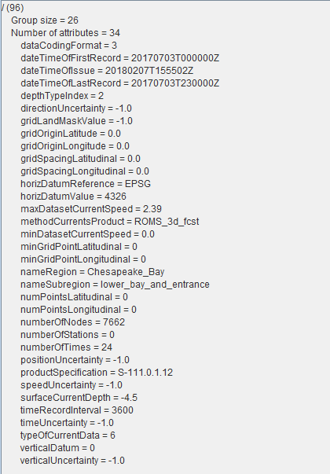

Figure G.7 – Display of a sample file (using HDFView) containing the 34 dataset root directory attributes (listed in alphabetical order) for an ungeorectified grid (*dataCodingFormat* = 3).

### G.6.4 Moving Platform

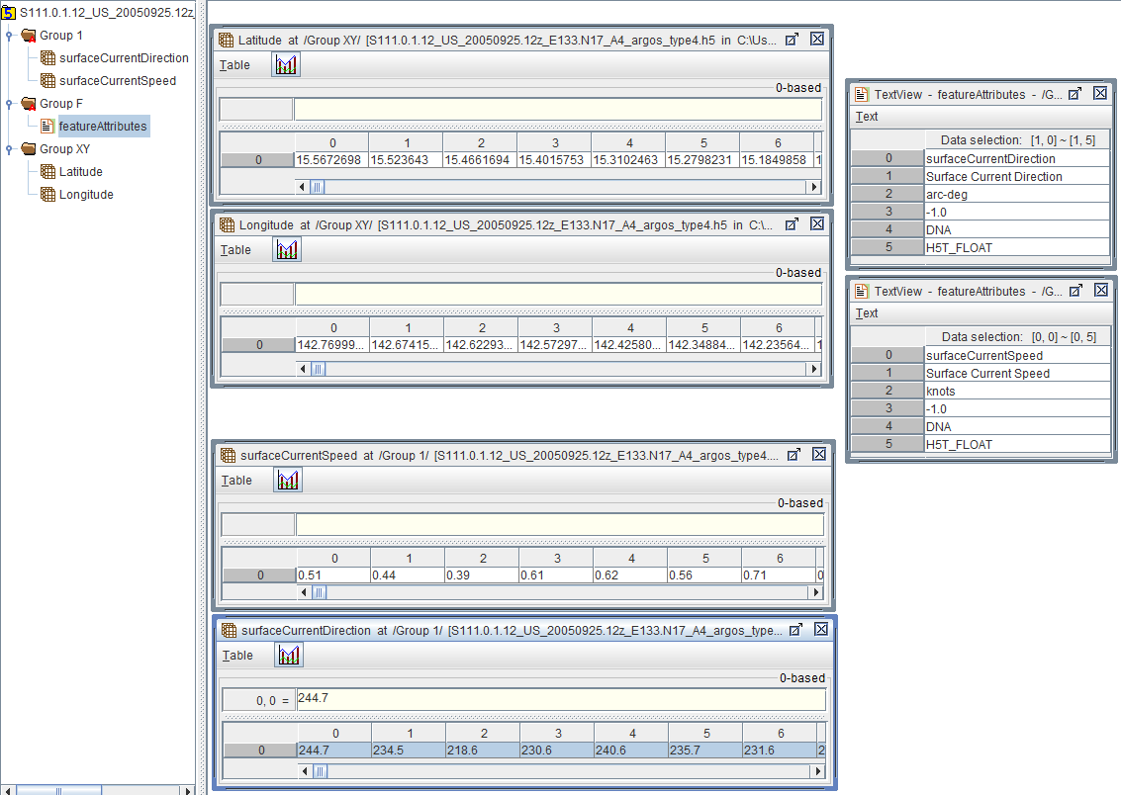

Figure G.8 – Display of a sample file (using HDFView) containing speed and direction data for a moving platform (e.g., a surface drifter), with the longitudes and latitudes of the drifters (*dataCodingFormat* = 4). The attributes in Group_F are the same as shown in Figure G.2.

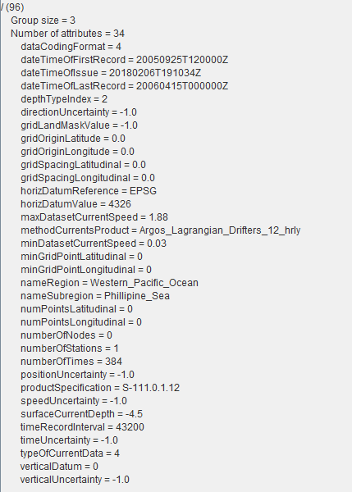

Figure G.9 – Display of a sample file (using HDFView) containing the 34 dataset root directory attributes (listed in alphabetical order) for a moving platform (*dataCodingFormat* = 4).

# ANNEX H. COLOUR TABLES

Below are the colour tables for the day, dusk, and night conditions. The estimates for dusk and night were obtained by first converting the values for RGB colours for day conditions (Clause 9.2.3) to xyL values, where L is luminance. Existing xyL data for dusk and night conditions for approximately 50 colors from S-52 (S-52 Presentation Library Edition 4.0.0, Part 1, Appx. A) demonstrate that luminance is reduced while the x and y values (mostly) remain constant. For each S-111 colour, the closest S-52 colour for day conditions (based on the x and y values) was then found, and that colour’s luminance reduction factors for other conditions were used to calculate the xyL values. Finally, the new xyL values were converted back to RGB.

Table H.1 – Colour parameters for DAY conditions for each speed band.

|  |  |  |  |  |  |  |  |  |  |
| --- | --- | --- | --- | --- | --- | --- | --- | --- | --- |
| **Band** | **Token** | **Colour** | **x** | **y** | **L** | **R** | **G** | **B** | **RGB Hex** |
| 1 | SCBN1 | purple | 0.21 | 0.14 | 15 | 118 | 82 | 226 | 7652E2 |
| 2 | SCBN2 | dark blue | 0.21 | 0.24 | 29 | 72 | 152 | 211 | 4898D3 |
| 3 | SCBN3 | light blue | 0.23 | 0.29 | 51 | 97 | 203 | 229 | 61CBE5 |
| 4 | SCBN4 | dark green | 0.33 | 0.52 | 40 | 109 | 188 | 69 | 6DBC45 |
| 5 | SCBN5 | light green | 0.39 | 0.53 | 61 | 180 | 220 | 0 | B4DC00 |
| 6 | SCBN6 | yellow-green | 0.43 | 0.50 | 51 | 205 | 193 | 0 | CDC100 |
| 7 | SCBN7 | orange | 0.49 | 0.45 | 48 | 248 | 167 | 24 | F8A718 |
| 8 | SCBN8 | pink | 0.40 | 0.33 | 48 | 247 | 162 | 157 | F7A29D |
| 9 | SCBN9 | red | 0.64 | 0.33 | 21 | 255 | 30 | 30 | FF1E1E |

Table H.2 – Colour parameters for DUSK conditions for each speed band.

|  |  |  |  |  |  |  |  |  |  |
| --- | --- | --- | --- | --- | --- | --- | --- | --- | --- |
| **Band** | **Token** | **Colour** | **x** | **y** | **L** | **R** | **G** | **B** | **RGB Hex** |
| 1 | SCBN1 | purple | 0.21 | 0.14 | 7 | 81 | 55 | 159 | 51379E |
| 2 | SCBN2 | dark blue | 0.21 | 0.24 | 3 | 20 | 52 | 76 | 14344C |
| 3 | SCBN3 | light blue | 0.23 | 0.29 | 1 | 6 | 24 | 29 | 06181C |
| 4 | SCBN4 | dark green | 0.33 | 0.52 | 13 | 64 | 114 | 39 | 3F7126 |
| 5 | SCBN5 | light green | 0.39 | 0.53 | 21 | 110 | 136 | 0 | 6E8700 |
| 6 | SCBN6 | yellow-green | 0.43 | 0.50 | 18 | 126 | 119 | 0 | 7E7600 |
| 7 | SCBN7 | orange | 0.49 | 0.45 | 15 | 147 | 97 | 1 | 936100 |
| 8 | SCBN8 | pink | 0.40 | 0.33 | 5 | 86 | 53 | 51 | 553533 |
| 9 | SCBN9 | red | 0.64 | 0.33 | 9 | 178 | 1 | 1 | B10101 |

Table H.3 – Colour parameters for NIGHT conditions for each speed band.

|  |  |  |  |  |  |  |  |  |  |
| --- | --- | --- | --- | --- | --- | --- | --- | --- | --- |
| **Band** | **Token** | **Colour** | **x** | **y** | **L** | **R** | **G** | **B** | **RGB Hex** |
| 1 | SCBN1 | purple | 0.21 | 0.14 | 1 | 26 | 15 | 59 | 190F3A |
| 2 | SCBN2 | dark blue | 0.21 | 0.24 | 1 | 4 | 17 | 28 | 03101B |
| 3 | SCBN3 | light blue | 0.23 | 0.29 | 0 | 1 | 6 | 8 | 010607 |
| 4 | SCBN4 | dark green | 0.33 | 0.52 | 2 | 19 | 40 | 8 | 122708 |
| 5 | SCBN5 | light green | 0.39 | 0.53 | 3 | 38 | 49 | 0 | 263000 |
| 6 | SCBN6 | yellow-green | 0.43 | 0.50 | 2 | 45 | 42 | 0 | 2C2900 |
| 7 | SCBN7 | orange | 0.49 | 0.45 | 2 | 54 | 33 | 0 | 352000 |
| 8 | SCBN8 | pink | 0.40 | 0.33 | 1 | 33 | 17 | 17 | 201110 |
| 9 | SCBN9 | red | 0.64 | 0.33 | 1 | 63 | 0 | 0 | 3F0000 |

# ANNEX I. SCALABLE VECTOR GRAPHICS (SVG) CODING

The following shows a sample XML file for creating a layer with surface current arrows, along with a sample figure showing the arrows, and the Cascading Style Sheet (.CSS) file.

NOTE: symbol and colour names in the following examples are for illustration only; the final names and instructions in the Portrayal Catalogue may be different.

## I.1 Sample SVG Image

A sample image showing the vector arrows generated by the SVG and CSS codes appears in Figure I.1. The image was created by opening the file in Microsoft Internet Explorer©.

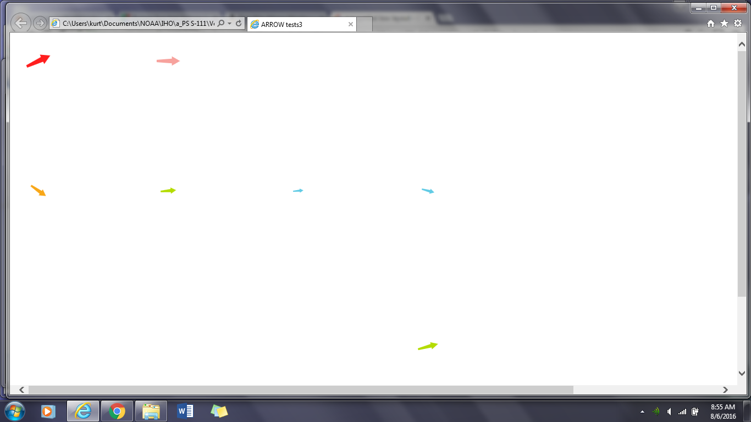

Figure I.1 – Image showing the arrows generated by the .svg and .css codes in this Annex.

## I.2 Sample SVG File to Display Arrows

The sample .svg file shown describes a screen measuring 200 mm wide by 130 mm high. The basic arrows are 10 mm high, and are rotated clockwise by a certain number of degrees to show the current direction. They are also translated in the x- and y-directions by a number of mm to show position, and scaled in length to denote speed relative to the reference speed. The color is denoted by the *fstep* parameter (see the .css file).

<?xml version="1.0" encoding="UTF-8"?>

<?xml-stylesheet href="SVGStyle_S111.css" type="text/css"?>

<!-- width and height of viewport, in mm. The viewBox is x-min y-min width height -->

<svg xmlns="http://www.w3.org/2000/svg" version="1.2" baseProfile="tiny"

xml:space="preserve" style="shape-rendering:geometricPrecision; fill-rule:evenodd;"

width="200.0mm" height="130.0mm" viewBox="-1.0 -1.0 200.0 130.0">

<title>ARROW tests3</title>

<desc>Surface Current direction and speed vector</desc>

<metadata>

<iho:S100SVG xmlns:iho="http://www.iho.int/SVGMetadata">

<iho:Description iho:publisher="IHB" iho:creationDate="2016-04-26"

iho:source="S111Register" iho:format="S100SVG" iho:version="0.1"/>

</iho:S100SVG>

</metadata>

<path class="sl f0 fSTEP9" fill='none' style="stroke-width: 0.05" d=" M -.5,5. L -.5,5. -1.,-1.5 -2.,-1.5 0.,-5. 2.,-1.5 1.,-1.5 .5,5. -.5,5. Z" transform="translate(10.0 10.0) rotate(65.0) scale (1. 1.)"/>

<path class="sl f0 fSTEP8" fill='none' style="stroke-width: 0.05" d=" M -.5,5. L -.5,5. -1.,-1.5 -2.,-1.5 0.,-5. 2.,-1.5 1.,-1.5 .5,5. -.5,5. Z" transform="translate(60.0 10.0) rotate(90.0) scale (0.90 0.90)"/>

<path class="sl f0 fSTEP7" fill='none' style="stroke-width: 0.05" d=" M -.5,5. L -.5,5. -1.,-1.5 -2.,-1.5 0.,-5. 2.,-1.5 1.,-1.5 .5,5. -.5,5. Z" transform="translate(10.0 60.0) rotate(125.0) scale (0.70 0.70)"/>

<path class="sl f0 fSTEP5" fill='none' style="stroke-width: 0.05" d=" M -.5,5. L -.5,5. -1.,-1.5 -2.,-1.5 0.,-5. 2.,-1.5 1.,-1.5 .5,5. -.5,5. Z" transform="translate(60.0 60.0) rotate( 85.0) scale (0.60 0.60)"/>

<path class="sl f0 fSTEP3" fill='none' style="stroke-width: 0.05" d=" M -.5,5. L -.5,5. -1.,-1.5 -2.,-1.5 0.,-5. 2.,-1.5 1.,-1.5 .5,5. -.5,5. Z" transform="translate(110.0 60.0) rotate( 85.0) scale (0.40 0.40)"/>

<path class="sl f0 fSTEP3" fill='none' style="stroke-width: 0.05" d=" M -.5,5. L -.5,5. -1.,-1.5 -2.,-1.5 0.,-5. 2.,-1.5 1.,-1.5 .5,5. -.5,5. Z" transform="translate(160.0 60.0) rotate( 105.0) scale (0.50 0.50)"/>

<path class="sl f0 fSTEP5" fill='none' style="stroke-width: 0.05" d=" M -.5,5. L -.5,5. -1.,-1.5 -2.,-1.5 0.,-5. 2.,-1.5 1.,-1.5 .5,5. -.5,5. Z" transform="translate(160.0 120.0) rotate( 75.0) scale (0.70 0.80)"/>

</svg>

## I.3 Sample CSS File

Below is the .css file used in the above display.

.layout {display:inline} /* used to control visibility of symbolBox, svgBox, pivotPoint (none or inline) */.symbolBox {stroke:none;stroke-width:0.03;} /* show the cover of the symbol graphics */.svgBox {stroke:none;stroke-width:0.01;} /* show the entire SVG cover */.pivotPoint {stroke:none;stroke-width:0.01;} /* show the pivot/anchor point, 0,0 */.sl {stroke-linecap:round;stroke-linejoin:round} /* default line style elements */.f0 {fill:none} /* no fill */.sSTEP1 {stroke:#7652E2} /* sRGB line colour for colour token STEP1: S111 Step 1 color */.fSTEP1 {fill:#7652E2} /* sRGB line colour for colour token STEP1: S111 Step 1 color */.sSTEP2 {stroke:#4898D3} /* sRGB line colour for colour token STEP2: S111 Step 2 color */.fSTEP2 {fill:#4898D3} /* sRGB line colour for colour token STEP2: S111 Step 2 color */.sSTEP3 {stroke:#61CBE5} /* sRGB line colour for colour token STEP3: S111 Step 3 color */.fSTEP3 {fill:#61CBE5} /* sRGB line colour for colour token STEP3: S111 Step 3 color */.sSTEP4 {stroke:#6DBC45} /* sRGB line colour for colour token STEP4: S111 Step 4 color */.fSTEP4 {fill:#6DBC45} /* sRGB line colour for colour token STEP4: S111 Step 4 color */.sSTEP5 {stroke:#B4DC00} /* sRGB line colour for colour token STEP5: S111 Step 5 color */.fSTEP5 {fill:#B4DC00} /* sRGB line colour for colour token STEP5: S111 Step 5 color */.sSTEP6 {stroke:#CDC100} /* sRGB line colour for colour token STEP6: S111 Step 6 color */.fSTEP6 {fill:#CDC100} /* sRGB line colour for colour token STEP6: S111 Step 6 color */.sSTEP7 {stroke:#F8A718} /* sRGB line colour for colour token STEP7: S111 Step 7 color */.fSTEP7 {fill:#F8A718} /* sRGB line colour for colour token STEP7: S111 Step 7 color */.sSTEP8 {stroke:#F7A29D} /* sRGB line colour for colour token STEP8: S111 Step 8 color */.fSTEP8 {fill:#F7A29D} /* sRGB line colour for colour token STEP8: S111 Step 8 color */.sSTEP9 {stroke:#FF1E1E} /* sRGB line colour for colour token STEP9: S111 Step 9 color */.fSTEP9 {fill:#FF1E1E} /* sRGB line colour for colour token STEP9: S111 Step 9 color */

# ANNEX J. SURFACE CURRENT PORTRAYAL RULES

J.1 Introduction

This section summarizes the rules and formulae discussed in SECTION 9 – PORTRAYAL for display of the surface current arrow symbol. The placement of the color scale and the pick report boxes are not discussed.

The surface current feature is characterized by (1) a speed (knots) and (2) a direction (arc-degrees clockwise from north). Speed values are given to the nearest 0.01 knot, and direction values to the nearest 0.1 arc-deg. The speed and direction values are stored in the HDF file as a dataset (DS). The current speed and direction values are applicable to a specific geographic location, denoted by (1) a longitude (arc-degrees) and (2) a latitude (arc-degrees). The current is valid for a specific depth, or as a vertical average over a depth. The the depth and datum, or the averaging depth, are given in the Carrier Metadata. The current is also valid for a specific date and time, the values of which are given either as an attribute of the DS (a time stamp) or must be calculated using the time of the first value, the length of time interval, and the number in the series.

**J.2 The Surface Current Symbol**

Rule 1. The basic symbol for SVG is as shown in Figure J.1. The nominal height of the symbol is 10.0 mm.

(0.0, -5.0)

(2.0, -1.5)

(-2.0, -1.5)

(1.0, -1.5)

(-1.0, -1.5)

(0.5, 5.0)

(-0.5, 5.0)

+

X direction

Y direction

Figure J.1 - Surface current arrow symbol, showing x- and y-coordinates

of the vertices (mm) and the pivot point (+).

Rule 2. A null value for speed and direction (see Table 12.1, *gridLandMaskValue*) means that the point represents land, or the value is missing. In either case, no arrow symbol is displayed.

Rule 3. The colour of the arrow is set by the band within which the speed falls. The colours for nine speed bands are shown in Table J.1.

Table J.1 - Speed bands, colour names, RGB colour values,

and resulting day colours for current speeds.

|  |  |  |  |  |  |  |  |
| --- | --- | --- | --- | --- | --- | --- | --- |
| **Speed Band** | **Min**  **Speed (kn)** | **Max**  **Speed (kn)** | **Colour** | **Colour Scale Intensity** | | | **Displayed Colour** |
| **Red** | **Green** | **Blue** |
| 1 | 0.00 | 0.49 | purple | 118 | 82 | 226 |  |
| 2 | 0.50 | 0.99 | dark blue | 72 | 152 | 211 |  |
| 3 | 1.00 | 1.99 | light blue | 97 | 203 | 229 |  |
| 4 | 2.00 | 2.99 | dark green | 109 | 188 | 69 |  |
| 5 | 3.00 | 4.99 | light green | 180 | 220 | 0 |  |
| 6 | 5.00 | 6.99 | yellow-green | 205 | 193 | 0 |  |
| 7 | 7.00 | 9.99 | orange | 248 | 167 | 24 |  |
| 8 | 10.00 | 12.99 | pink | 247 | 162 | 157 |  |
| 9 | 13.00 | 99.99 | red | 255 | 30 | 30 |  |

Rule 4. Colours for dusk and night are given in ANNEX H – COLOUR TABLES.

Rule 5. There is a separate symbol for each speed band. Each symbol has a unique colour.

**J.3 Symbol Size and Orientation**

Rule 6. The size of the arrow symbol is scaled in proportion to the current speed. The height of the arrow, H (mm), is a function of the speed of the current, S (knots). Allowances are made to (a) display a small symbol even if the speed to near zero and (b) enforce a maximum arrow size. The scaling relationship is:

H = Href∙min{max(Slow,S),Shigh}/Sref.

The following table gives the nominal values for the four constants.

Table J.2 – Summary of recommended values for arrow display size. With these values, an arrow representing 5 kn will have a length of 10 mm.

|  |  |  |
| --- | --- | --- |
| **Constant** | **Description** | **Recommended Value** |
| Href | Reference height for arrow scaling | 10 mm |
| Sref | Reference speed for arrow scaling | 5 kn |
| Slow | Minimum speed to be used for arrow length computations | 0.01 kn |
| Shigh | Maximum speed to be used for arrow length computations | 13 kn |

Rule 7. The arrow is rotated to show the direction of current using the value for direction (Figure J.2).

idl

Figure J.2. Portrayal of the arrow’s direction, based on the current direction. The dashed line is the arrow’s centerline, and the origin of the East-North axis is at the arrow’s pivot point.

True north has a direction of 0 degrees.

**J.4 Placement of the Symbol**

Rule 8. The surface current arrow is placed in the display so that the pivot point corresponds to the given values of longitude and latitude.

Rule 9. The HO must insure that the pivot point shall not be located over land. That a portion of the arrow symbol lies over land is acceptable.

Rule 10. The HO must insure that if the arrow’s pivot point lies in a geographic area designated as intertidal, then when the time-varying water depth has gone to zero the symbol is not displayed.

**J.5 Thinning of a Field of Arrows**

Displaying at a low resolution (i.e., zooming out) increases the density of symbols. However, by applying a thinning algorithm, vector symbol overlap can be reduced. The algorithm discussed below works for regularly gridded data only.

Suppose that the grid cell has a width of *gridSpacingLongitudinal* and height of *gridSpacingLatitudinal* (see Table 12.1), and has a diagonal distance of D mm. Note that D is dependent on the map scale of the display. Also suppose that the height of the arrow symbol for the maximum speed in the display area is Hmax.

Suggested Rule 11. For plotting regularly gridded data, arrows at every nth column and every nth row are drawn, making sure that the row and column with the maximum vector is drawn. With a Rmax value of 0.5,

n =1 + fix{Hmax/(0.5D)}

**J.7 Temporal Rules**

Let Ts be the time selected by the user or the ENS for display of data, and let TE be equal to *dateTimeOfLastRecord* + *timeRecordInterval.*

Rule 12a. If Ts is *earlier* than the timestamp of the first data in the series, *dateTimeOfFirstRecord,* no arrows are displayed.

Rule 12b. If Ts is *later* than TE*,* no arrows are displayed.

Rule 12c. If Ts is *later* than the first timestamp and *earlier* than TE, then the arrows for the data are plotted if the timestamp is (a) later than Ts, but (b) less than Ts + *timeRecordInterval.*